

Financial Certification Website
Administrative Manual

Clerks of the Circuit Court

~April 2012~

Table of Contents

Financial Certification Website Overview 1
Introduction 1
Access Requirements 1
Web Address 1
Financial Certification Website Security 2
Authority 2
Gaining Access to the Website 2
Completing the Locality Security Maintenance Form 3
Accessing the Website 5
Access the Website 5
Log On 5
First Access for New Users 7
Edit Personal Options 7
Forgot Password 8
Navigating the Website 11
Navigation 11
Broadcast Messages 12
Review Broadcast Messages 12
Main Menu 13
Access Main Menu 13
Adding a Certification 14
Add Certification 14
Deleting a Certification 23
Delete Certification 23
Viewing a Certification 24
View Certification 24
Personal Options 26
View Personal Options 26
Edit Personal Options 26
Name Change 27
Request an Extension 28
Request an Extension 28
Extension Request Status 29
Using Help Screens 31
Help Screens 31
How to Contact Us 32
Contact Us 32
Log Off 33
Log Off 33

Financial Certification Website Overview

Introduction | DOA has developed a web-based system to provide localities the ability to certify to DOA monthly that they have reconciled their internal accounting records to CARS, the official accounting record of the Commonwealth.  Along with the Certification, localities should provide notification of any processing irregularities (adjustments) that need to be corrected by DOA. Clerks of the Circuit Court and their designees may access the Financial Certification Website at http://certification.doa.virginia.gov.  This Website has been designed to be as user friendly as possible and requires little intervention from outside resources. However, DOA realizes that there may be functions individuals may need assistance with and has developed this administrative manual to aid Website users. A Contact Us link is also available throughout the Website, where a user can email DOA and receive a response.

Access Requirements | - Browser must be enabled for Java Script.  - Browser must be enabled for Cookies.  - Browser must be enabled for Secure Socket Layer (SSL) Security (128-bit version).  - If connecting to the site from behind a firewall or proxy server it must allow SSL (port 443) communication.  - Internet Explorer or Netscape browsers, version 4.0 or higher.  - Designed to be viewed at a screen resolution of 800 by 600 or greater, with a minimum of 256 colors.  - Connection speed of 56k modem (or higher) is highly recommended.

Web Address | http://certification@doa.virginia.gov

Financial Certification Website Security

Authority | The Code of Virginia (58.1-816) requires each Locality to certify to the State Comptroller that its internal records have been reconciled to CARS, the official record of the Commonwealth. Each Clerk may designate a maximum of two alternates to submit the certification on the Website.

Gaining Access to the Website | In order to gain access to the Financial Certification Website, the Clerk of the Circuit Court will need to complete the Locality Security Maintenance Form.

Continued on next page
Financial Certification Website Security, Continued

Completing the Locality Security Maintenance Form | The automated Certification Locality Security Maintenance Form is located on DOA’s website at www.doa.virginia.gov under the DOA Forms link. The form should be completed online by the Clerk using the instructions below. Once all information is entered, click the ‘Submit to DOA’ button (top of the form), which will generate an email from the Clerk. The email will be sent to the appropriate DOA staff at certification@doa.virginia.gov. If there are questions, they should be directed to this email address. After receipt of the form the user will be emailed a temporary password.  The Clerk enters their Name, Locality Name (from drop down menu), Phone Number and E-mail address. The Function is entered based on the purpose of the form. If access needs to be established for a user, the function should be ‘A’. If a change is being made to the user’s current access, the function should be ‘C’. And finally ‘D’ if the access of the user needs to be deleted.  User ID is standard and begins with a C and continues with the three digit FIPS Code. Alpha character A, B or C should follow (i.e. C001A, C001B, and C001C). Only three users are allowed access.  User Type 1 is an Administrator. The administrator submits the monthly certification, exceptions (if any), receives all system-generated emails (i.e. late notices, extensions) and requests deadline extensions from the Department of Accounts. Preferably the Clerk would be set up as a User Type 1 but may designate other personnel as an administrator.  User Type 2 is a General User. All other users will be general users. General Users can submit only the monthly certification and exceptions (if any).  Information pertaining to the user should be entered in the remaining fields under User Information. The include First Name, Last Name, Locality, Phone Number and E-mail Address. Each of these fields is required.  Access Localities are selected from the drop down menu. Select the FIPS Code for your locality and any additional localities to which the user requires access.  Please leave blank the portion below the Department of Accounts Use Only bar.

Continued on next page
Financial Certification Website Security, Continued

Completing the Locality Security Maintenance Form (continued) | 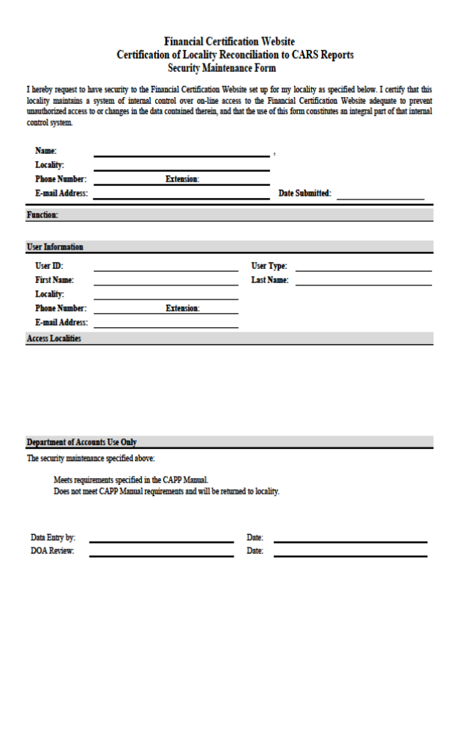

Accessing the Website

Access the Website | Perform the following steps to access the Website.

Step | Action
1 | Go to the DOA Website: www.doa.virginia.gov
2 | Select Financial Certification under Links in the right-hand margin.  Note: Users may also type in the direct link in the address bar on their internet browser http://certification.doa.virginia.gov/.

Log On | 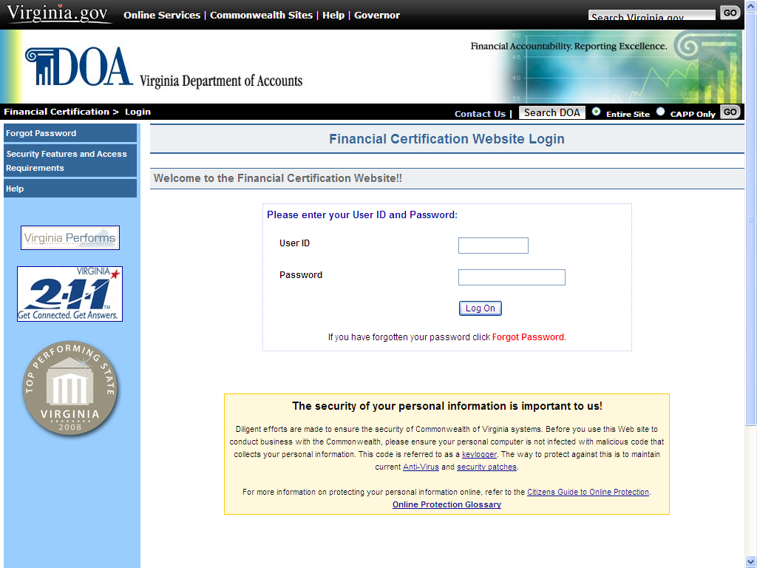

Step | Action
1 | Enter the User ID assigned by DOA.
2 | Enter the User Password.
3 | Click on the Log On button or press Enter.

continued on next page
Accessing the Website, Continued

Log On (continued) | This links the user to the Broadcast Messages page for important information and other menu selections.  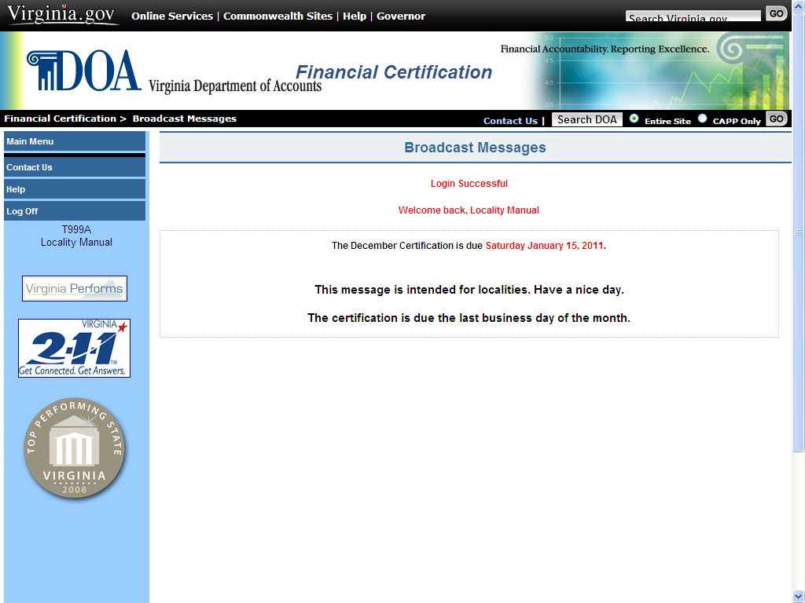

continued on next page
Accessing the Website, Continued

First Access for New Users | After logging on the first time, a user should change their password to a personalized password and set up their personal options. The user edits his Personal Options by selecting:

Step | Action
1 | Select Main Menu in the left margin
2 | Select Personal Options in the left margin. This brings the user to the View Personal Options screen
3 | Select Edit Personal Options

Edit Personal Options | At the Edit Personal Options screen, create a personalized Password that meets the site’s six security standards as follows:  Passwords must:  - be at least eight characters in length  - utilize at least three of the following four:  - special characters ( $ ! @ { } & ~ + ? [ ] ) _,  - upper case alphabetical characters (A - Z),  - lower case alphabetical characters (a - z),  - numerical characters (0-9),  - not contain spaces or ( ' ), ( < ), ( > ), or ( # )  - not match last 24 passwords  - not match assigned temporary password  - not be changed more than once per day.  Enter a valid Email Address (enter twice for verification) and two Challenge Questions of your choice. Create a Password Hint. After you have entered all of the required data on the Edit Personal Options screen, click Accept. If all criteria have been met, the screen returns with Record Updated.

Continued on next page
Accessing the Website, Continued

Forgot Password | If a user enters their User ID and an invalid password, you receive the message: Invalid Password (#Violations).

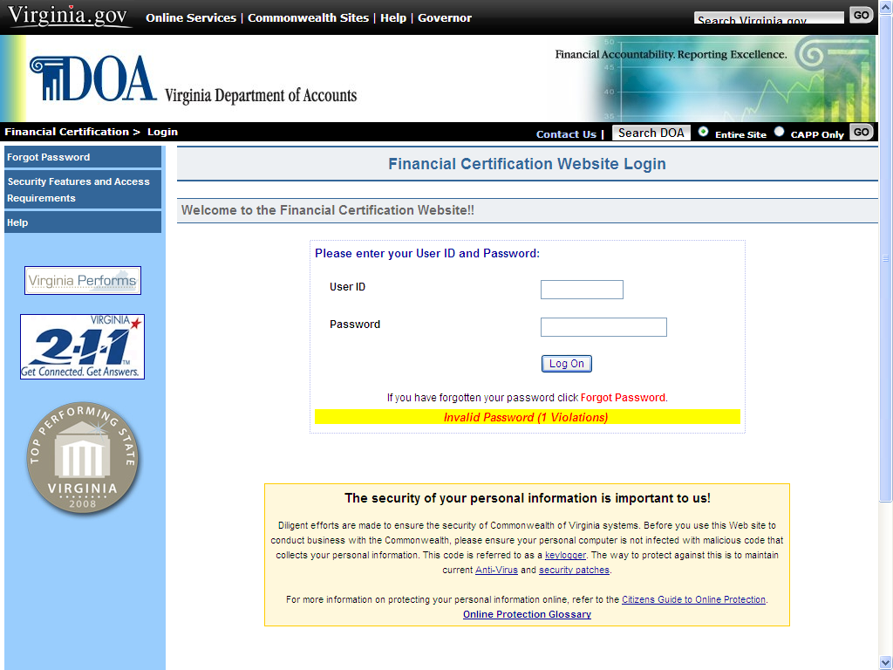

Continued on next page

Accessing the Website, Continued

Forgot Password  (continued) | The user may attempt to enter their User ID and password again or click the Forgot Password button.  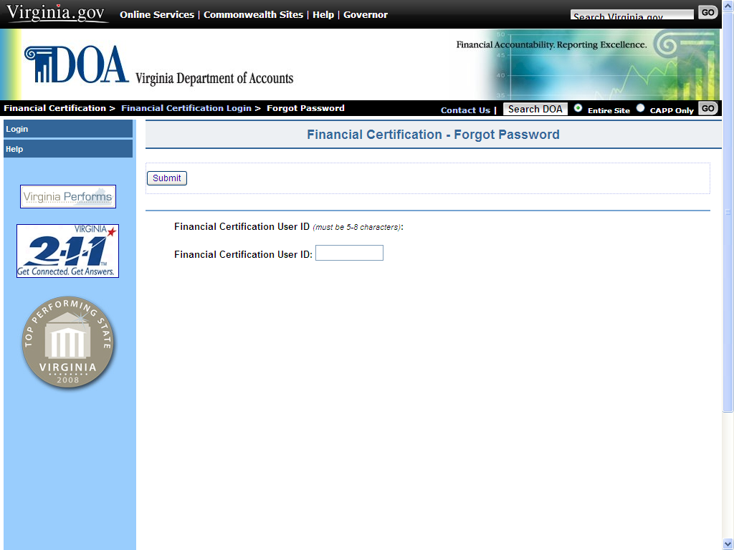  Clicking Forgot Password links the user to the Forgot Password page. Here, the user is asked to enter their previously-assigned User ID and then clicks Submit. Additionally, if the user has set up answers to the challenge questions, the next screen will prompt the user to answer the questions. If answered correctly, the user is allowed to change their password and other personal information.  If the user cannot remember the challenge question answers, they can enter their email address in the box provided and then click Send. If the email address matches the one previously entered, the user is asked to enter a personal phrase. A temporary password is then emailed to the email address entered. The user can then use the temporary password, along with the personal phrase to log in. The user would then have to establish a permanent password. A password may not be changed more than once in a 24-hour period.

Continued on next page
Accessing the Website, Continued

Forgot  Password  (continued) | 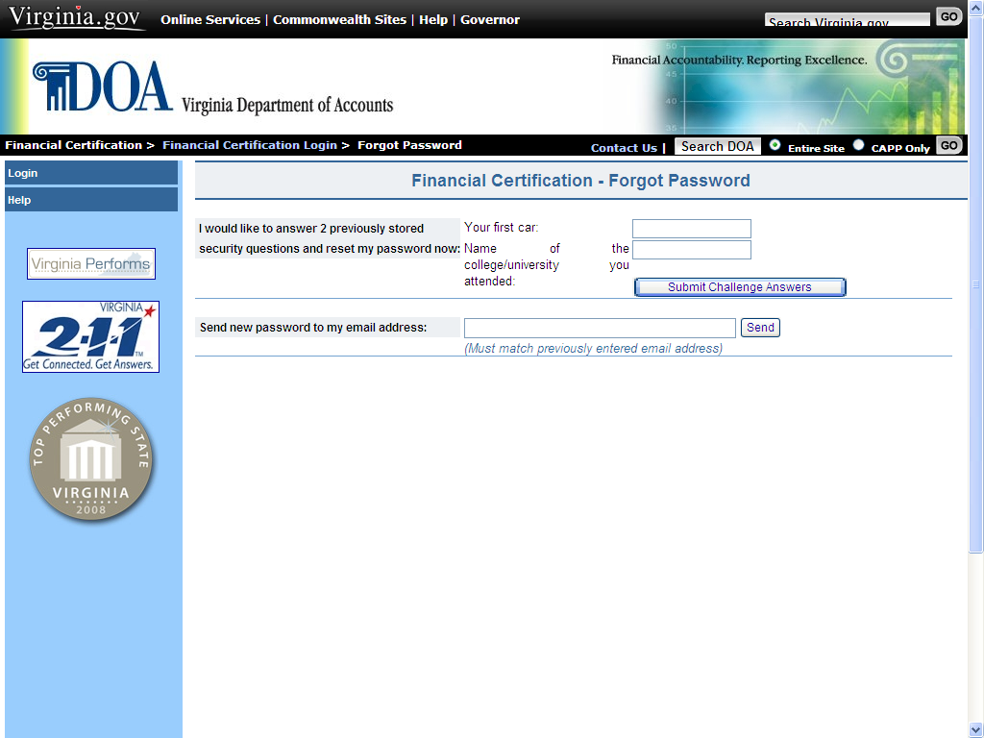

After 5 (five) failed logon attempts, the following message is displayed Account suspended due to security violations. A user that suspends their password will need to contact DOA through the Contact Us button and request their ID be reset.

If a user decides to have his password e-mailed, the e-mail address has to be entered into the box provided and then click Send.

If the e-mail address does not match the one stored in the security record, the message Email address (circuitcourt@courts.state.va.us) did not match displays. The user then has the option of entering the response to the two challenge questions, if previously completed, or entering the correct email address.

Navigating the Website

Navigation | Navigation buttons located in the left-hand margin of the page link the user to other Certification screens or perform requested functions as described below. The list of navigation buttons varies depending on the page and the function that is available from that particular location.
  Button | Description
  Broadcast Messages | Links the user to the Broadcast Messages page where global messages and updates can be viewed.
  Special Announcement | If the button appears, it links the user to a Special Announcement regarding the Certification process.
  Help | Links the user to detailed information about the current page and the selections available on the page.
  Main Menu | Links the user to the Main Menu page. This is the central navigation page for the Financial Certification Website.
  Add Certification | Links the user to the pages used to certify that the locality has reconciled as well as to notify DOA of corrections that are needed.
  View Certification | Links the user to pages used to view certification information that has been previously entered and to make changes up to the due date of the current month’s certification.
  Personal Options | Links the user to a page containing their personal data such as name and email address. Changes to personal information are made on this page.
  Request Extension | Links the user to a page that allows them to request an extension beyond the prescribed due date. The user must have security access with Administrator capability to have this selection.
  Printer Friendly Version | Provides a summary of the certification that can be printed by the locality for their records.
  Contact Us | Allows the user to send an e-mail with suggestions and/or questions to DOA.
  Log Off | Returns the user to the Log On page and signs the user out of the Financial Certification Website.

Broadcast Messages

Review Broadcast Messages | The Broadcast Messages screen provides pertinent information to Website users. DOA will place messages regarding the Certification process or other important information on this page.  The Locality should review the Broadcast Messages periodically to be aware of updates or changes to the process. Additionally, if any special announcement needs to be communicated to the locality, the statement will appear at the bottom of the screen ‘There is a special announcement’. Click on the statement, read the announcement, and delete the message when appropriate.

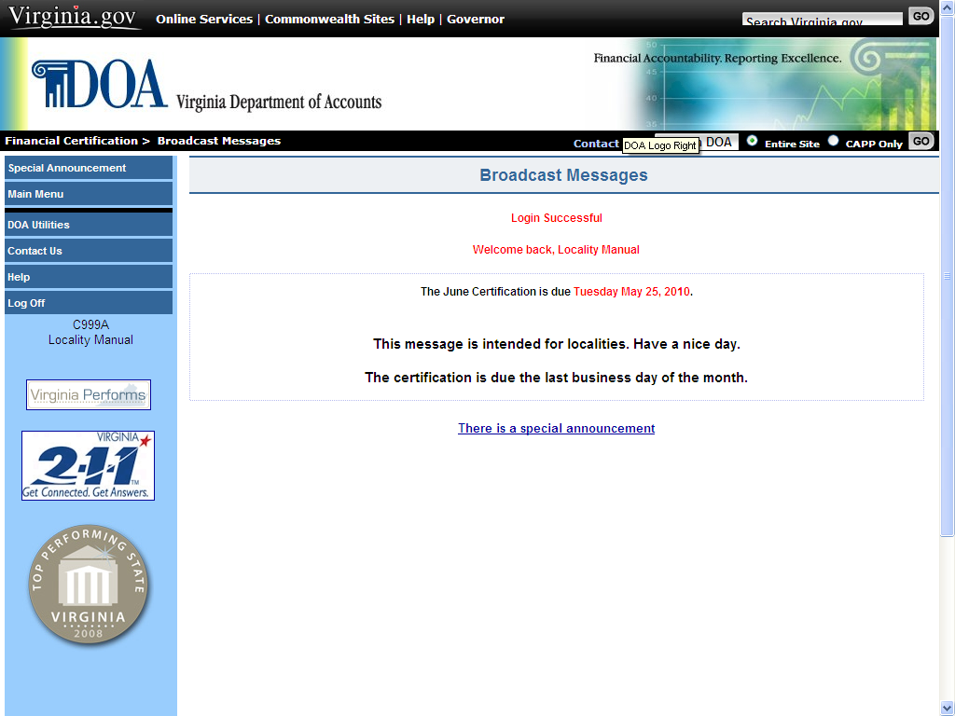

Main Menu

Access Main Menu | The Main Menu is the central navigation screen for the Certification process. To access, the user would select the Main Menu button from the list of choices in the left-hand margin on the Broadcast Messages screen).

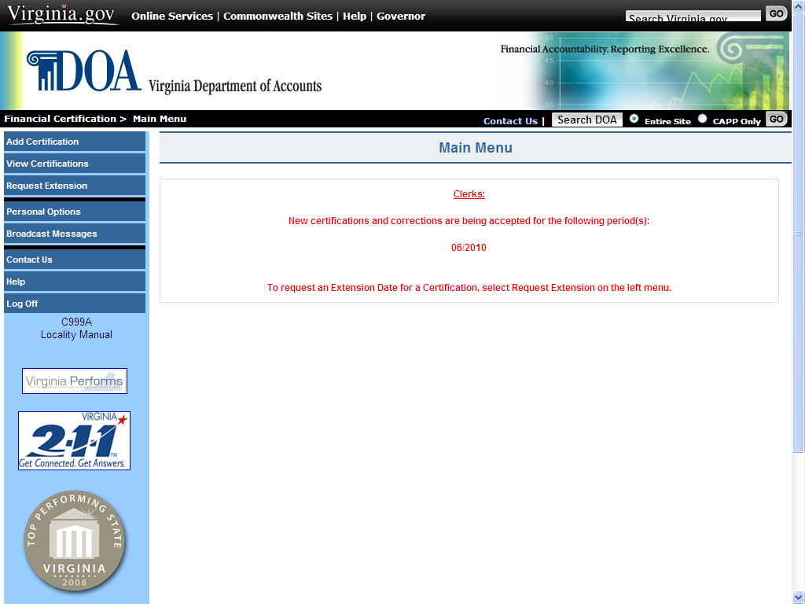

Adding a Certification

Add Certification | Clerks of the Circuit Court are required to certify to DOA that the locality has reconciled their internal records to CARS transactions/balances. The certification due date is posted on the Broadcast Messages screen, but is generally the last business day of the month.  The following steps detail how to enter a Certification using the Website application. Clerks may designate a maximum of two alternates to certify via the Financial Certification Website.

Step | Action
1 | Select Add Certification from the Main Menu. This links the user to the New Certification - Responsibilities screen.
2 | On the New Certification screen, select the locality being certified as reconciled from the drop down menu (only if the user is responsible for more than one locality, otherwise this option is not available and the correct locality will automatically display).
3 | Read the Locality Responsibility and Certification statement. Select I understand and accept or Decline if the Clerk cannot attest to these statements.

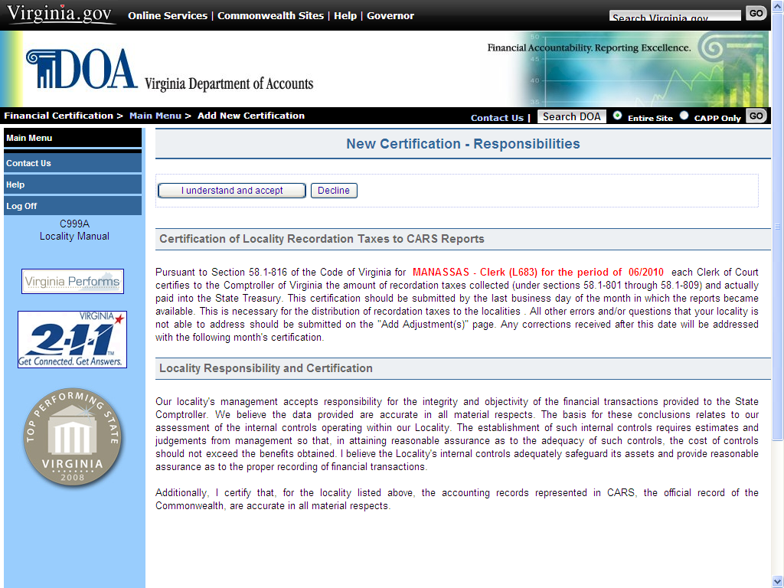

Continued on next page
Adding a Certification, Continued

Add Certification (continued)
  Step | Action
  4 | Read To the Comptroller statement.
  5 | Select the respective radio button that corresponds:  - I do not have adjustments  - I have adjustments/deeds
  6 | Select Accept.

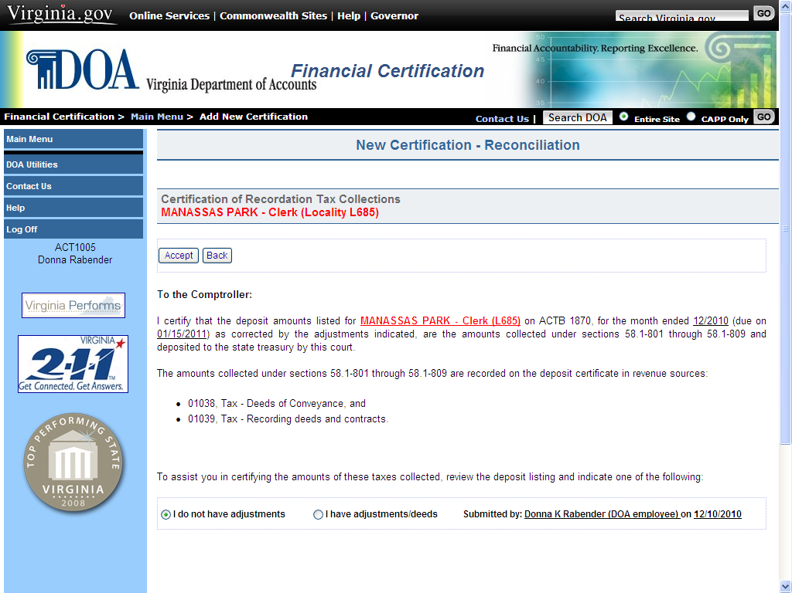

Continued on next page
Adding a Certification, Continued

Add Certification (continued)
  If… | Then
  The Locality selected “I do not have adjustments” | The next screen reads: Record successfully added and a View Certifications button appears. Click on View Certifications then Details. Select Printer Friendly Version in the left column, click Print. This allows the user to print the Certification for their records. The Certification has now been successfully submitted and the user may log off.

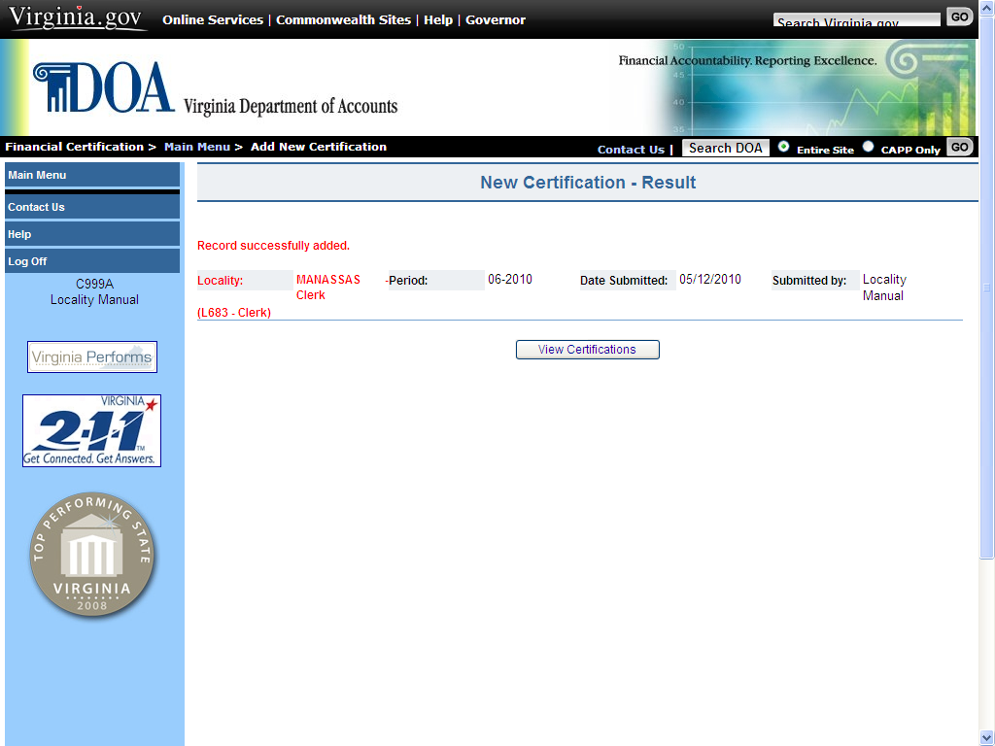

Continued on next page

Adding a Certification, Continued

Add  Certification  (continued) | 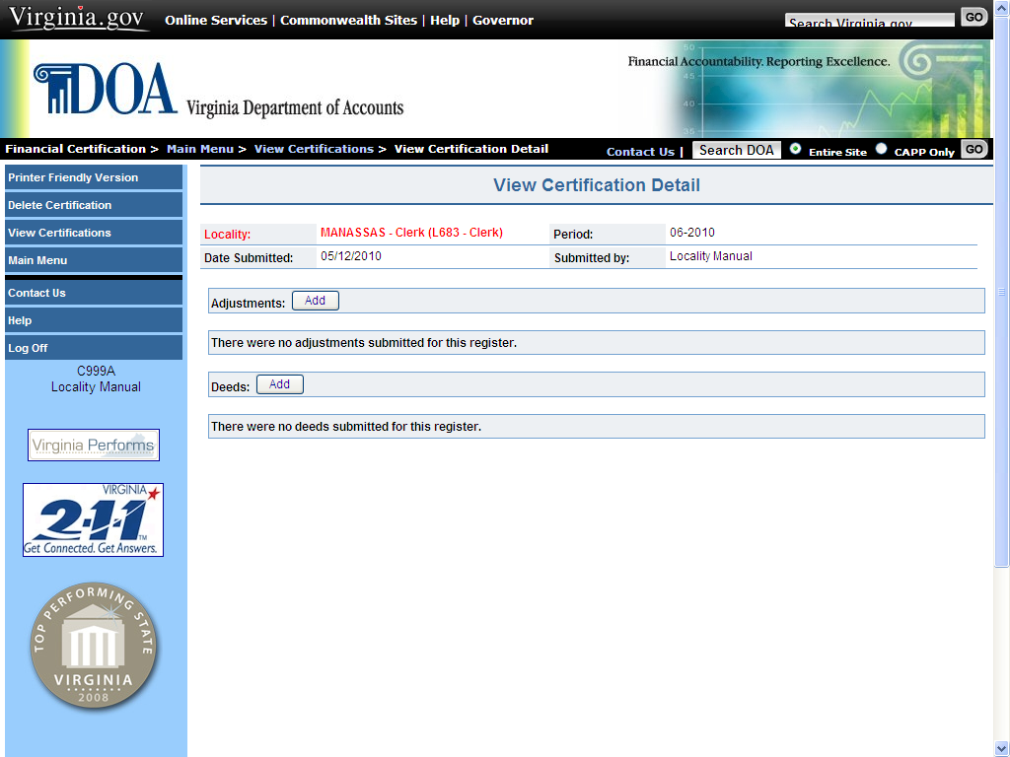

If… | Then…
The Locality selected “I have adjustments/deeds” | The screen reads:  Record successfully added. The user has the option to View Certifications, Add Adjustment or Add Deed.

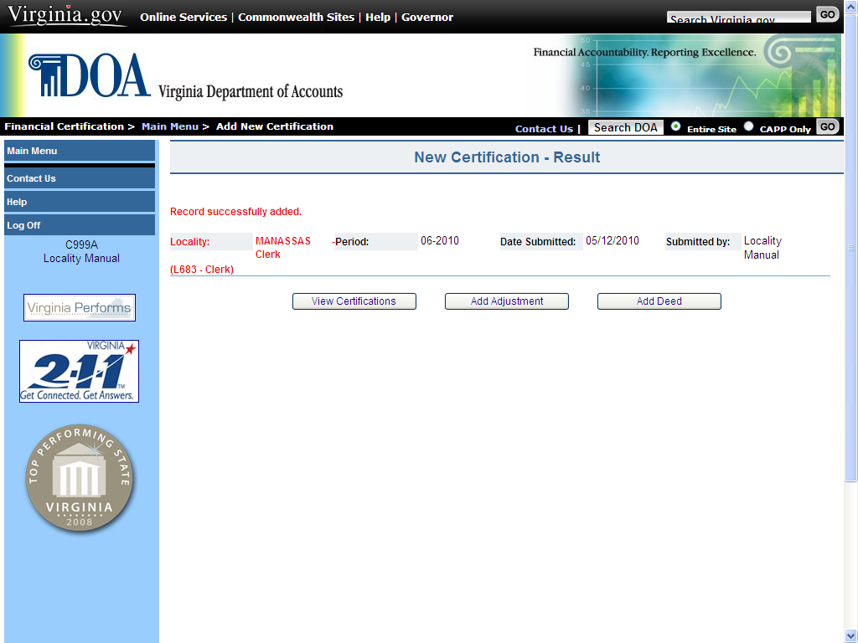

Continued on next page

Adding a Certification, Continued

Add
Certification
If | Then…
The Locality has an adjustment | Click on Add Adjustment.
1 | Select the Adjustment Type that applies to the Locality’s situation by clicking on the associated radio button.
2 | Enter Adjustment Details as required. There is also a Description field where you can add an explanation (500 character maximum).
3 | Select Accept.
(Continued)
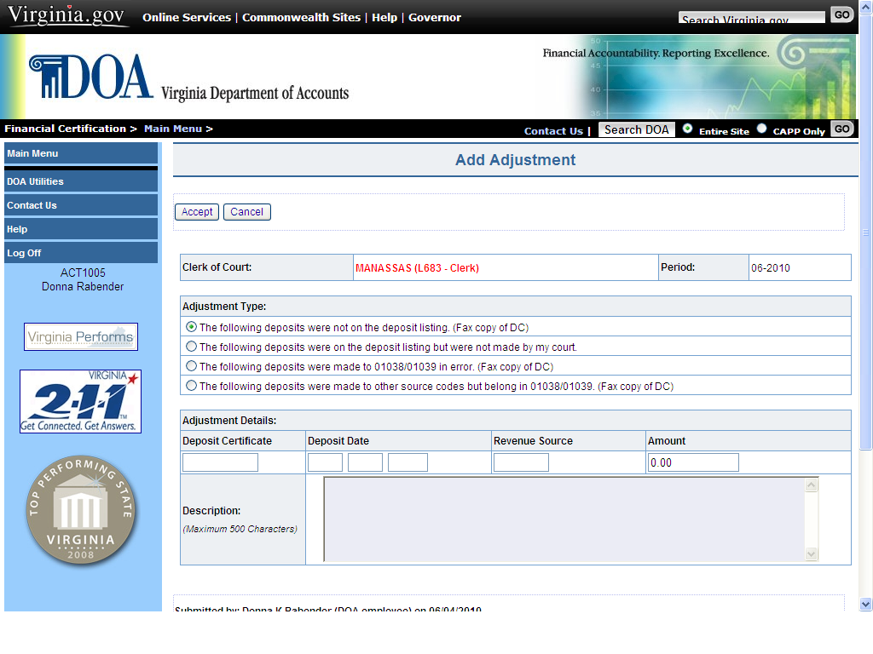

Continued on next page
Adding a Certification, Continued

Add
4 | The next screen reads: Adjustment successfully added.
Certification
(Continued)

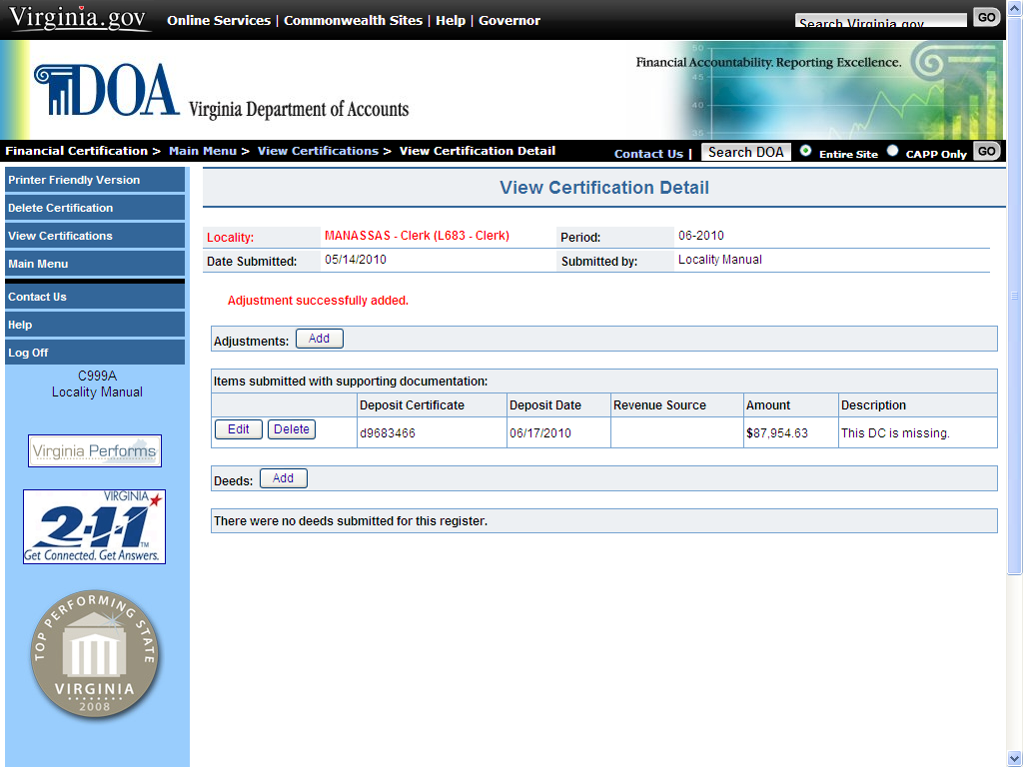

Continued on next page
Adding a Certification, Continued

Add Certification (continued)
If | Then
5 | At this point, there are several options as follows:
Option | Description
Printer Friendly Version | Provides a summary of the Certification that can be printed by the Locality for its records. This is required for audit purposes.
Delete Certification | Allows the user to Delete the entire Certification and any related adjustments previously entered into the system up to the due date.
View Certification | Displays a listing of Certifications previously entered into the system which can be viewed and printed.
Adjustments: Add or Deeds: Add | Links to the Add Adjustment or Add Deed page and allows the user to add adjustments/deeds up to the due date.
Edit/Delete Adjustment or Deed | Located to the left of the adjustment/deed listed on this screen. The user can update an existing adjustment/deed or delete it up to the due date.

Continued on next page
Adding a Certification, Continued

Add
If… | Then…
The Locality has a deed | Click on the Add button next to Deeds: or from the New Certification – Result screen, select Add Deed
1 | Enter the Recording Date, Value, and Total Recordation Tax paid under 58.1-803.
2 | Select ‘Accept’
Certification
(Continued)

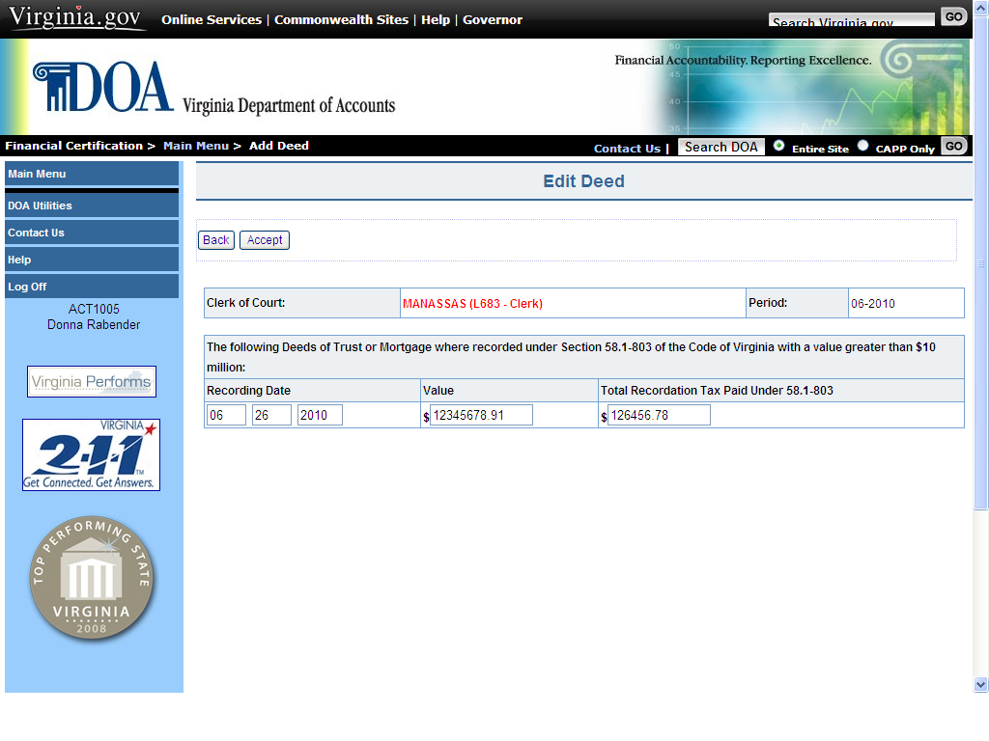

Continued on next page

Adding a Certification, Continued

Add
Certification
If | Then…
3 | Once completed, localities are required to print a copy of the Certification for its records.  From the left-hand margin, select Printer Friendly Version then click on Print located at the top left of the Print Summary Screen.
(Continued)

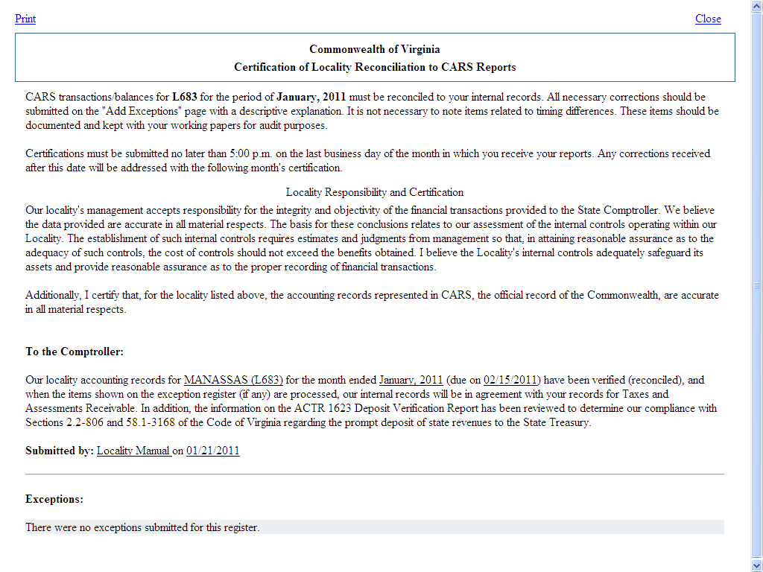

Deleting a Certification

Delete Certification
If at some point it is determined the Certification should not be added and the user is in the process of adding the Certification, there are selections throughout the process to cancel the certification. They are as follows:

Decline | Choose this selection from the first screen for Add Certification. This will take you to the Main Menu.
Back | This selection is available on the page with the statement To the Comptroller. It will take the user to New Certification – Responsibilities where Decline can be selected and it will take user back to the Main Menu. The Certification has not been accepted by the system.
Delete Certification | Available when the user has completed adding a Certification and is on the View Certification screen. Click on Details then in the left column Delete Certification.  Only available if the due date has not passed.

Viewing a Certification

View Certification | The View Certification screen allows the user to view current and previous months’ Certifications.  Current-month certifications can be updated, using this selection, up to the due date.  The following steps explain how to view a Certification and the update options available.
 | Step | Action
 | 1 | At the Main Menu, select View Certification.
 | 2 | Select the period and Locality of the Certification to be viewed from the drop down menu or choose directly from the list that appears automatically with the screen based upon user access. Click on Search.
 | 3 | Click Details button next to the selected Certification.

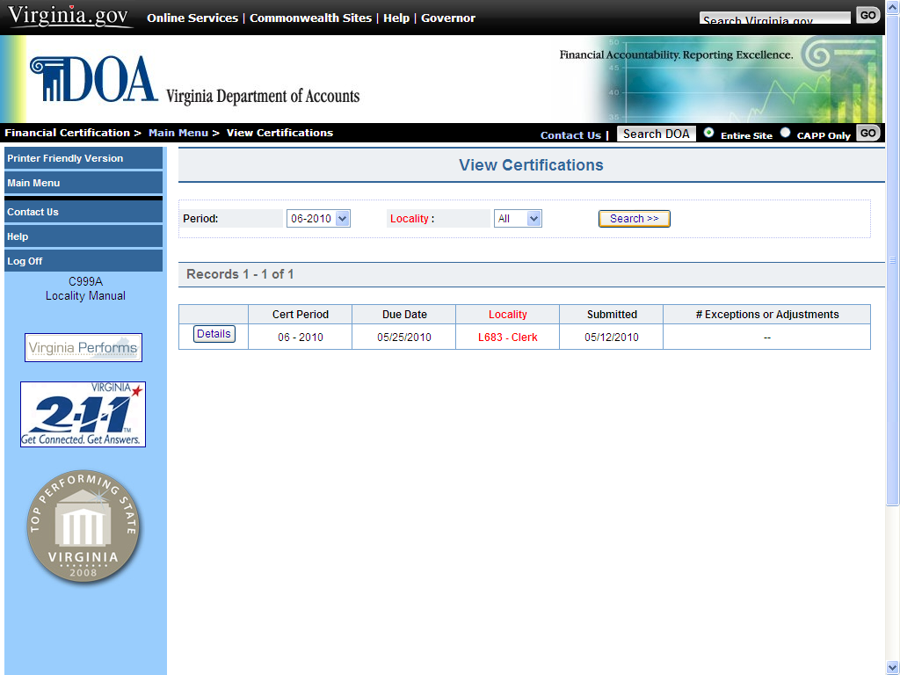

Continued on next page

Viewing a Certification, Continued

View
Certification
If… | Then…
The Certification is from a prior month and the due date has passed | The user can view the Date Submitted, the Submitted By information and Adjustments, if any. Also the user can select Printer Friendly Version to print a copy of the Certification.
The Certification is for the month currently due and the due date has not passed | The user can select from Printer Friendly Version, Add Adjustments, Add Deeds, and Delete Certification. The Edit/Delete option is also available for adjustments/deeds.  Add Adjustments, Delete Certification and the Edit/Delete options are not available after the due date has passed.
(Continued)
Step | Action
4 | Select Main Menu to return and select other functions or Log Off to return to the Financial Certification Website Log In screen where you will be logged off.

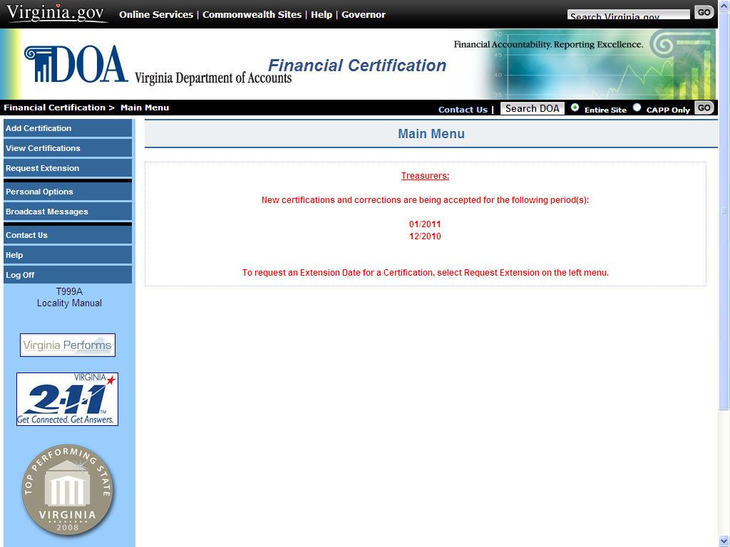

Personal Options

View Personal Options | The Personal Options page allows users to view and update account information. Users can change their password, update their phone number or e-mail address in Personal Options. There are also options to enter “Challenge Questions” and a “Hint” that would be available if a user forgets their password. To access the Personal Options Screen, select the Personal Options button from the Main Menu.

Edit Personal Options | The Personal Options screen allows the user the ability to change any one or all of the following:

- Password (the actual password is not displayed).
- E-mail address (s)
- Phone Number
- Challenge Question (s)
- Hint (to help user in remembering their current password).

The following steps explain how to change personal options.

Step | Action
1 | To make changes, select the Edit Personal Options button on the Personal Options screen.
2 | Enter desired changes to Required or Optional fields. Required fields are shaded.
3 | Select Accept to submit changes. Select Cancel to exit and not save changes.

Continued on next page
Personal Options, Continued

Edit Personal  Options  (continued) | 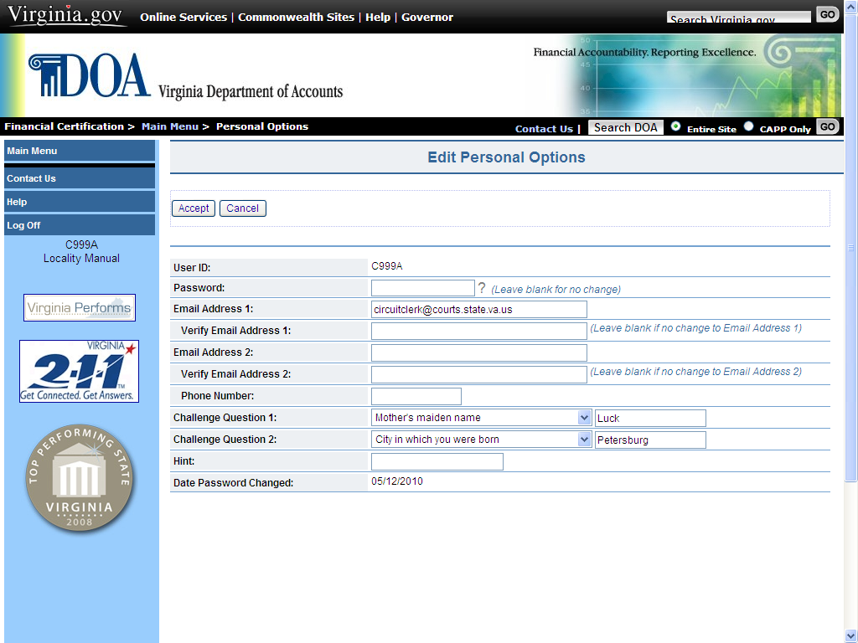

Name Change | To change the name of an employee assigned to a User ID, the Locality is required to submit a Locality Security Maintenance Form found on the Financial Certification Website (see Website Security) to DOA indicating a change to the User ID and provide the new name to be assigned to the User ID.

Request an Extension

Request an Extension | Situations may arise at a locality that will prevent the timely reconciliation to CARS balances/transactions. In the event the locality can foresee not being able to meet the monthly deadline, an extension should be requested. Only a user with Administrator access can request an extension. Localities may request online an extension only up to the due date. After the due date has passed, the Locality contacts DOA directly by emailing certification@doa.virginia.gov.  The following steps detail the procedures for the Administrator to request an online extension:

Step | Action
1 | Select Request Extension from the Main Menu. Only users with Administrator capability will have access to this feature.
2 | The locality name, FIPS code and period for which extensions are being accepted will appear. If the user is responsible for multiple localities, select the appropriate Locality and period.
3 | Enter the Extension Date Requested in mm/dd/yyyy format.
4 | Enter the Request Details (up to 500 characters). If the explanation is too long, please note that additional details can be emailed to certification@doa.virginia.gov.
5 | Select Submit. A summary of the request will immediately appear on the screen and a system-generated email will be sent to the Administrator as confirmation your request was received. The email address from the Administrator’s security record appears in the address label.

Continued on next page
Request an Extension, Continued

Request an Extension (continued) | 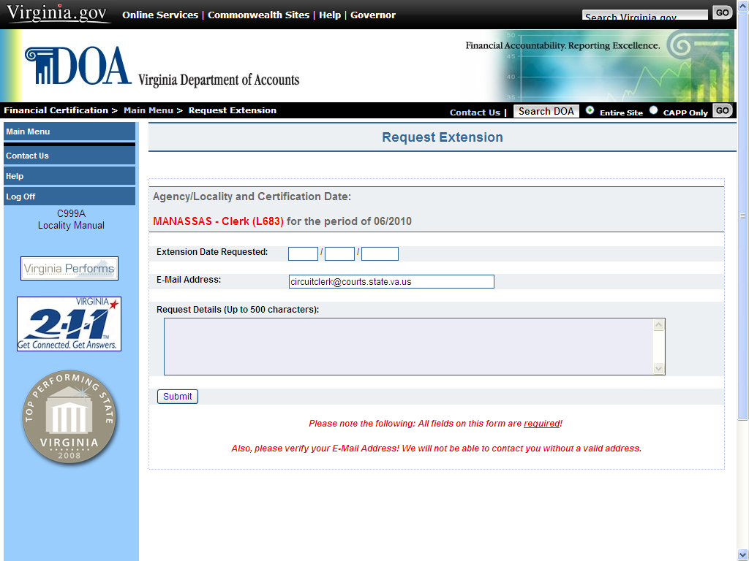

Extension Request Status | The following conditional table provides how the status of an extension request is generated.

If… | Then…
Extension Request is approved | A system-generated email will be sent to the Administrator stating the request was approved.  The new due date will appear to all users with access to the Locality at the Main Menu.
Extension Request is not approved | A system-generated email is sent to the Administrator stating the request was denied.  A statement as to why the request was denied is included in the email.

Continued on next page
Request an Extension, Continued

Request an Extension (continued) | 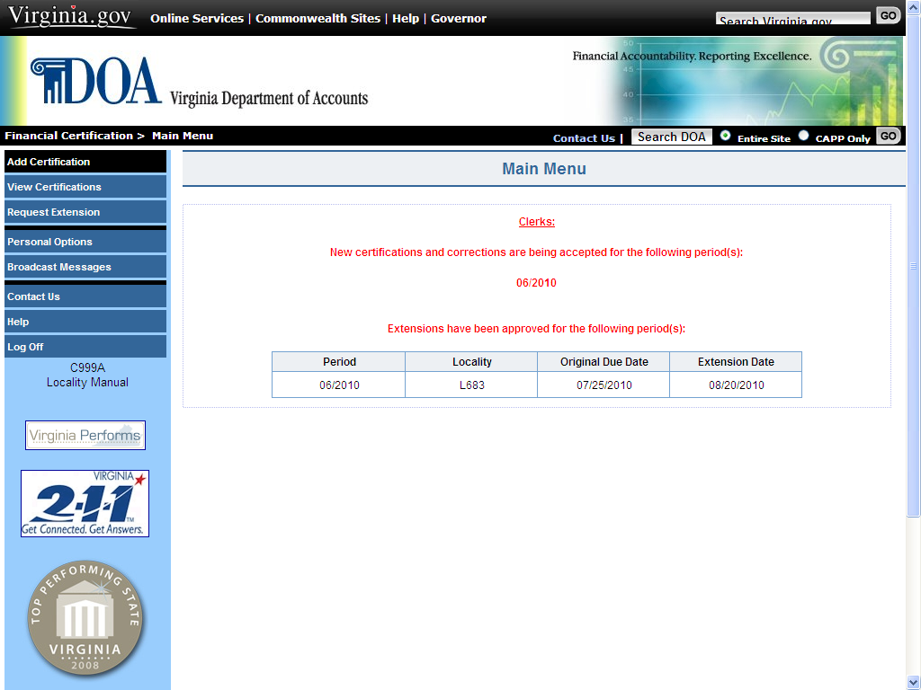

Using Help Screens

Help Screens | These screens provide detailed information about the current page and the selections available on that page. Help Screens are accessible on every page of the web application. To access the Help Screens, select the Help button located in the left-hand margin of the page.

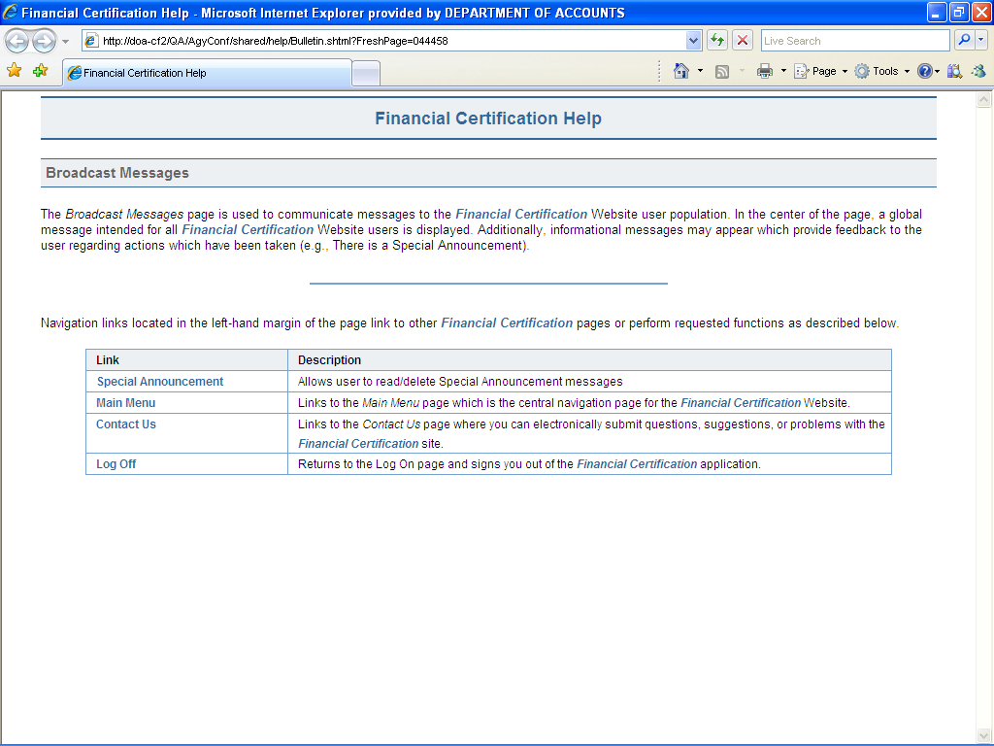

How to Contact Us

Contact Us | Provides the user with the ability to contact DOA for assistance with the web application and/or to send comments regarding the site.

 |  | Step | Action
 |  | 1 | Select Contact Us from the list in the left-hand margin of the page or at the top of each Website page.  Note: This selection is available on all pages of the web application.
 |  | 2 | Under Category, select the reason for contacting DOA.
 |  | 3 | Insert any comments or the help needed in the comment box.
 |  | 4 | Email address entered in your Personal Options appears.  Note: DOA must have your correct e-mail address to be able to respond.
 |  | 5 | Enter User ID. Although optional, this helps to facilitate a response to your question.
 |  | 6 | Select Submit.
 | 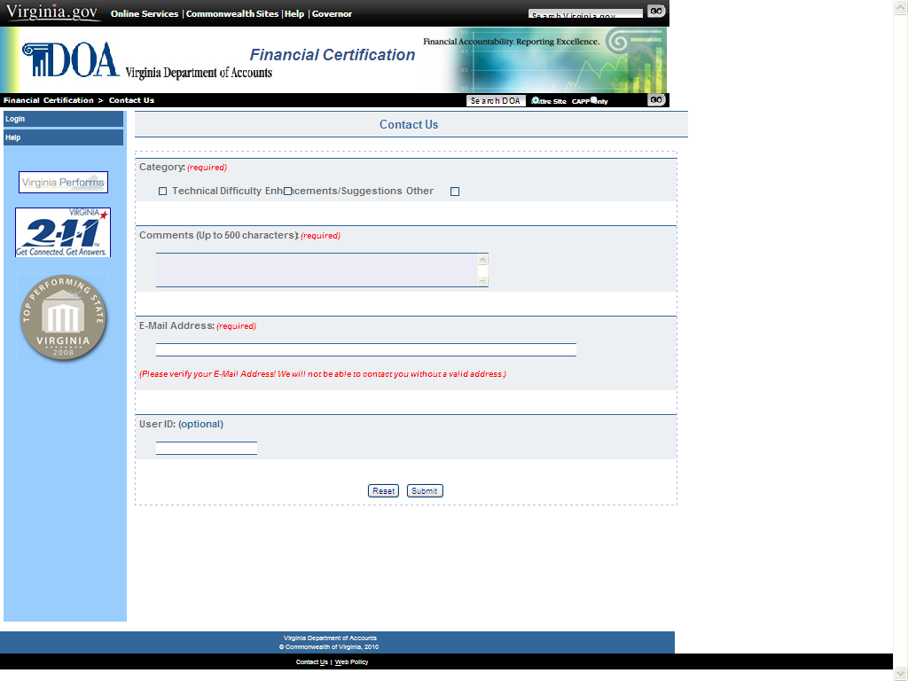

Log Off

Log Off | Once all transactions have been completed on the web application, select Log Off from the list of selections located in the left-hand margin of the screen. When Log Off has been selected the user is returned to the Welcome page.  Note: This selection is available on all pages of the web application.



