Financial Certification Website
Administrative Manual

Locality Treasurer

~February 2016~

Table of Contents

Financial Certification Website Overview 1
Introduction 1
Access Requirements 1
Web Address 1
Financial Certification Website Security 2
Authority 2
Gaining Access to the Website 2
Completing the Locality Security Maintenance Form 2
Accessing the Website 5
Access the Website 5
Log On 5
First Access for New Users 7
Forgot Password 9
Navigating the Website 12
Navigation 12
Broadcast Messages 13
Review Broadcast Messages 13
Special Announcement 14
Special Announcement 14
Main Menu 15
Access Main Menu 15
Adding a Certification 16
Add Certification 16
Deleting a Certification 24
Delete Certification 24
View Certification 25
View Certification 25
Entering a Deposit Certificate 27
Entering a Deposit Certificate 27
Searching Deposits 32
Searching Deposits 32
CARS Reports 33
CARS Reports 33
Viewing Previous Period CARS Reports 34
Cardinal Reports 35
Cardinal Reports 35
Viewing Previous Period Cardinal Reports 36
Personal Options 37
View Personal Options 37
Edit Personal Options 37
Name Change 38
Request an Extension 39
Request an Extension 39
Extension Request Status 40
Using Help Screens 42
Help Screens 42
How to Contact Us 43
Contact Us 43
Log Off 44
Log Off 44

Financial Certification Website Overview

Introduction The Financial Certification Website is a web-based system that provides localities the ability to record their deposits of state revenues and to certify to DOA monthly that they have reconciled their internal accounting records to CARS, the official accounting system for the Commonwealth until June 30, 2016, and Cardinal the official accounting system beginning with Fiscal Year 2017.

Along with the Certification, localities should provide notification of any processing irregularities (exceptions) that need to be corrected by DOA. Treasurers and their designees may access the Financial Certification Website at http://certification.doa.virginia.gov.

This website has been designed to be as user friendly as possible and require little intervention from outside resources. However, DOA realizes that there may be functions individuals may need assistance with and has developed this administrative manual to aid website users. A Contact Us link is also available throughout the website, where a user can email DOA and receive a response.

Access Requirements
- Browser must be enabled for Java Script.
- Browser must be enabled for Cookies.
- Browser must be enabled for Secure Socket Layer (SSL) Security (128-bit version).
- If connecting to the site from behind a firewall or proxy server it must allow SSL (port 443) communication.
- Internet Explorer or Netscape browsers, version 4.0 or higher.
- Designed to be viewed at a screen resolution of 800 by 600 or greater, with a minimum of 256 colors.
- Connection speed of 56k modem (or higher) is highly recommended.

Web Address http://certification.doa.virginia.gov

Financial Certification Website Security

Authority Each Locality is required to certify to the State Comptroller that its internal records have been reconciled to CARS, the official accounting system for the Commonwealth until June 30, 2016, and Cardinal the official accounting system of the Commonwealth beginning with Fiscal Year 2017. In addition, the information on the CARS ACTR1623 Deposit Verification Report and the Cardinal RAR 729 Deposit and Revenue Summary for Local Treasurers has been reviewed to determine compliance with Section 2.2-806 and 58.1-3168 of the Code of Virginia regarding the prompt deposit of state revenues to the State Treasury. Each Treasurer may designate a maximum of two alternates to submit the certification on the website.

Gaining Access to the Website
In order to gain access to the Financial Certification Website, the Treasurer will need to complete the Locality Security Maintenance Form.

Completing the Locality Security Maintenance Form
The automated Financial Certification Security Maintenance Form - Locality is located on DOA’s website at www.doa.virginia.gov under the DOA Forms link. The form should be completed online by the Treasurer using the instructions below. Once all information is entered, click the ‘Submit to DOA’ button (top of the form), which will populate the Date field and generate an email from the Treasurer. The email will be sent to the appropriate DOA staff at certification@doa.virginia.gov. If there are questions, they should be directed to this email address. After receipt of the form the user will be emailed a temporary password.

The Treasurer enters their Name, Locality (from the drop down menu), Phone Number and E-mail Address. The Function is entered based on the purpose of the form. If access needs to be established for a user, the function should be ‘Add’. If a change is being made to the user’s current access, the function should be ‘Change’. And finally ‘Delete’ if the access of the user needs to be deleted.

User ID is standard and begins with a T and continues with the three digit FIPS Code. Alpha character A, B, or C should follow (i.e. T001A, T001B, or T001C) for the users authorized to enter a Certification. The Treasurer and two alternates are allowed access to enter the Certification. Alpha characters D-Z should follow for users authorized to view reports and/or enter deposits.

Continued on next page

Financial Certification Website Security, Continued

Completing the Locality Security Maintenance Form (continued)
User Type 1 is an Administrator. The administrator receives all system- generated emails (i.e. late notices, extensions) and requests deadline extensions from the Department of Accounts. Preferably the Treasurer would be set up as a User Type 1 but may designate other personnel as an administrator.

User Type 2 is a General User. All other users will be general users.

Both a User Type 1 and 2 can have any combination of Security Access as detailed below.

Information pertaining to the user should be entered in the remaining fields under User Information. They include First Name, Last Name, Locality, Phone Number and E-mail Address. Each of these fields is required.

Security Access defines the roles that can be assigned to a user. Select the appropriate option from the drop down menu.

Role | Description
Certifications | This role allows the user to certify and/or view previously entered Certifications. Available options are Update, View or None.  Note: Update is restricted to User IDs assigned the Alpha character A, B, or C.
Reports | This role grants the user access to view CARS and Cardinal reports. Available options are View or None.
Deposits | This role allows the user to enter deposits and /or view previously entered deposits. Available options are Update, View or None.

Please select None when the user should not have access to a particular role.

Access Localities are selected from the drop down menu. Select the FIPS Code for your locality and any additional localities to which the user requires access.

Please leave blank the portion below the Department of Accounts Use Only bar.

Continued on next page

Financial Certification Website Security, Continued

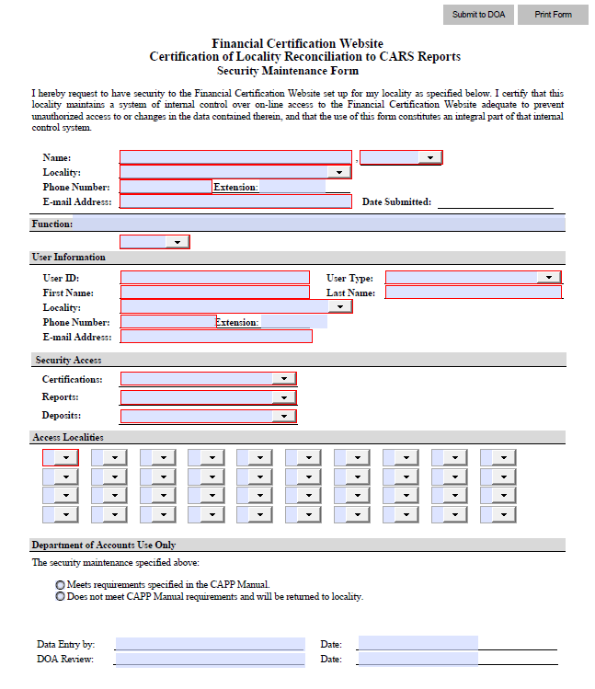Completing the Locality Security Maintenance Form (continued)

Accessing the Website

Access the Website
Perform the following steps to access the website.

Log On

Step | Action
1 | Go to the DOA website: www.doa.virginia.gov
2 | Under Links in the right-hand margin select Financial Certification.  Note: Users may also type in the direct link in the address bar on their internet browser http://certification.doa.virginia.gov/.

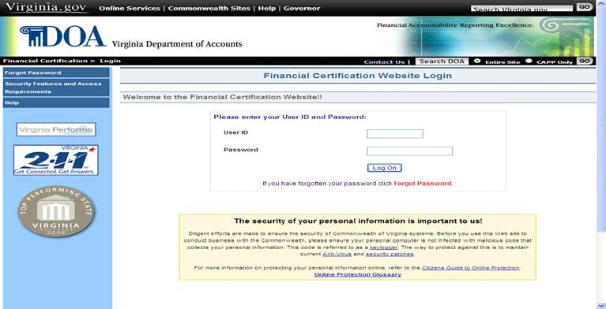

Step | Action
1 | Enter the User ID assigned by DOA.
2 | Enter the User Password.
3 | Click on the Log On button or press Enter.
Continued on next page

Accessing the Website, Continued

Log On
(continued)
This links the user to the Broadcast Messages page for important information and other menu selections.

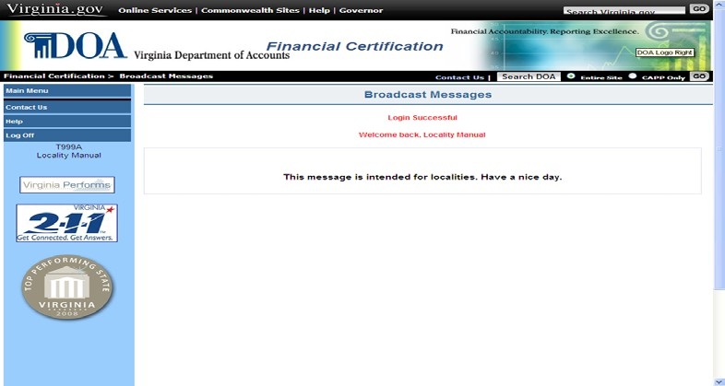

Continued on next page

Accessing the Website, Continued

First Access for New Users
After logging on the first time, a user should change their password to a personalized password and set up their personal options. The user edits their Personal Options by selecting:

Step | Action
1 | Select Main Menu in the left margin
2 | Select Personal Options in the left margin. This brings the user to the View Personal Options screen
3 | Select Edit Personal Options

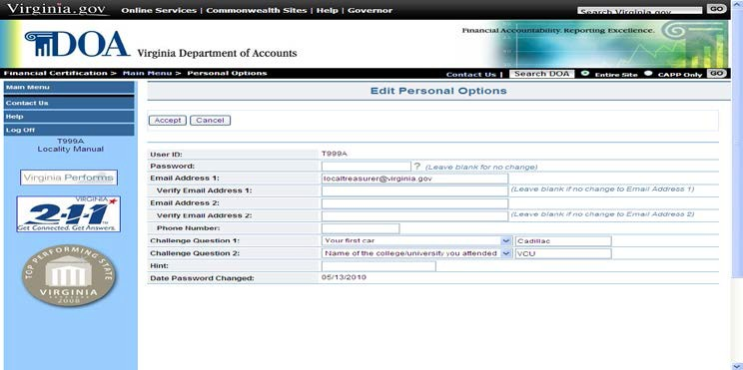

Continued on next page

Accessing the Website, Continued

First Access for New Users (continued)
At the Edit Personal Options screen, create a personalized Password that meets the site’s six security standards as follows:

Passwords must:
  - be at least eight characters in length
  - utilize at least three of the following four:
    - special characters ( $ ! @ { } & ~ + ? [ ] ),
    - upper case alphabetical characters (A - Z),
    - lower case alphabetical characters (a - z),
    - numerical characters (0-9),
  - not contain spaces or ( ' ), ( < ), ( > ), or ( # )
  - not match last 24 passwords
  - not match assigned temporary password
  - not be changed more than once per day.

Enter a valid e-mail address (enter twice for verification) and two challenge questions of your choice and a password hint. After you have entered all of the required data on the Edit Personal Options screen, click Accept. If all criteria have been met, the screen returns with Record Updated.

Continued on next page

Accessing the Website, Continued

Forgot Password
If a user enters their User ID and an invalid password, you receive the message: Invalid Password (#Violations).

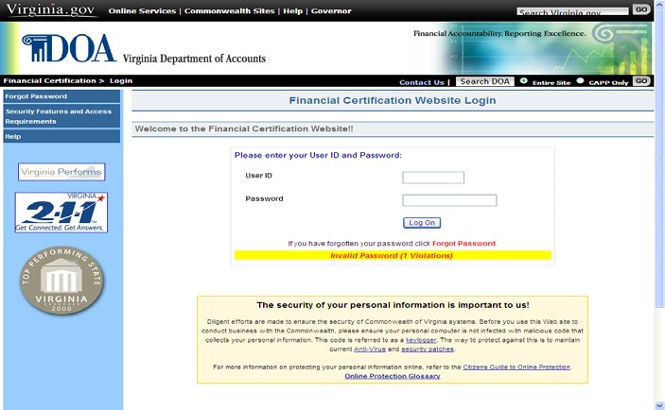

Continued on next page

Accessing the Website, Continued

Forgot Password (continued)
The user may attempt to enter the User ID and password again or click the
Forgot Password button.

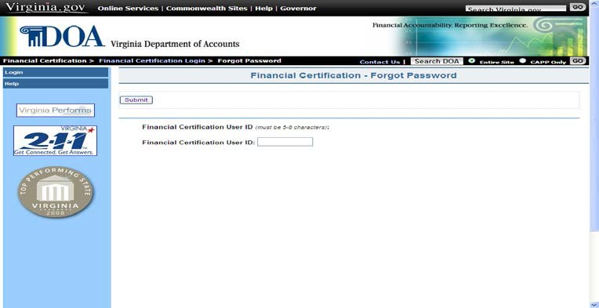

Clicking Forgot Password links the user to the Forgot Password page. Here, the user is asked to enter their previously-assigned User ID and then click Submit. Additionally, if the user has set up answers to the challenge questions, the next screen will prompt the user to answer the questions. If answered correctly, the user is allowed to change their password and other personal information.

If the user cannot remember the challenge question answers, they can enter their email address in the box provided and then click Send. If the email address matches the one previously entered, the user is asked to enter a personal phrase. A temporary password is then emailed to the email address entered. The user can then use the temporary password, along with the personal phrase to log in. The user would then have to establish a permanent password. A password may not be changed more than once in a 24-hour period.

Continued on next page

Accessing the Website, Continued

Forgot Password (continued)

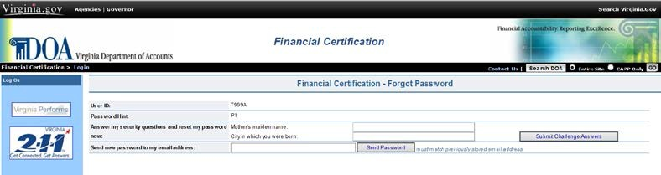

After 5 (five) failed logon attempts, the following message is displayed Account suspended due to security violations. A user that suspends their Password will need to contact DOA through the Contact Us button and request their ID be reset.

If a user decides to have his password e-mailed, the e-mail address has to be entered into the box provided and then click Send.

If the e-mail address does not match the one stored in the security record, the message Email address (treasurer@virginia.gov) did not match displays. The user then has the option of entering the response to the two challenge questions, if previously answered, or entering the correct email address.

Navigating the Website

Navigation Navigation buttons located in the left-hand margin of the page link the user to other Certification screens or perform requested functions as described below. The list of navigation buttons varies depending on the page and the function that is available from that particular location.

Button | Description
Broadcast Messages | Links the user to the Broadcast Messages screen where important messages and updates can be viewed.
Special Announcement | If the button appears, it links the user to a Special Announcement regarding the Certification process.
Help | Links the user to detailed information about the current screen and the selections available on the screen.
Main Menu | Links the user to the Main Menu screen. This is the central navigation screen for the Financial Certification Website.
Add Certification | Links the user to the screens used to certify that the locality has reconciled as well as to notify DOA of corrections that are needed.
View Certification | Links the user to screens used to view certification information that has been previously entered and to make changes up to the due date of the current month’s certification. Also able to Print a certification.
Local Treasurer Deposits | Links the user to screens used to enter, view, and search for deposit certificates that interface into Cardinal.
CARS Reports | Links the user to the CARS Reports page where monthly CARS reports can be accessed.
Cardinal Reports | Links the user to the Cardinal Reports page where monthly Cardinal reports can be accessed.
Personal Options | Links the user to a screen containing their personal data such as name and email address. Changes to personal information are made on this screen.
Request Extension | Links the user to a screen that allows them to request an extension beyond the prescribed due date. The user must have security access with Administrator capability to have this selection.
Printer Friendly Version | Provides a summary of the Certification that can be printed by the locality for their records.
Contact Us | Allows the user to send an e-mail with suggestions and/or questions to DOA.
Log Off | Returns the user to the Log On page and signs the user out of the Financial Certification Website.

Broadcast Messages

Review Broadcast Messages
The Broadcast Messages screen provides pertinent information to website users. DOA will place messages regarding the Certification and/or Deposit process or other important information on this screen.

The Locality should review the Broadcast Messages periodically to be aware of updates or changes to the process.

Special Announcement

Special Announcement
If any special announcement needs to be communicated to the locality, the statement “There is a special announcement” will appear at the bottom of the Broadcast Messages screen and the Special Announcement button will appear in the list of choices in the left-hand margin. Click on the statement or button, read the announcement, and delete the message when appropriate.

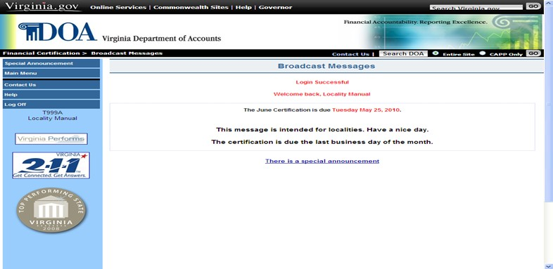

Main Menu

Access Main Menu
The Main Menu is the central navigation screen for the Certification process. To access, the user would select the Main Menu button from the list of choices in the left-hand margin on the Broadcast Messages screen.

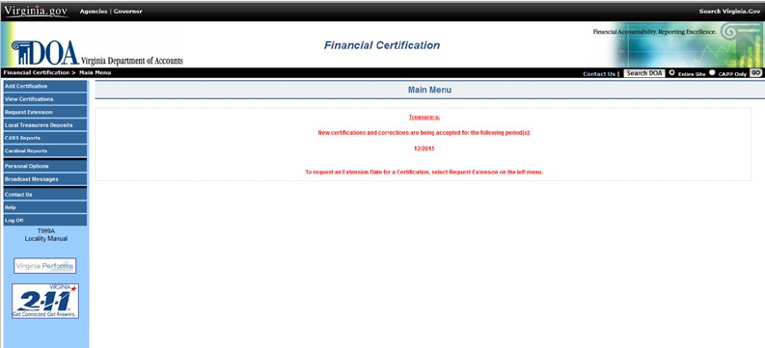

Adding a Certification

Add Certification
Treasurers are required to certify to DOA that the locality has reconciled their internal records to CARS, the official accounting system for the Commonwealth until June 30, 2016, and Cardinal, the official accounting system beginning with Fiscal Year 2017, transactions/balances. The certification due date is posted on the Broadcast Messages screen, but is generally the last business day of the month. The following steps detail how to enter a Certification using the website application. A Treasurer may designate a maximum of two alternates to certify via the Financial Certification Website.

Step | Action
1 | Select Add Certification from the Main Menu. This links the user to the New Certification – Responsibilities screen.
2 | On the New Certification screen, select the locality being certified as reconciled from the drop down menu (only if the user is responsible for more than one locality, otherwise this option is not available and the correct locality will automatically display).
3 | Read the Locality Responsibility and Certification statement. Select I understand and accept or Decline if the Treasurer cannot attest to these statements.

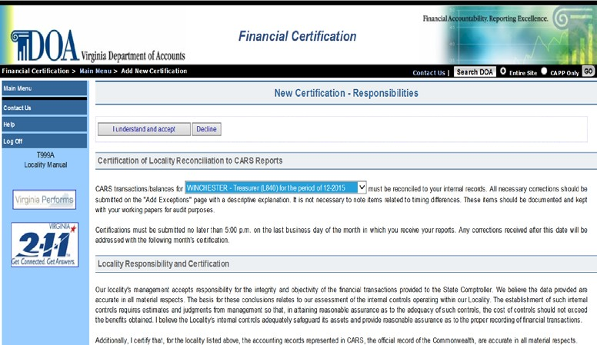

Continued on next page

Adding a Certification, Continued

Add Certification (continued)
Step | Action
4 | Read To the Comptroller statement.
5 | Select the respective radio button that corresponds to whether the locality has corrections:  - I do not have exceptions  - I have exceptions (locality has corrections that require DOA journal entry).
6 | Select Accept.

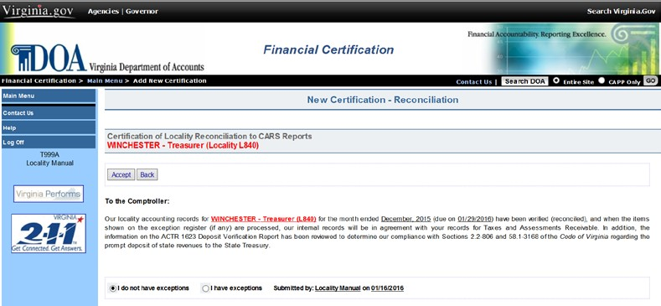

Continued on next page

Adding a Certification, Continued

Add Certification (continued)
If | Then
The Locality selected ‘I do not have exceptions’ | The next screen reads:  Record successfully added and a View Certifications button appears. Click on View Certifications, Details, select Printer Friendly Version in the left column, and finally click on Print. This allows the user to print the Certification for their records. The Certification has now been submitted successfully and the user may log off.

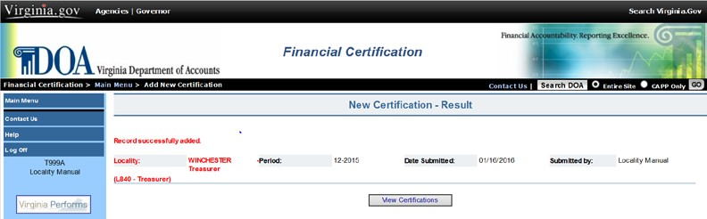

Continued on next page

Adding a Certification, Continued

Add Certification (continued)

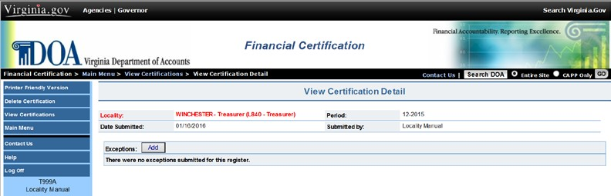

Continued on next page

Adding a Certification, Continued

Add Certification (continued)
If | Then
The Locality selects ‘I have exceptions’ | The screen reads  Record successfully added and the following buttons appear: View Certifications and Add Exception.  Continue with Step 7 below.

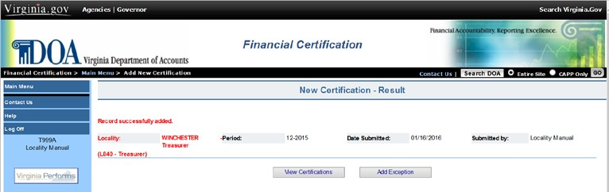

Step | Action
7 | Select Add Exception.
8 | Select the Exception Type that applies to the Locality’s situation by clicking on the associated radio button.
9 | Enter Exception Details as required. Shaded fields indicate which information is required. There is also a Description field where you can add an explanation (500 character maximum).
10 | Select Accept.

Continued on next page

Adding a Certification, Continued

Add Certification (continued)
Step | Action
11 | The next screen reads: Exception successfully added, screen will show current exceptions submitted.

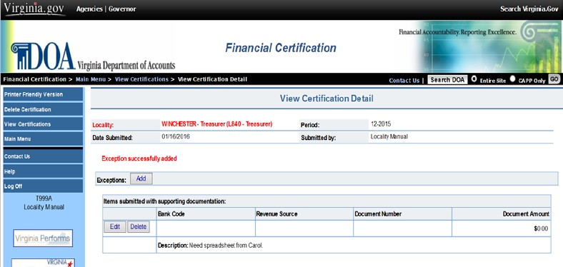

Continued on next page

Adding a Certification, Continued

Add Step Action
Certification 12 At this point, the user has several options as follows:
(continued)
 | Option Description
Printer F Version | riendly Provides a summary of the certification submitted by the Locality to print. This is required for audit purposes.
Add Exception Links to the Add Exception screen and
allows the user to add another exception up to the due date.
Delete Certification Allows the user to Delete the entire
Certification and any related exceptions previously entered into the system up to the due date.
View Ce | rtification Displays a listing of Certifications  previously entered into the system.
Edit/Del | ete Exceptions Located to the left of the exception  listed on this screen; the user can update an existing exception or delete it up to the due date.
Continued on next page

Adding a Certification, Continued

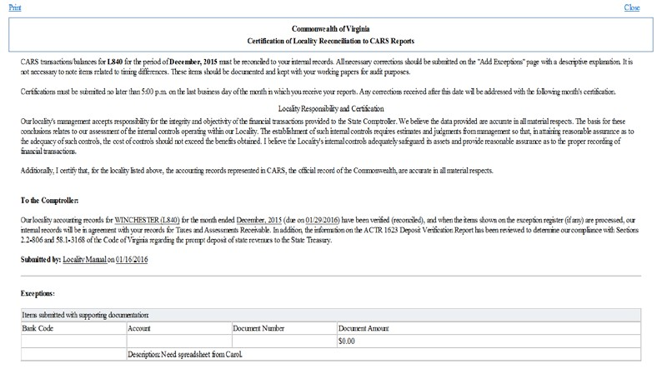Add Certification (continued)

Deleting a Certification

Delete Certification
If at some point it is determined the Certification should not be added and the user is in the process of adding the Certification, there are selections throughout the process that allows the user to cancel the certification. They are as follows:

Decline | Choose this selection from the first screen for Add Certification. This will take you to the Main Menu.
Back | This selection is available on the page with the statement To the Comptroller. It will take the user to New Certification-Responsibilities. Select Decline to go back to Main Menu. The certification has not been accepted by the system.
Delete Certification | Available when the user has completed adding a certification and is on the View Certification screen. Click on Details then Delete Certification in the left column.  Only available if Certification due date has not passed.

View Certification

View Certification
The View Certification screen allows the user to view current and previous months’ Certifications. Current-month certifications can be updated using this selection up to the due date.

The following steps explain how to view a certification and the update options available:

Step | Action
1 | At the Main Menu, select View Certification.
2 | Select the period and Locality of the Certification to be viewed from the drop down menu or choose directly from the list that appears automatically with the screen based upon user access.
3 | Click on the Details button next to the selected Certification.

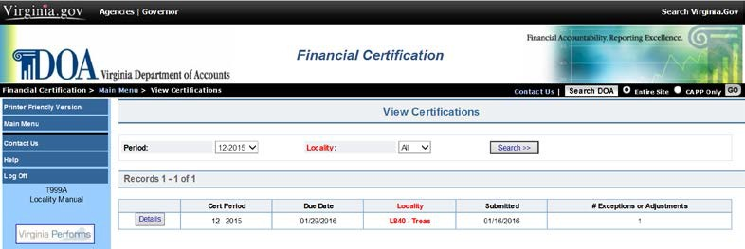

Continued on next page

View Certification, Continued

View Certification (continued)
If | Then
The Certification is from a prior month and the due date has passed | The user can view the Date Submitted, the Submitted By information and Exceptions, if any. Also the user can select Printer Friendly Version to print a copy of the Certification.
The Certification is for the month currently due and the due date has not passed | The user can select from Printer Friendly Version, Add Exceptions, Delete Certification and View Certification. The Edit/Delete option is also available to the user.

Step | Action
4 | Select Main Menu to return and select other functions or Log Off to return to the Financial Certification Website Log In screen where you will be logged off.

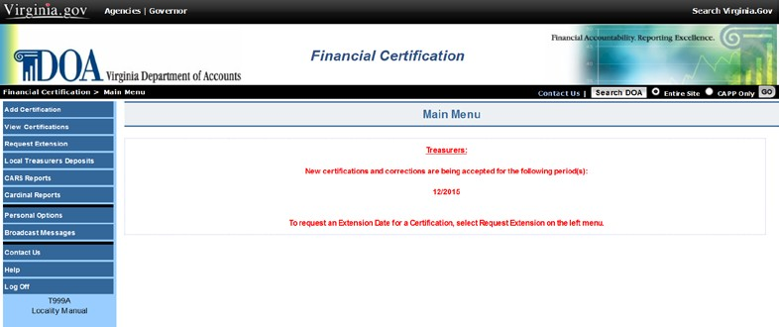

Entering a Deposit Certificate

Entering a Deposit Certificate
The following steps explain how to enter a Deposit Certificate:

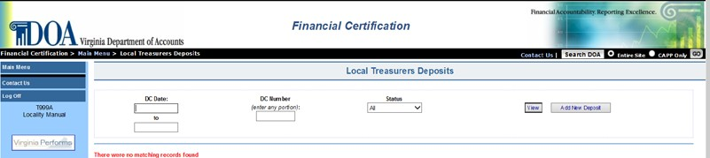

Step | Action
1 | Select Local Treasurers Deposits from the Main Menu.
2 | Select Add New Deposit button.
3 | Enter appropriate information from Deposit Certificate into the fields as described below.

Element | Description
Deposit Unit | Business Unit 99800 is automatically populated for all deposits.
Deposit Date | The date the locality made the deposit at the bank.
Deposit Amount | The net of the individual transactions per deposit certificate that have been authorized by the locality for receipt. (Include decimal point.)
Bank Code | Four-digit code identifying the bank account into which a deposit is made.
DC Number | Eight-digit field that is the deposit certificate number on the deposit certificate.
Accounting Date | Defaults to the current date but can be changed. This date determines the accounting period in which the deposit posts to the General Ledger. (Open period dates are shown above data entry fields.)

Continued on next page

Entering a Deposit Certificate, Continued

Entering a Deposit Certificate (continued)

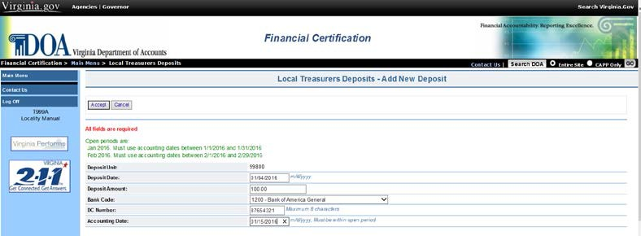

Step | Action
4 | Select Accept after all data has been entered and verified.
5 | Select the Add Distribution button to enter deposit details.

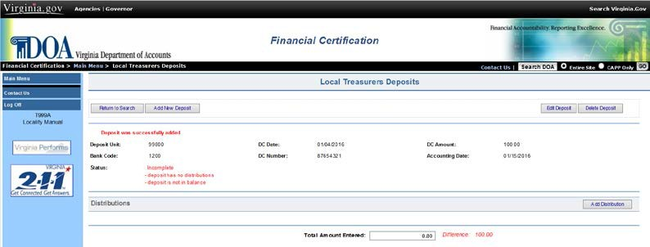

Continued on next page

Entering a Deposit Certificate, Continued

Entering a Deposit Certificate, (continued)
Step | Action
6 | Using the provided drop-down menus, select the appropriate coding for the distribution of deposited funds. Key dollar amount of distribution including a decimal point followed by two digits (.xx).  Note: The FIPS value displayed will default to the FIPS code that was marked on the security form for the Username that is logged in.
7 | Once the distribution information is entered, select Accept.
8 | Repeat steps 5-7 until all distribution lines for the DC have been entered.
9 | Once all distributions have been keyed, verify coding and that the Total Amount Entered (summed and displayed at the bottom of the screen) equals the DC Amount that was keyed in Step 3, displayed above the distribution lines.

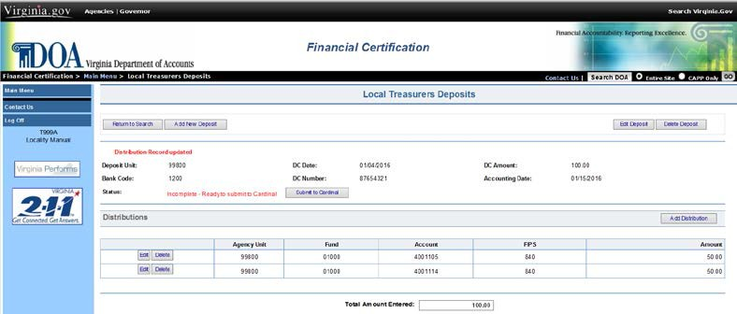

Continued on next page

Entering a Deposit Certificate, Continued

Entering a Deposit Certificate, (continued)
If | Then
Distribution information is correct, and the Total Amount Entered equals the DC Amount | Select Submit to Cardinal and proceed to Step 10.
Distribution information is not correct | Select the Edit button on the distribution line requiring changes, enter changes, then select Accept.
The Total Amount Entered does not equals the DC Amount | User will need to identify why difference exists, and correct by adding/deleting a distribution, editing one or more distributions, or correcting the DC Amount by selecting Edit Deposit.

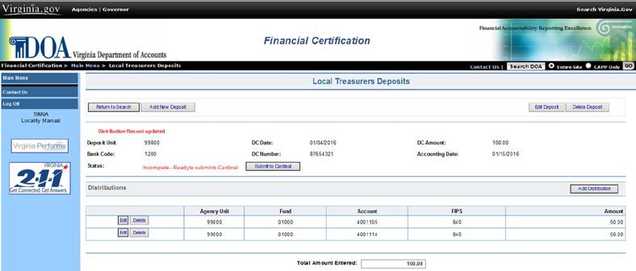

10 | Select Accept to mark deposit ready to be uploaded to Cardinal.
11 | Verify that Status displayed is Pending Upload to Cardinal.
12 | This Deposit is complete and ready to upload to Cardinal though the nightly processing. Select Add New Deposit, Return to Search, Main Menu, or Log Off depending on further needs.

Entering a Deposit Certificate, Continued

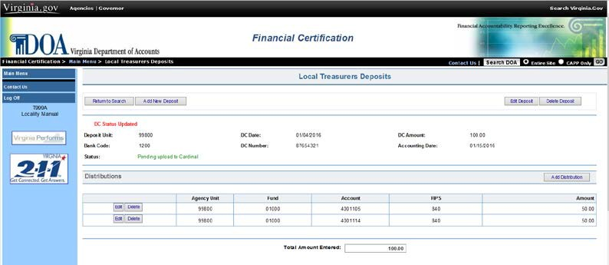Entering a Deposit Certificate (continued)

Searching Deposits

Searching Deposits
The following steps explain how to search previously entered Deposit Certificates:

Step | Action
1 | Select Local Treasurers Deposits from the Main Menu.
2 | Enter search criteria which could include DC date, DC Number and/or Status.
3 | Select View.
4 | Deposits matching the search criteria will display. Select Details  to the left of the deposit to be viewed.

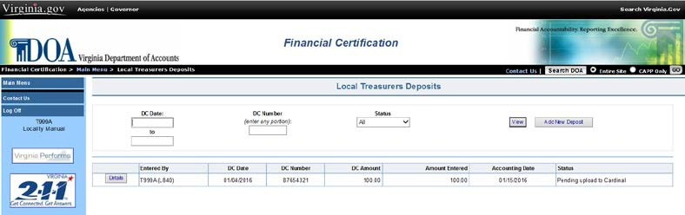

If | Then
Deposit Status is Pending Upload to Cardinal | User can Edit/Delete a distribution or Edit Deposit/Delete Deposit.
Deposit Status is Incomplete | Select Details to view deposit details and make necessary edits, and return to Entering Deposits: Step 9.
Deposit Status is Complete | User can view deposit certificate details.

CARS Reports

CARS Reports The CARS Reports page allows users to view monthly deposit reports created by CARS. There are three reports available to Treasurers to assist with monthly reconciliation and certification. They are:

ACTB1643 – Tax Assessments/Collections City/County Treasurers ACTB1623 – Deposit Verification Report
ACTB1624 – Revenue Detail Report by Agency

The following steps explain how to view and CARS reports:

Step | Action
1 | At the Main Menu, select CARS Reports.
2 | The most recent month’s reports will display for the users locality. To open a report, select the txt or pdf button to the right of the report title.
3 | The selected report will open in the web browser window.
4 | Use the web browsers Back button to return to the Main Menu.

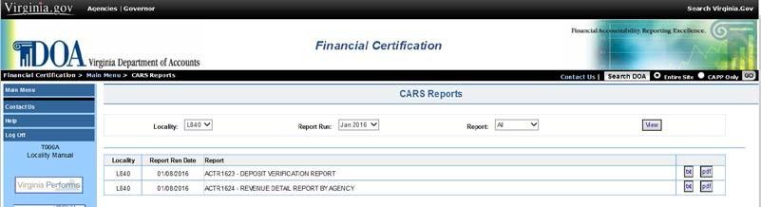

CARS Reports, Continued

Viewing Previous Period CARS Reports
Step | Action
1 | At the Main Menu, select CARS Reports.
2 | The most recent month’s reports will display for the users locality. Use the Report Run drop down menu to select the desired month/year report.
3 | Select View.
4 | The report for the selected month and year will display. To open the report, select the txt or pdf button to the right of the report title.
5 | The selected report will open in the web browser window.
6 | Use the web browser Back button to return to the Main Menu.

Cardinal Reports

Cardinal Reports
The Cardinal Reports page allows users to view monthly reports created by Cardinal. Beginning with February 2016 fiscal month close, Cardinal report RAR729 – Deposits and Revenue Summary for Local Treasurers (formerly the CARS ACTR1623/ACTR1624) will be available to Treasurers.

Beginning with July 2016 fiscal month close, Cardinal report RAR721 – Tax Assessments and Collections Summary for Local Treasurers (formerly the CARS ACTR1643) will be available to Treasurers.

The following steps explain how to view Cardinal reports:

Step | Action
1 | At the Main Menu, select Cardinal Reports.
2 | The most recent month’s report(s) will display for the users locality. To open a report, select the txt or pdf button to the right of the report title.
3 | The selected report will open in the web browser window.
4 | Use the web browsers Back button to return to the Main Menu.

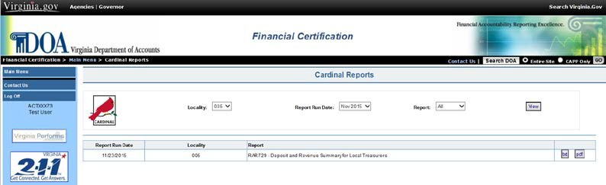

Cardinal Reports, Continued

Viewing Previous Period Cardinal Reports
Step | Action
1 | At the Main Menu, select Cardinal Reports.
2 | The most recent month’s reports will display for the users locality. Use the Report Run drop down menu to select the desired month/year report.
3 | Select View.
4 | The report will display, to view the report, select the txt or pdf  button to the right of the report title.
5 | The selected report will open in the web browser window.
6 | Use the web browsers Back button to return to the Main Menu.

Personal Options

View Personal Options
The Personal Options page allows users to view and update account information. Users can change their password, update their phone number, or e-mail address in Personal Options. There are also options to enter “Challenge Questions” and a “Hint” that would be available if a user forgets their password. To access the Personal Options screen, select the Personal Options button from the Main Menu.

Edit Personal Options
The Personal Options screen allows the user the ability to change any one or all of the following:

- Password (the actual password is not displayed).
- E-mail address (s)
- Phone Number
- Challenge Question (s)
- Hint (to help user in remembering their current password).

The following steps explain how to change personal options.

Step | Action
1 | To make changes, select the Edit Personal Options button on the  Personal Options screen.
Continued on next page

Personal Options, Continued

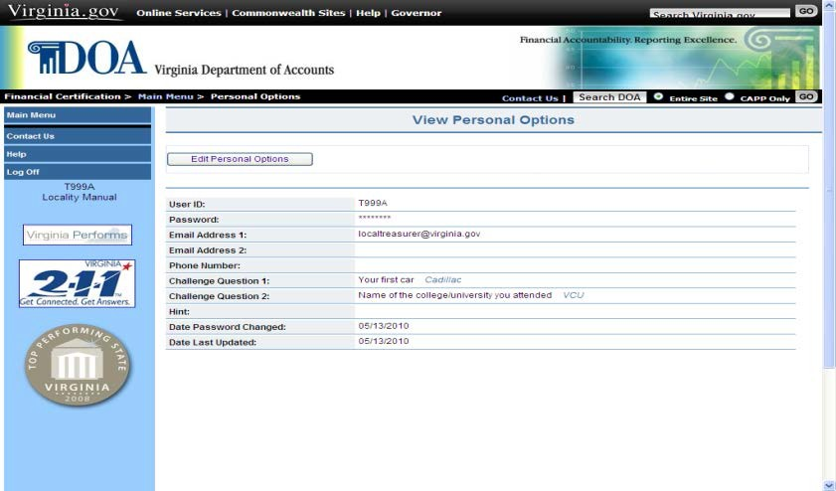Edit Personal Options (continued)
Step | Action
2 | Enter desired changes to Required or Optional fields. Required fields are shaded.
3 | Select Accept to submit changes. Select Cancel to exit and not save changes.

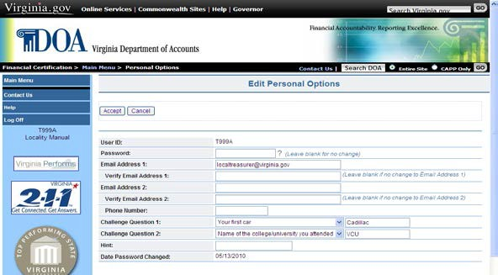

Name Change To change the name of the employee assigned to a User ID, the Locality is required to submit to DOA a Financial Certification Security Maintenance Form – Locality found on the Financial Certification Website (see Website Security) indicating a change for the User ID and provide the new name to be assigned to the User ID.

Request an Extension

Request an Extension
Situations may arise at a Locality that will prevent the timely reconciliation to CARS balances/transactions. In the event the locality can foresee not being able to meet the monthly deadline, an extension should be requested. Only a user with Administrator security can request an extension. Localities may request an extension online only up to the due date. After the due date has passed, the Locality contacts DOA directly by emailing certification@doa.virginia.gov.

The following steps detail the procedures for the Administrator to request an online extension.

Step | Action
1 | Select Request Extension from the Main Menu. Only users with Administrator security will have access to this feature.
2 | The locality FIPS code and period for which extensions are being accepted will appear. If the user is responsible for multiple localities, select the appropriate Locality and period.
3 | Enter the Extension Date Requested in mm/dd/yyyy format.
4 | Enter the Request Details (up to 500 characters). If the explanation is too long, please note that additional details can be emailed to certification@doa.virginia.gov.
5 | Click Submit. A summary of the request will immediately appear on the screen and a system-generated email will be sent to the Administrator as confirmation your request was received. The email address from the Administrators security record appears in the email address field.

Continued on next page

Request an Extension, Continued

Request an Extension (continued)

Extension Request Status

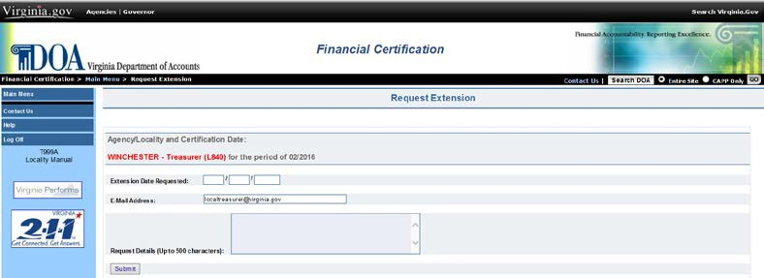

The following conditional table provides how the status of an extension request is generated.

If | Then
Extension Request is approved | A system-generated email will be sent to the Administrator stating the request was approved.  The new due date will appear to all users with access to the Locality at the Main Menu.
Extension Request is not approved | A system-generated email is sent to the Administrator stating the request was denied.  A statement as to why the request was denied will be included in the email.
Continued on next page

Request an Extension, Continued

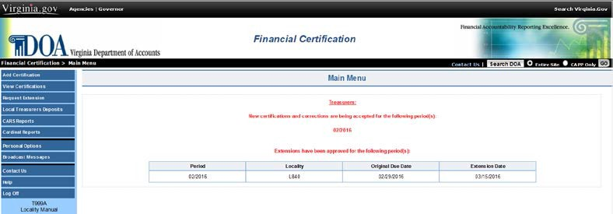Extension Request Status (continued)

Using Help Screens

Help Screens These screens provide detailed information about the current page and the selections available on that page. Help Screens are accessible on every page of the web application. To access the Help Screens, select the Help button located in the left-hand margin of the page.

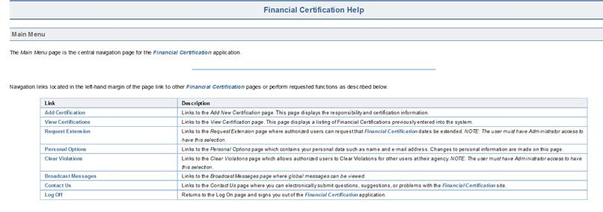

How to Contact Us

Contact Us Provides the user with the ability to contact DOA for assistance with the web application and/or to send comments regarding the site.

Step | Action
1 | Select Contact Us from the list in the left-hand margin of the page or at the top of each website page.  Note: This selection is available on all pages of the web application.
2 | Under Category, select the reason for contacting DOA.
3 | Insert your comments for the help needed in the comment box.
4 | E-Mail address used in Personal Options appears.  Note: DOA must have your correct e-mail address to be able to respond.
5 | Enter User ID. Although optional, this helps to facilitate a response to your question.
6 | Select Submit.

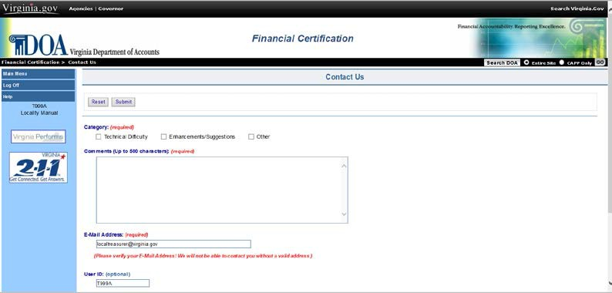

Log Off

Log Off Once all transactions have been completed on the web application, select Log Off from the list of selections located in the left-hand margin of the screen.
When Log Off has been selected, the user is returned to the Welcome page. Note: This selection is available on all pages of the web application.

