Department of Accounts
Payroll Bulletin

Calendar Year 2012 | March 27, 2012 | Volume 2012-05

In This Issue of the Payroll Bulletin….... | - New Support/Garnishment Processing Features  - Garnishment Processing Examples  - PAT 1500 Reports – Employees with Multiple EIN Records  - Processing Assistance for CIPPS or Payline  - Updated VSDP and Pay Dock Spreadsheets Available on Web | The Payroll Bulletin is published periodically to provide CIPPS agencies guidance regarding Commonwealth payroll operations. If you have any questions about the bulletin, please call Cathy McGill at (804) 371-7800 or Email at cathy.mcgill@doa.virginia.gov  State Payroll Operations  Director Lora L. George  Assistant Director Cathy C. McGill

New Support/Garnishment Processing Features

Advanced Features | In an effort to make child support and garnishment processing less of a manual process, State Payroll Operations has tested some advanced features provided with the software. If used, these features provide a systematic way to ensure that court-ordered deductions do not exceed the appropriate maximums.  These enhancements:  - Include the amount of mandatory employee-paid retirement (deduction 012) when determining disposable earnings (gross less taxes less employee-paid retirement);  - Link support and garnishments together for determining maximum withholdings; and  - Provide the means to define the maximum percentage withholdings allowed.  Usage of these features eliminates the need to manually adjust child support/garnishment payment amounts when an employee’s disposable earnings fluctuates due to dockings, hourly pay or additional pay items.  Additionally, the amount of the child support deductions will be considered in determining the amount of a garnishment that can be withheld. While the amount of the child support does not reduce the amount of disposable earnings, it is included when determining the maximum combined amount of support and garnishments that can be withheld. That is, if the employee receives a court-ordered garnishment in addition to the child support order, the garnishment can only be withheld to the extent that the combination of child support and garnishment does not exceed 25% of disposable earnings. Therefore, if the child support payment is more than 25% of the employee’s disposable earnings, no withholding amount for the court-ordered garnishment is permitted.  On the pages that follow common support and garnishment conditions are demonstrated along with how to use the advanced features. Keep in mind that each order is written uniquely and must be reviewed in detail to ensure compliance.  The Matrix of Deductions found on DOA’s website at the link below has been updated to reflect the new features:  http://www.doa.virginia.gov/Payroll/Forms/Payroll_Forms_Main.cfm

Garnishment Processing Examples

Example A:  Child Support Orders | According to the Consumer Credit Protection Act and the Code of Virginia withholding for child support orders is generally limited to 60% of an individual’s disposable earnings unless the obligor is supporting another family. If the individual is supporting another family, the limit becomes 50%. These limits increase by 5% each if the payments are in arrears greater than 12 weeks. Each Income Withholding Order (IWO) will specify the withholding limit that applies to the obligor.  For the example below the employee is supporting another family but is more than 12 weeks behind on his support payments. Therefore, the maximum percentage of disposable earnings that can be withheld is 55%. The per pay period amount to be withheld on the IWO is $250. To establish this child support order and ensure that the amount will not exceed the specified withholding limit on the IWO, establish the child support deduction as follows:  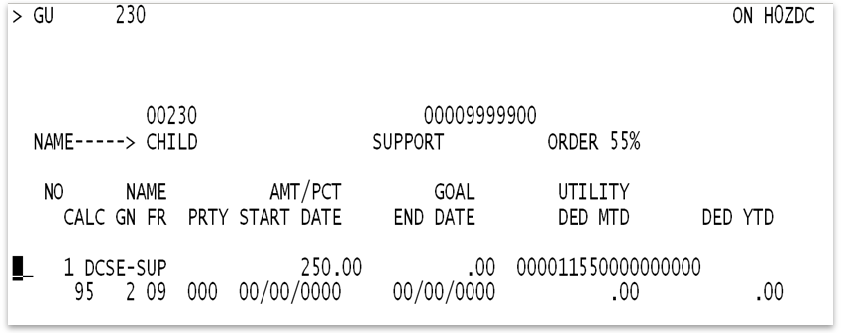  - If the IWO is from Virginia, use Deduction 001 and the amount will be sent to DSS via EFT. If this is an out of state IWO, use Deduction 002.  - Enter $250 in the Amt/Pct field on H0ZDC  - Enter the following values in the Deduction Utility Field:  - Enter a “1” in the 5th position of the utility field. This designates the disposable earnings as “Gross less Taxes less Mandatory Employee-Paid Retirement”.  - Enter a “1” in the 6th position of the utility field. This will link the support to garnishments using the same value (“1” in the 6th position) for ensuring withholding maximums are not exceeded.  - Enter “5500” in positions 7-10 of the utility field. This represents 55% - the maximum amount of disposable earnings to be attached. If the employee is docked, the lesser of $250 or 55% of disposable earnings will be withheld.  - If using Deduction 002, use position 17 of the utility field to designate the H0901 name number to use for this IWO.  With this configuration, if the employee’s disposable earnings are $450, CIPPS will deduct $247.50 for the Child Support payment as 55% of $450.00 = $247.50 which is less than $250.00.

Garnishment Processing Examples, continued

Example B:  Flat Dollar Amounts Limited to a Percentage of Disposable Earnings | Some orders, such as tax liens from localities (not to be confused with federal tax levies which are presented in another example), instruct you to take the lesser of the amount specified or a certain percentage of disposable pay until the item has been paid in full.  For the example below the writ requires a withholding of $350 not to exceed 25% of disposable income. The writ is completed once $1000 has been collected. Establish the deduction as follows to allow CIPPS to calculate this for you:  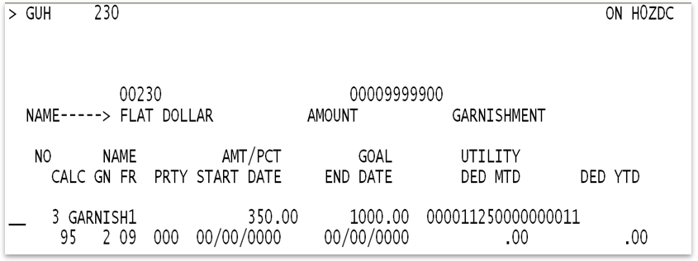  - Choose garnishment deduction number 003, 004 or 005. This feature does not work with 006, 007 or 008.  - Enter $350 in the Amt/Pct field on H0ZDC.  - Enter $1000.00 in the GOAL field.  - Enter the following values in the Deduction Utility Field:  - Enter a “1” in the 5th position of the utility field. This designates the disposable earnings as “Gross less Taxes less Mandatory Employee-Paid Retirement”.  - Enter a “1” in the 6th position of the utility field. This will link the support to garnishments using the same value (“1” in 6th position) for ensuring withholding maximums are not exceeded.  - Enter “2500” in positions 7-10 of the utility field. This represents 25% - the maximum amount of disposable earnings to be attached. If the employee is docked, the lesser of $350 or 25% of disposable earnings will be withheld.  - Enter the name number from H0901 in Position #17  - Enter a “1” in position #18 if you would like to decrement the goal.  With this configuration, if the employee’s disposable earnings are $1250, CIPPS will deduct $312.50 as 25% of $1250.00 = $312.50 which is less than $350.

Garnishment Processing Examples, continued

Example C:  Single Standard Percentage Garnishment | When you have a standard court-ordered withholding summons the usual case scenario is to withhold 25% of disposable earnings until either the complete balance is paid or the return date of the summons has been reached. In addition, Virginia Code mandates that employees be provided a guaranteed net pay amount that equates to 40 times the current minimum wage rate as prorated for the number of pays the employee receives in a year.  For the example below the writ requires a withholding of 25% of disposable income until $1000 has been collected. Establish the deduction as follows to ensure that CIPPS will withhold the proper amount as required by law:  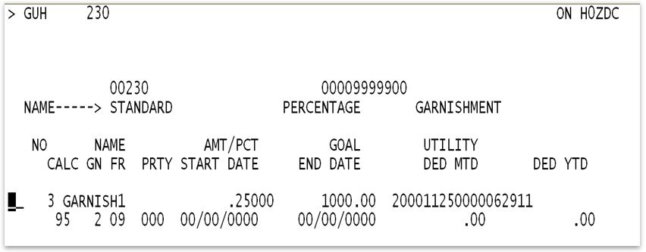  - Choose garnishment deduction number 003, 004 or 005. This feature does not work with 006, 007 or 008.  - Enter .25000 (representing 25%) in the AMT/PCT field.  - Enter $1000.00 in the GOAL field.  - Enter the following values in the Deduction Utility Field:  - Enter a “2” in the first position to specify that the AMT/PCT field contains a percentage.  - Enter a “1” in the 5th position of the utility field. This designates the disposable earnings as “Gross less Taxes less Mandatory Employee-Paid Retirement”.  - Enter a “1” in the 6th position of the utility field. This will link the support to garnishments using the same value (“1” in 6th position) for ensuring withholding maximums are not exceeded.  - Enter “2500” in positions 7-10 of the utility field. This represents 25% - the maximum amount of disposable earnings to be attached.  - Enter a whole dollar guaranteed minimum net in positions 11-16 for this employee according to the pay frequency. Amounts for a minimum wage rate of $7.25 are Semi-Monthly “000629”, Bi-Weekly “000580”, Weekly “000290” and Monthly “001257”.  - Enter the name number from H0901 in Position #17  - Enter a “1” in position #18 if you would like to decrement the goal.  With this configuration, if the disposable earnings are $800, CIPPS would try to take $200 ($800 X 25%) but since the guaranteed minimum net is $629, CIPPS will only take $171 ($800 - $629).

Garnishment Processing Examples, continued

Example D:  Child Support Order with a Percentage Garnishment | Child support orders take priority under State law over any other legal process against the same income. As mentioned in Example A child support orders can represent up to as much as 65% of the employees disposable earnings. However, court-ordered garnishments are generally limited to 25% of disposable earnings. If the amount of the child support payment is less than 25% of disposable earnings, the remainder of the 25% should go towards the garnishment.  Assuming that the child support order described in Example A is in effect and a court ordered garnishment for 25% of disposable earnings up to a total of $780 is received, establish the garnishment deduction as follows to withhold the item as required by law:  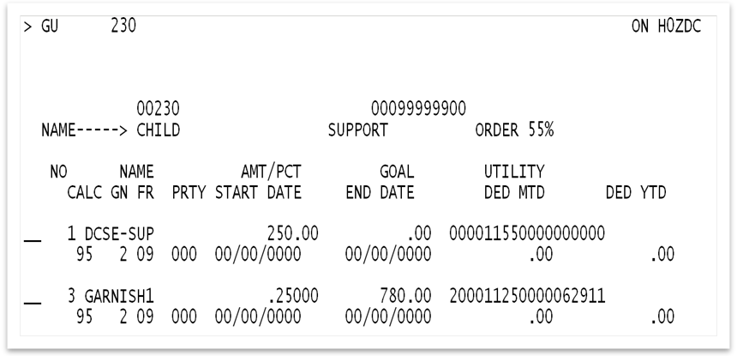  - Select either Deduction 003, 004 or 005 for the Garnishment. These features are not available for deduction 006, 007 or 008.  - Enter .25000 (representing 25%) in the AMT/PCT field.  - Enter $780.00 in the GOAL field.  - Enter the following values in the Deduction Utility Field of the garnishment:  - Enter a “2” in the first position to specify that the AMT/PCT field contains a percentage.  - Enter a “1” in the 5th position of the utility field. This designates the disposable earnings as “Gross less Taxes less Mandatory Employee-Paid Retirement”.  - Enter a “1” in the 6th position of the utility field. This will link the support to garnishments using the same value (“1” in 6th position) for ensuring withholding maximums are not exceeded.  - Enter “2500” in positions 7-10 of the utility field. This represents 25% - the maximum amount of disposable earnings to be attached.  - Enter a whole dollar guaranteed minimum net in positions 11-16 for this employee according to the pay frequency. Amounts for a minimum wage rate of $7.25 are Semi-Monthly “000629”, Bi-Weekly “000580”, Weekly “000290” and Monthly “001257”.  - Enter the name number from H0901 in Position #17  - Enter a “1” in position #18 if you would like to decrement the goal.
Continued on next page

Garnishment Processing Examples, continued

Example D:  Child Support Order with a Percentage Garnishment  (continued) | - For an employee with a Semi-Monthly Salary/Rate of $1500, taxes totaling $250 and Employee Retirement $75, CIPPS will process the amounts as follows:  - $1500 Gross minus $250 Taxes minus $75 Employee Retirement equals Disposable Earnings of $1175.  - $1175 X 55% = $646.25; the Child Support Amount of $250 will be taken  - $1175 X 25% = $293.75; this is the maximum amount that can be taken for the Child Support Payment and the Garnishment.  - $1175 - $293.75 = $881.25; this amount is greater than the guaranteed minimum net of $629 so CIPPS will process the garnishment.  - $293.75 minus $250 taken for the Child Support equals $43.75, which is the amount available for garnishment.
  Gross | $1,500.00
  Less Taxes | $250.00
  Less Employee-Paid Retirement | $75.00
  Disposable Earnings | $1,175.00 |  | Disposable Earnings | $1,175.00
  Percentage to Determine Max Amount of Disposable Earnings Attachable | 0.25 |  | Guaranteed net | $629.00
  Total Disposable Earnings Available for court-ordered withholdings | $293.75 |  | Amount Available for court-ordered withholdings | $546.00
  Less Child Support | $250.00 |  | Less Child Support | $250.00
  Amount Available for Garnishment | $43.75 |  | Remaining Net | $296.00
  
  
  CIPPS WILL TAKE THE LESSER OF THE TWO

Garnishment Processing Examples, continued

Example E:  Multiple Garnishments | When multiple garnishments are in place simultaneously the combined total cannot exceed 25% of the employee’s Disposable Earnings.  In the example below there are two writs, both requiring a withholding of 25% of disposable income. One has a maximum collection amount of $300 and the other $1000. Establish the deductions as follows to ensure that CIPPS will withhold the proper amount as required by law:  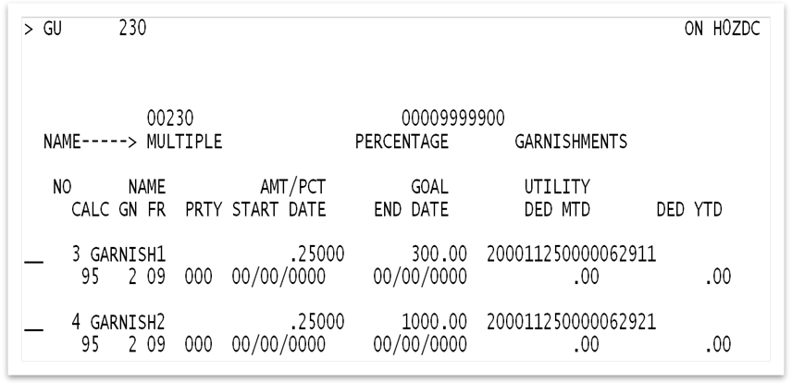  - Select Deductions 003, 004 or 005 for the Garnishments. These features are not available for deduction 006, 007 or 008. Make sure that the first garnishment received is given the lowest deduction number since it has the greater priority.  - For each deduction enter .25000 (representing 25%) in the AMT/PCT field.  - Enter the total balance due in the GOAL field of each. In this example $300.00 on the first garnishment and $1000.00 on the second.  - For each deduction enter the following values in the Deduction Utility Field of each garnishment:  - Enter a “2” in the first position to specify that the AMT/PCT field contains a percentage.  - Enter a “1” in the 5th position of the utility field. This designates the disposable earnings as “Gross less Taxes less Mandatory Employee-Paid Retirement”.  - Enter a “1” in the 6th position of the utility field. This will link the garnishments using the same value (“1” in 6th position) to ensure that the total withholding maximum is not exceeded.  - Enter “2500” in positions 7-10 of the utility field. This represents 25% - the maximum amount of disposable earnings to be attached.  - Enter a whole dollar guaranteed minimum net in positions 11-16 for this employee according to the pay frequency. Amounts for a minimum wage rate of $7.25 are Semi-Monthly “000629”, Bi-Weekly “000580”, Weekly “000290” and Monthly “001257”.  - Enter the applicable name number from H0901 in Position #17  - Enter a “1” in position #18 if you would like to decrement the goal

Continued on next page

Garnishment Processing Examples, continued

Example E:  Multiple Garnishments  (continued) | - For an employee with Disposable Earnings of $1500, the maximum amount of both garnishments would be limited to $375.00 ($1500.00 * 25%).  - Deduction 003 (highest priority) is evaluated first. The lesser of 25% of disposable income or the total to be collected (the goal) is $300. Therefore $300 will be withheld for this garnishment deduction.  - Since the maximum amount available for garnishment is $375, only $75 remains available for the next garnishment (deduction 004).  - Available net pay at this point is $1200 ($1500 - $300) which is greater than the required guaranteed net of $629. There is still $571 available for garnishment attachment.  - Deduction 004 is then evaluated. The lesser of 25% of disposable income ($375) or the amount remaining available for garnishment ($75) will be withheld. So $75 dollars will be withheld for the second garnishment deduction.
  Disposable Earnings | $1,500.00 |  | Disposable Earnings | $1,500.00
  Percentage to Determine Max Amount of Disposable Earnings Attachable | 0.25 |  | Guaranteed net | $629.00
  Total Disposable Earnings Available for court-ordered withholdings | $375.00 |  | Amount Available for court-ordered withholdings | $871.00
  Garnishment 003 | $300.00 |  | Garnishment 003 | $300.00
  Amount Available for Garnishment 004 | $75.00 |  | Amount Available for Garnishment 004 | $571.00
  
  
  CIPPS WILL TAKE THE LESSER OF THE TWO

Garnishment Processing Examples, continued

Example F:  Federal Tax Levy | Federal Tax Levies have a different set of rules than standard garnishments. Employees are generally allowed a protected amount according to the chart in IRS Publication 1494. In addition, the IRS usually exempts all deduction amounts already being taken at the time the levy is received.  For the example below the total of the Federal Tax Levy is $10,500. Establish the deduction as follows to ensure that CIPPS will withhold the proper amount as required by law:  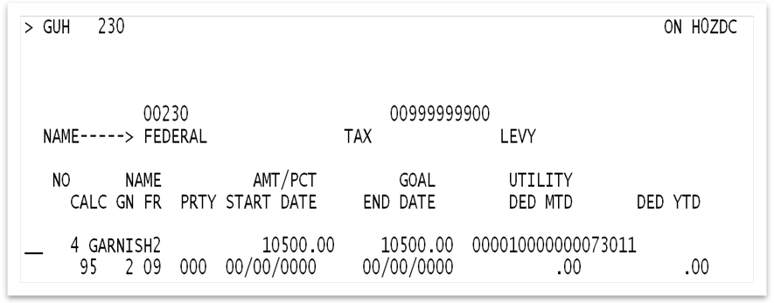  - Select either Deduction 003, 004 or 005 for the levy. These features are not available for deduction 006, 007 or 008.  - Enter the TOTAL amount of the levy in the AMT/PCT field of the deduction. ALL of the employee’s pay is subject to the levy with the exception of the protected amount.  - Enter the TOTAL amount of the levy again in the GOAL field of the deduction.  - Enter the following values in the Deduction Utility Field.  - Enter a “1” in the 5th position of the utility field. This designates the disposable earnings as “Gross less Taxes less Mandatory Employee-Paid Retirement”.  - Enter the whole dollar amount to be protected in positions 11-16 based on the calculation found in the note below. For this example the value would be “000730”.  - Enter the name number from H0901 in position 17.  - Enter a “1” in position 18 to decrement the goal.  Note:  - Use the filing status and number of exemptions from the taxpayer’s certification, Part 3 of the Levy, to determine the amount “exempt from levy” according to IRS Publication 1494. For this example, the exempt amount is $389.58.  - Determine other deductions in effect prior to the levy which will also be exempt. Do not include taxes withheld or the mandatory employee-paid retirement deduction as these will already be exempt from the levy. Do not include Direct Deposit Deductions as these are methods of payment. For this example, the total deductions are $340.00.  - Add the amounts from Step a and b above and round to the nearest whole dollar to determine the protected amount. ($389.58 plus $340.00 equals $729.58 rounded to the nearest whole dollar equals $730)  Regardless of pay fluctuations that may occur from dockings or overtime, CIPPS will deduct all of the employee’s disposable earnings and leave them with the protected amount and enough to take deductions that were in place at the time the levy was received. If done correctly, the net pay should equal the amount specified in IRS Publication 1494.

Garnishment Processing Examples, continued

Example G:  Education Loan Garnishment and Standard Court Ordered Garnishment | Federal Education Loan (FEL) garnishments are usually subject to 15% of disposable earnings, while standard court-ordered garnishments are subject to 25% of disposable earnings. According to the Consumer Credit Protection Act and the Code of Virginia the total of the amount deducted for both is limited to 25% of disposable earnings and the employee is to be left with an amount that is the equivalent of 40 hours per week at the minimum wage rate.  In this example the employee has a FEL garnishment for a total of $10,780 and a court-ordered garnishment for a total of $8000. Establish the deductions as follows to ensure that CIPPS will withhold the proper amount as required by law:  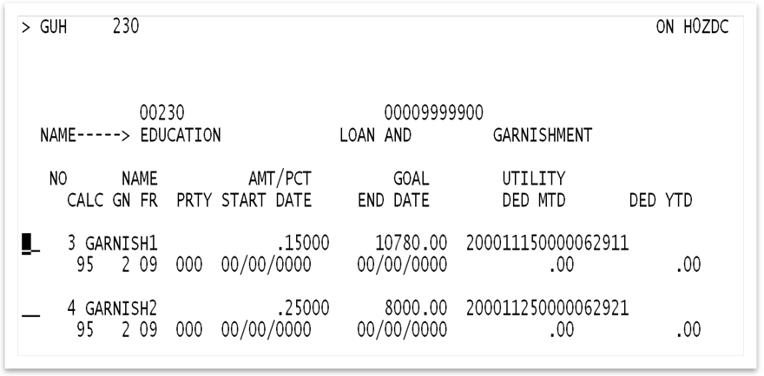  - Select Deduction 003, 004 or 005 for the garnishments. These features are not available for deduction 006, 007 or 008. Make sure that the first garnishment received is given the lowest deduction number since it has the greater priority.  - For the Education Loan garnishment (Deduction 003 in this example):  - Enter “.15000” in the AMT/PCT field to deduct 15% of the employee’s disposable earnings.  - Enter the total amount due for the Education Loan garnishment in the Goal field.  - In the Deduction Utility Field:  - In position #1, enter a “2” to specify that the AMT/PCT field contains a percentage.  - Enter a “1” in the 5th position of the utility field. This designates the disposable earnings as “Gross less Taxes less Mandatory Employee-Paid Retirement”.  - Enter a “1” in the 6th position of the utility field. This will link the garnishments using the same value (“1” in 6th position) to ensure that the total withholding maximum is not exceeded.  - Enter “1500” in positions 7-10 of the utility field. This represents 15% - the maximum amount of disposable earnings to be attached.  - Enter a whole dollar guaranteed minimum net in positions 11-16 for this employee according to the pay frequency. Amounts for a minimum wage rate of $7.25 are Semi-Monthly “000629”, Bi-Weekly “000580”, Weekly “000290” and Monthly “001257”.  - Enter the name number from H0901 in Position #17.  - Enter a “1” in position #18 to decrement the goal.
Continued on next page

Garnishment Processing Examples, continued

Example G:  Education Loan Garnishment and Standard Court Ordered Garnishment (continued) | - For the standard court-ordered garnishment (Deduction 004 in this example):  - Enter “.25000” in the AMT/PCT field to deduct 25% of the employee’s disposable earnings.  - Enter the total amount due for the court-ordered garnishment in the Goal field.  - In the Deduction Utility Field:  - Enter a “2” in the first position to specify that the AMT/PCT field contains a percentage.  - Enter a “1” in the 5th position of the utility field. This designates the disposable earnings as “Gross less Taxes less Mandatory Employee-Paid Retirement”.  - Enter a “1” in the 6th position of the utility field. This will link the garnishments using the same value (“1” in 6th position) to ensure that the total withholding maximum is not exceeded.  - Enter “2500” in positions 7-10 of the utility field. This represents 25% - the maximum amount of disposable earnings to be attached.  - Enter a whole dollar guaranteed minimum net in positions 11-16 for this employee according to the pay frequency. Amounts for a minimum wage rate of $7.25 are Semi-Monthly “000629”, Bi-Weekly “000580”, Weekly “000290” and Monthly “001257”.  - Enter the name number from H0901 in Position #17.  - Enter a “1” in position #18 to decrement the goal.  - D. For an employee with Disposable Earnings of $1000:  - The maximum amount of attachable earnings is 25% of disposable earnings or $250 ($1000 * .25)  - Deduction 003 (highest priority) is evaluated first. Fifteen percent (15%) of disposable earnings is calculated to equal $150. ($1000 * .15).  - Available net pay at this point is $850 ($1000 - $150) which is greater than the required guaranteed net of $629. There is still $221 available for garnishment attachment.  - Deduction 004 is then evaluated. The lesser of 25% of disposable income ($100) or the amount remaining available for garnishment ($221) will be withheld. So $100 will be withheld for the second garnishment
  Disposable Earnings | $1,000.00 |  | Disposable Earnings | $1,000.00
  Percentage to Determine Max Amount of Disposable Earnings Attachable | 0.25 |  | Guaranteed net | $629.00
  Total Disposable Earnings Available for court-ordered withholdings | $250.00 |  | Amount Available for court-ordered withholdings | $371.00
  Garnishment 003 | $150.00 |  | Garnishment 003 | $150.00
  Amount Available for Garnishment 004 | $100.00 |  | Amount Available for Garnishment 004 | $221.00
  
  
  CIPPS WILL TAKE THE LESSER OF THE TWO

PAT 1500 Hour Reporting – Employees with Multiple Records in CIPPS

Employment Date | In some cases hourly employees have multiple records within an agency representing different work areas or rates of pay. The CIPPS employee number is an 11 digit number comprised of the Statewide Employee ID (the first 9 digits) and a sub account number (last two digits) assigned by the agency to distinguish the CIPPS record. When this occurs, the 1500 Hour Monthly Summary Report in PAT will list each of the CIPPS employee numbers for that employee and will provide a cumulative total of hours.  The 1500 Hour Warning Report in PAT uses the same cumulative total when considering the threshold being reported.  Always use the same Employment Date on H0BID when establishing multiple records for a wage employee. This should be the employee’s actual start date with the agency regardless of when the employee started performing the work paid for under that specific employee number.

Processing Assistance for CIPPS or Payline

Contact Information | When assistance is needed with CIPPS processing or Payline, please call any of the THREE support analysts in the Payroll Operations Unit. All have numerous years working with CIPPS in both a functional and analytical capacity. Their contact information is provided below.  Martha Laster  Martha.laster@doa.virginia.gov  (804) 225-2382  Shannon Gulasky  Shannon.gulasky@doa.virginia.gov  (804) 225-3065  J. R. Rodgers  John.rodgers@doa.virginia.gov  (804) 225-3079

Updated VSDP and Pay Dock Spreadsheets Available on Web

Retirement Rate Changes Effective 3/25 applied | The Enhanced VSDP, Pay Dock and Retirement Calculation spreadsheets have been updated to include the VRS rate changes effective 3/25/2012 announced in Payroll Bulletin 2012-03.  The Pay Calculation spreadsheets can be found on our website at:  http://www.doa.virginia.gov/Payroll/Forms/Payroll_Forms_Main.cfm

