Department of Accounts
Payroll Bulletin

Calendar Year 2013 | June 24, 2013 | Volume 2013-08

In This Issue of the Payroll Bulletin….... | - July Check Dates  - Health Care/Automated Update Changes for July 1, 2013  - Change in Utility Field for Pre-tax Deductions  - Optional Group Life Rate Changes  - Modification to PAT 1500-Hour Report | The Payroll Bulletin is published periodically to provide CIPPS agencies guidance regarding Commonwealth payroll operations. If you have any questions about the bulletin, please call Cathy McGill at (804) 371-7800 or Email at cathy.mcgill@doa.virginia.gov  State Payroll Operations  Director Lora L. George  Assistant Director Cathy C. McGill

July Check Distribution

July Check Dates | Under no circumstances are payroll checks with any July 2013 check date to be placed into the U.S. mail prior to 2:00 p.m. on June 28, 2013.  Additionally, under no circumstances are checks with a July 2013 check date to be placed into an employee’s possession prior to July 1, 2013.

Health Care/Automated Update Changes for July 1, 2013

Automated BES to CIPPS Update Modification | Beginning in Fiscal Year 2014 employees can earn a discount to their employee-paid health care premiums. This reduction in premiums is known as a Health Care Reward. Deduction 025, HC Reward, will be used to account for the discounted premium amount. Deduction 025 will not create an expenditure to the agency and therefore will not be reflected on the Reports U022/U033. It simply accounts for the reward amount covered by the Health Insurance Fund (HIF) for inclusion in the monthly health care reconciliation.  Effective July 1, 2013, the BES to CIPPS interface will be enhanced to update all related health care changes including premium reward amounts. For employees that qualify for the new Health Care Reward, the interface will automatically reduce the employee-paid health care premium (deduction 024) by the reward amount and establish deduction 025, HC Reward, accordingly. No data entry will be required by agency personnel for health care deductions unless an employee is listed on the Report U130, BES/CIPPS TRANSACTION ERROR LISTING. Please review all transactions for accuracy.  The U130, BES/CIPPS TRANSACTION ERROR LISTING, and U131, BES/CIPPS UPDATE LISTING, have been improved to mirror the format of the PMIS to CIPPS interface reports. The U131 now:  - Sorts and page-breaks by the BES transaction effective date, as well as  - Indicates which transactions are retroactive and may need manual action and/or adjustments (e.g., retroactive deductions).

Health Care/Automated Update Changes for July 1, 2013, continued

Manual Health Care Data Entry | All agencies are encouraged to allow the BES interface to update CIPPS at all times. However, should an event occur that requires manual data entry, enter the health care provider and membership codes on HMCU1 and then access H0ZDC to verify the amounts for deductions 024 (employee-paid premium) and 026 (agency-paid premium). If the employee qualified to have the Health Care Reward, you will need to go to a blank line and insert deduction 025, the pay period reward amount and frequency 09, and then reduce deduction 024 by that same amount. The amounts reflected on the U130 are per pay period amounts.  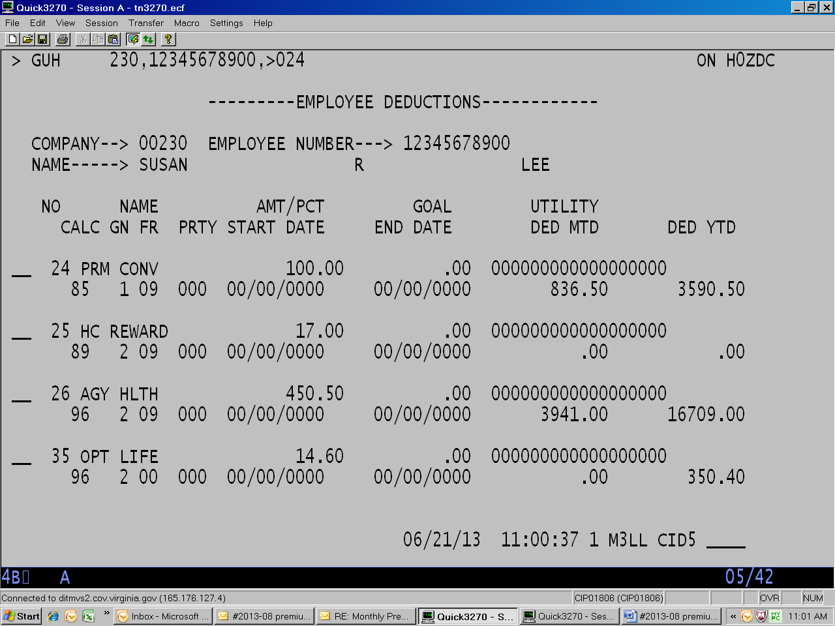

Monthly  Health  Care  Recon | In order to monitor the premium amounts covered by the HIF DOA will provide DHRM a monthly file of the health care amounts collected by deduction for each employee. These will be compared to the BES employee record and variances reported on a DHRM report - PREMIUM REWARD DISCREPANCIES. The primary purpose of this report is to ensure the amount covered by the HIF matches that which has been approved. This report will be placed in each agency’s folder in DHRM’s repository within the first couple of work days of each month.  As part of the monthly Health Care Reconciliation procedure this report must be printed, reviewed, signed by the Fiscal Officer, and submitted along with the monthly Health Care Reconciliation certification. Absence of this report or the Fiscal Officer’s signature will constitute an incomplete submission.

Change in Utility Field for Pre-tax Deductions

Change to Pre-tax Deduction Utility Fields | As the result of changes in CIPPS effective 7/1/2013 the utility field will no longer be required to be populated to invoke a pre-tax treatment for non-pension related pre-tax deductions (e.g, Premium Conversion-024, Flex Spending-021, 022, 023, Parking-050). While the utility fields will be updated to reflect all zeros these deductions will continue to be pre-tax. This is not true for pension-related deductions such as employee-paid retirement (012) or buybacks (043).

Optional Group Life Rate Changes

Mid-year Rate Reduction | Effective July 1, 2013, (July 16, 2013 payday) the Optional Group Life rates for the three age brackets shown below will be reduced. The rates will continue to be based on the salary of the member and the age of the member or spouse as of January 1, 2013.  Age 35 – 39 Reduced $0.01 from $0.08 to $0.07, per month, per $1,000 of coverage  Age 50 – 54 Reduced $0.01 from $0.21 to $0.20, per month, per $1,000 of coverage  Age 55 – 59 Reduced $0.06 from $0.40 to $0.34, per month, per $1,000 of coverage  Reports documenting the coverage and premium amounts were distributed June 21. The file to change the Deduction 035 amounts will be loaded on June 28. Be sure to review the Report U024, OPTIONAL GROUP LIFE PREMIUM LISTING, and Report U025, OPTIONAL GROUP LIFE ERROR REPORT, in sufficient time to identify and make any necessary adjustments prior to certification.  Questions regarding coverage or premiums should be directed to Joe Chang at Minnesota Life at:  Joe Chang, Richmond Branch Office  joseph.chang@minnesotalife.com  Phone: 1-800-441-2258, ext. 101  Fax: 804-644-2460

Modification to PAT 1500-Hour Report

Return to Reporting Work Period Hours | DHRM has notified DOA that the 1500-hour reporting period should be based upon a work year beginning May 1. The term “paid” in the Frequently Asked Questions is intended to communicate that the value of hours to be included are all those that are compensable (e.g. 8 hours on-call even if only worked 1 hour). The Payroll Audit Tool report will be modified accordingly.

