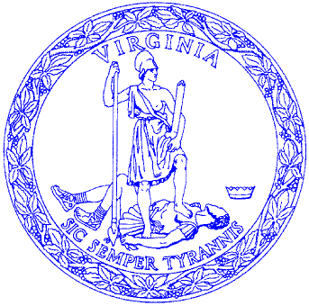

COMMONWEALTH of VIRGINIA

DAVID A. VON MOLL, CPA Office of the Comptroller P. O. BOX 1971
COMPTROLLER RICHMOND, VIRGINIA 23218-1971

February 8, 2017

MEMORANDUM

TO: Fiscal Officers of State Agencies and Institutions
Attention: Supervisors of Accounts Payable, Student Aid Accounting, Student Affairs, and Student Financial Services, 1099 Preparers

FROM: Sharon H. Lawrence, Director, Financial Reporting

SUBJECT: Calendar Year/Tax Year 2016 Information Returns Compliance Survey

This memorandum solicits your support in completing the attached 1099 survey. Please forward to the person(s) responsible for the preparation of IRS Forms 1099, W-2G (not W-2), 1042-S, and the 1098-T. Please complete the attached survey and return it as an e-mail attachment to Penny Williams using the 1099 email address at 1099@doa.virginia.gov by Thursday, March 9, 2017. Also see the instructions for completing the survey.

Survey results will be compared with last year’s results and used to identify statewide compliance issues. A summary of the results will be published in the March 31, 2017, edition of the Comptroller’s Report on Statewide Financial Management and Compliance (the Quarterly Report).

Please respond timely and provide all necessary information or your agency may be cited for the missing information in the Quarterly Report. If you have questions, or need additional assistance to complete the survey, please contact Penny Williams at (804) 225-3804.

The Department of Accounts (DOA) has also published a summary of the most significant changes affecting 1099 reporting in the “What’s New in 1099 Reporting” document located on the DOA website at:

http://www.doa.virginia.gov/Financial_Reporting/1099/2016_AndBeyond_Whats_New.pdf
Attachments

