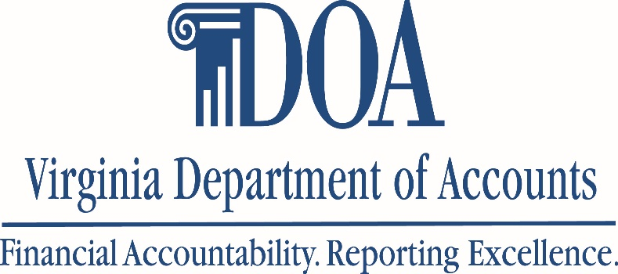

PA Newsletter
May 2021

Past Due Invoices | BOA Statement Payment | FAQ

Past Due Invoices

What it is and how to pay it
Have you ever received an invoice and struggled to determine if it was past due or not? Don’t worry, we’ve all been there! All payments to non-governmental and privately owned businesses for the purchase of goods and services must be due dated. Agencies should assign a payment due date 30 calendar days after receipt of the goods, services, or invoice, whichever is later, or the due date specified in the vendor’s contract.  Once you’ve verified that the invoice is past due, you have two options for payment:  - Submit a payment voucher through Cardinal or EDI Payment  - Submit a Past Due Invoice payment request to CCA  If you’ve chosen option 2, here’s some things you should know. CAPP 20355 requires one of the following:  - A copy of the invoice, with date stamp (showing the date the invoice was received)  - Email approval from the cardholder’s supervisor that provides detailed information to include: Invoice Date, Invoice Amount, Vendor Name, Invoice Received Date, Due Date and reason invoice is being paid late.  But CCA! Many of us still have not returned to the office and aren’t receiving physical mail. Can an email from the vendor providing the invoice as |  |  | an attachment be considered the received date?  Absolutely!  If you are still working remotely and have not received a physical invoice in the mail, an email from the vendor with the invoice attached can be considered the received date.  Here’s some other things to know:  - Cardholders have a responsibility to follow-up with vendors for invoices that are outstanding. If you have received the goods/services, but not an invoice, reach out to the vendor.  - Cardholders have a responsibility to follow-up with vendors for payments that have not posted within 2 weeks of payment information that has been provided.  - Cardholders should be monitoring their transactions in WORKS, at least, on a weekly basis. Outstanding payments will be easy to catch if you monitor your transactions.  - CAPP 20315 provides information on Prompt Pay and Due Date Practices  - CCA Database is used to submit your Past Due Invoice requests.

BOA Statement Payments

How to pay, what to pay, when to pay
Making sure your payments are received in a timely manner to the correct account like the rock star you are!
Have you received an email from CCA regarding an issue with your payments? We have a solution for that.  - Make sure you provide the 16 digit  account number in the Payment Message field. Do not use hyphens  spaces, or alpha characters.  - Make sure to use Bank of America’s Vendor ID: 0000042877  - Select Location: MAIN (for SPCC Payments)  - Select Location: EDI-88 (for Travel Card)  - Change the Pay Terms field to 00PP  - Enter the Payment Date of the 7th (MM/07/YY). Payments can be earlier than the 7th but no later than the 7th.  - Pay the full amount reflected in the Current Balance Due section of the charge card statement. Disputed amounts and Fraud credit will appear on subsequent invoices.  - Do not reduce monthly invoices by unapplied credits | 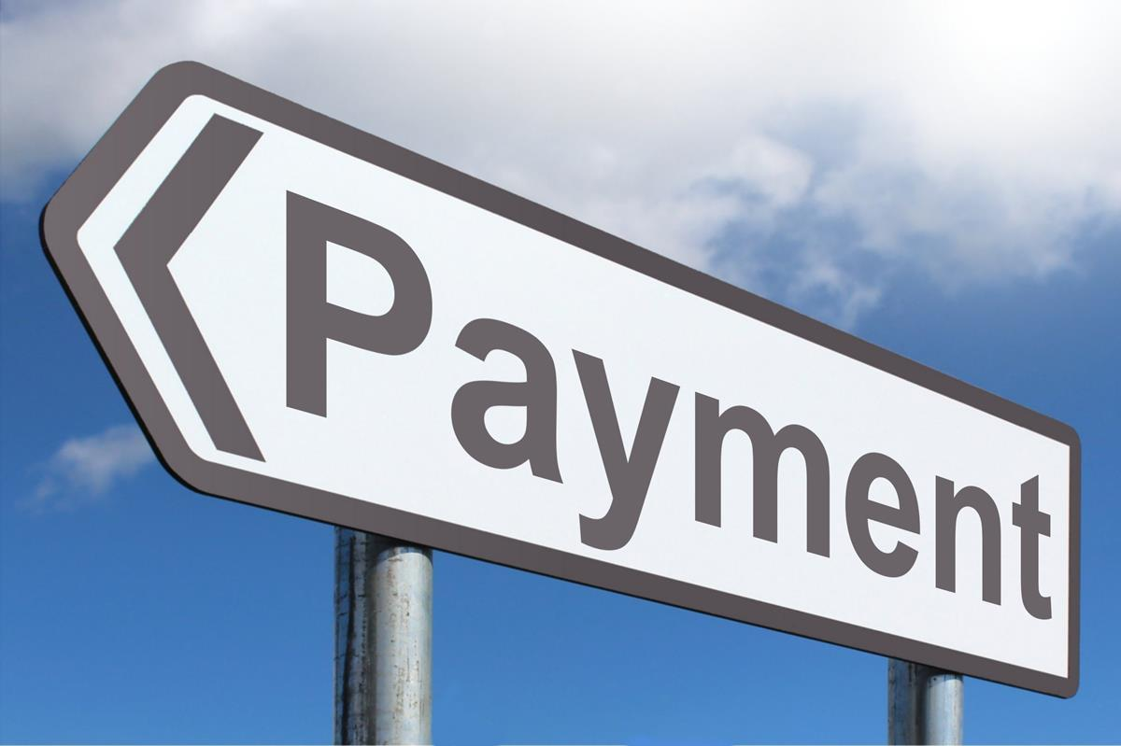

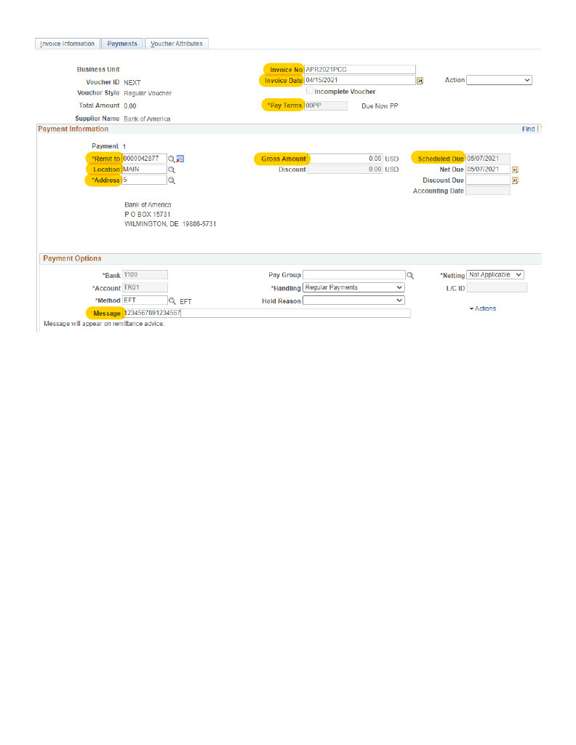

FAQ

If a cardholder has not utilized their card in 12+ months, do I have to cancel the card?

- Yes, all cards that have not been utilized in 12+ months should be cancelled, along with the user profile if not needed.

What is an Authorized Signatory?

- Authorized Signatory is anyone who has been designated by the Agency Head and who has signed the DOA Authorized Signatory Form (DA-04-121-Cardinal). Authorized Signatories are required to sign the Program Administrator Request Form and Gold Card Request Form.

As a Backup PA, can I perform the same duties as the Primary PA?
- Yes, both Primary and Backup PA’s have the same roles, responsibilities and access.
Is an Exception Request needed for all permanent restriction lifts or for requests with an extended period of time?
- Yes, Exceptions Requests are required for all permanent removals on an annual basis, due May 31st. If a request for an extended period of time is granted (case by case basis) this must also be placed on an exception request.
When should a Program Administrator be removed from the program?
- Program Administrators should be removed on the last working day at the Agency. Requests to remove a Program Administrator must be submitted no later than the last working day of the Program Administrator to ensure program security.

Can an IL Travel Card be used to pay for the travel needs for anyone other than the cardholder?

- No, IL Travel Cards are intended to be used by the cardholder ONLY for official business travel needs.

How do I find out why a card is declining?

- You can see declining transactions by looking at the Authorization Log within Works. On the Home screen, click the carrot under “Account ID” and choose “View Auth Log”.
- Below are a few declining codes:
  - Declined by Score 1 Fraud Strategy
  - Individual MCCG Excluded MCCG has been excluded
  - Bad Pin Invalid PIN number used
  - Account Amount Limit Exceeded Amount exceeds limits set

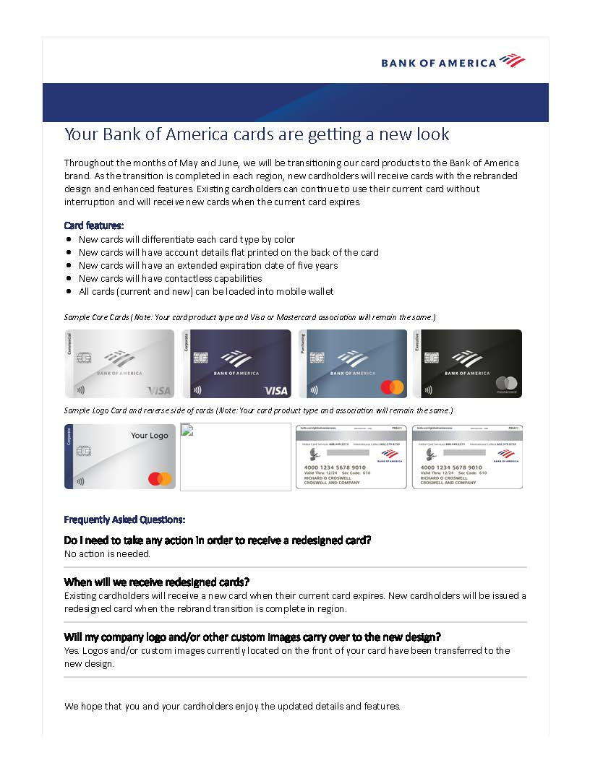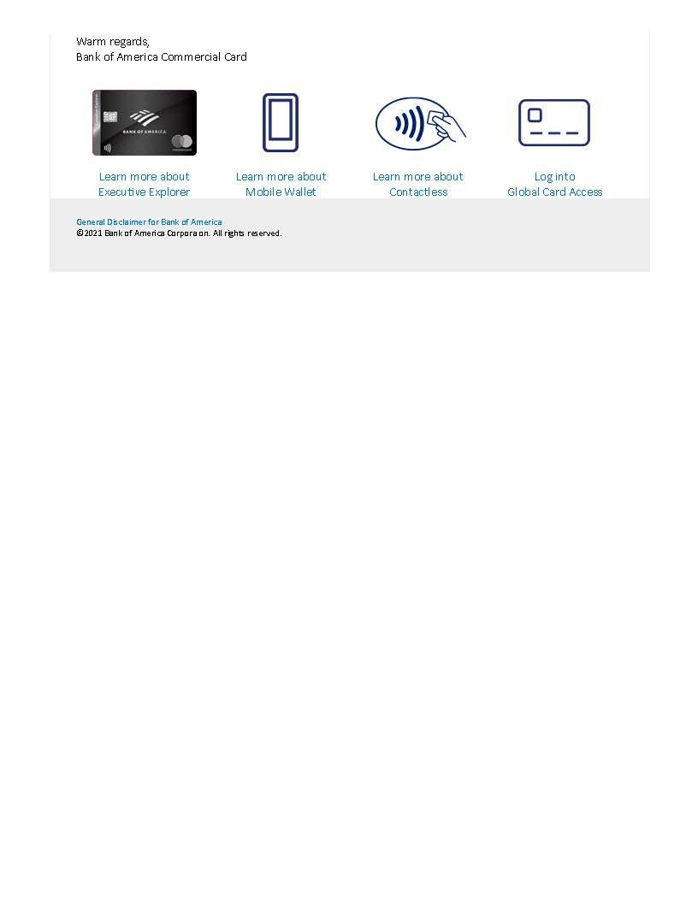
REMINDERS:
- Please use the CCA Automated Online Forms Request System. Email requests for paying late invoices, credit limit increases, temporary restriction removal, and submission of annual certifications will not be accepted effective July 1, 2016.
- Troubleshooting- if you are having issues logging on to https://cca.doa.virginia.gov/Login.cfm, please contact cca@doa.virginia.gov.
- DOA offers Monthly Program Administrator Training for all new PA’s as well as those who need a refresher beginning April 5, 2016. Training will be offered via WebEx on the first Tuesday of each month. Each monthly training session will be from 8:00 am to 12:00 pm. To register, please email cca@doa.virginia.gov. This monthly training will allow PA’s to receive detailed instructions about their responsibilities and day-to-day functions as a Program Administrator.
- The Commonwealth has a package relationship with NAPCP in order to get a (discounted) $99 membership rate. When you sign-up initially or renew your membership to this organization, please contact DOA for coupon code to receive your discounted membership rate.
- When contacting CCA, please call 804-786-0874 to leave a voicemail or email cca@doa.virginia.gov. Email is the best way to contact us. If your request is urgent, please mark it accordingly when sending an email. Do not send maintenance requests to individuals within the unit.
- When contacting Emily Ruzumma or Company Level Support at BOA, please email Dedicated_Card_East@bankofamerica.com. Please include your company number in all correspondence.
- DOA will be reviewing IL Travel cards monthly and PAs will be informed if the cardholder is past due more than one day. Program Administrators must review the delinquency reports in Works at least every two weeks to ensure cardholders are making timely payment for their IL cards.
  - Effective March 2021, CAPP 20360 states:
Past Due 31 Days: The TPA is required to suspend the IL Travel Card of any cardholder that becomes 31 days delinquent.
Past Due 61 Days: The TPA is required to cancel any IL Travel Card that has become 61 days past due.
  - State policy dictates at this point the agency will deduct the entire outstanding past due balance from the cardholder’s pay.
    - If the Cardholder has separated from the Agency and obtained employment with another State Agency, the TPA should reach out to the new employer’s payroll department, providing a copy of the signed Employee Agreement and the outstanding balance still owed.
    - If the Cardholder has separated from the Agency seeking employment outside of the Commonwealth the outstanding balance should be submitted to Comptroller’s Debt Set-off (CDS) https://www.doa.virginia.gov/reference/generalAccounting/index.shtml#Comptroller
- Agencies should evaluate the number of CL and STL increase requests and ensure the limits are in line with the cardholder’s needs. If you find that the cardholder regularly goes over the cycle limit, card limit, or single transaction limit, please review the need for a Gold Card at your agency.
- For information on Virtual Payables, please visit https://www.doa.virginia.gov/reference.shtml#vp or email ecommerce@doa.virginia/gov (NEW)
Contact Information for CCA: cca@doa.virginia.gov 804-786-0874 (HOTLINE)

