Tip of the Month - 13 Month Card Spend Analysis

- An overview of the 13 Month Card Spend Analysis. This report shows monthly spend, max spend and average spend as a % of current credit limit.
- Maureen will demo the report in Works.

Save the Date for the Annual Bank of America Card Summit

- Date: Thursday, September 15, 2022
- Location: Richmond Convention Center

- This event will only be open to current Program Administrators and their backups registered with the Department of Accounts.
- More details to follow.

CCA Database Secure Emails

- The Secure Email Form is intended to send general questions and/or sensitive information if your agency does not have secure email capabilities.
- This function should not be utilized in lieu of the forms functionality or to submit any other requests. (i.e. Gift Card Requests and/or Exceptions).
- All requests outside of the predetermined forms in the database should be emailed to
cca@doa.virginia.gov.
- If you cannot initiate a secure email, send an email request to cca@doa.virginia.gov and we will generate an active Virtru email.

Bank of America Payments

- Payments to Bank of America must be received by the 7th of each month.
- Please refer to CAPP 20355, page 53-56: Charge Card Statement Payment Procedures.
- Make sure you are paying the full amount notated in the “Total Payment Due” section within the payment coupon. Do not reduce payment by unapplied credits, disputes, etc.
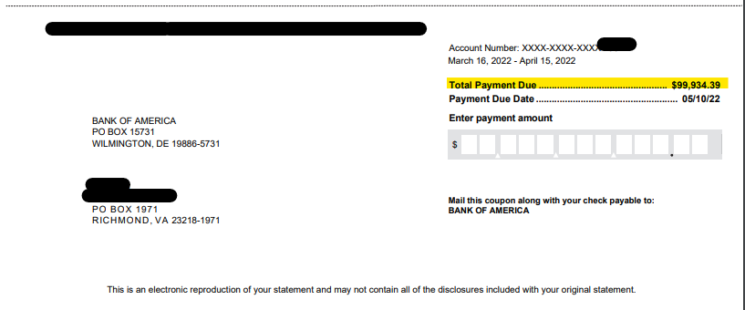

Annual Training – For State Agencies Only

- Annual training for all cardholders, PAs, and supervisors must be completed by May 31, 2022.

Annual Certifications – For State Agencies Only

- Annual Training Certifications are due May 31, 2022.
- Annual Cardholder Review Certifications are due May 31, 2022.
- Annual Security Review is due May 31, 2022.
  - Please remember you are certifying all inactive cards and user accounts have been deactivated as part of your review.

Annual Exceptions – For State Agencies Only

- Annual Exception Requests are due May 31, 2022.
- Any permanent restriction removals must be included on the Exception Request Form and submitted for approval. This includes all restrictions lifted on Gold Cards if applicable.

CAPP Updates – For State Agencies Only

- Effective April 27, 2022, updates to CAPP 20355 and CAPP 20360 were published to DOA's website.
- Please see the linked Memo for the latest CAPP updates:
https://www.doa.virginia.gov/reference/CAPP/Update_Memos/CAPP_Memo_177.pdf
- CAPP 20355 – Purchasing Charge Card https://www.doa.virginia.gov/reference/CAPP/CAPP_Topics_Cardinal/20355.pdf
- CAPP 20360 – Travel Charge Card
https://www.doa.virginia.gov/reference/CAPP/CAPP_Topics_Cardinal/20360.pdf
Gold Card Analysis
- Annual Gold Card Analysis are complete and all suggested changes have been made.
- The deadline to submit Gold Cardholder Employee Agreements for all Gold Cardholders in your agency is Thursday, May 12, 2022.

Reminders:
- Please use the CCA Automated Online Forms Request System. Email requests for paying late invoices, credit limit increases, temporary restriction removal, and submission of annual certifications will not be accepted.
- Troubleshooting- if you are having issues logging on to https://cca.doa.virginia.gov/Login.cfm, please contact cca@doa.virginia.gov.
- DOA offers Monthly Program Administrator Training for all new PA’s as well as those who need a refresher. Training will be offered via Google Meets on the first Tuesday of each month. Each monthly training session will be from 8:30 am to 12:00 pm. To register, please email cca@doa.virginia.gov. This monthly training will allow PA’s to receive detailed instructions about their responsibilities and day-to-day functions as a Program Administrator.
- The Commonwealth has a package relationship with NAPCP in order to get a (discounted) $99 membership rate. When you sign-up initially or renew your membership to this organization, please contact DOA for coupon code to receive your discounted membership rate.
- When contacting CCA, please call 804-786-0874 to leave a voicemail or email cca@doa.virginia.gov. Email is the best way to contact us. If your request is urgent, please mark it accordingly when sending an email. Do not send maintenance requests to individuals within the unit.
- When contacting Emily Ruzumma or Company Level Support at BOA, please email Dedicated_Card_East@bankofamerica.com. Please include your company number in all correspondence.
- DOA will be reviewing IL Travel cards monthly and PAs will be informed if the cardholder is past due more than 1 day. At 31 days past due, the PA must suspend the IL Travel Card. At 61 days past due, the agency TPA will need to cancel the card and submit the past due travel card balance to be deducted from the cardholder’s payroll.
  - Program Administrators must review the delinquency reports in Works at least every two weeks to ensure cardholders are making timely payment for their IL cards.
- Agencies should evaluate the number of CL and STL increase requests and ensure the limits are in line with the cardholder’s needs. If you find that the cardholder regularly goes over the cycle limit, card limit, or single transaction limit, please review the need for a Gold Card at your agency.

Contact Information for CCA:
- CCA: cca@doa.virginia.gov
- vPay: ecommerce@doa.virginia.gov
- 804.786.0874

