Department of Accounts
Payroll Bulletin

Calendar Year 2014 | January 3, 2014 | Volume 2014-02

In This Issue of the Payroll Bulletin….... | - VRS Hybrid Retirement Plan | The Payroll Bulletin is published periodically to provide CIPPS agencies guidance regarding Commonwealth payroll operations. If you have any questions about the bulletin, please call Cathy McGill at (804) 371-7800 or Email at cathy.mcgill@doa.virginia.gov  State Payroll Operations  Director Lora L. George  Assistant Director Cathy C. McGill

VRS Hybrid Retirement Plan

VRS Hybrid Retirement Plan | Employees who are hired or rehired January 1, 2014, and thereafter with no balance in VRS’ Defined Benefit program or an Optional Retirement Program will enter the Virginia Retirement System’s (VRS) Hybrid Retirement Plan. CIPPS has been modified to accommodate the new Hybrid Retirement Plan as follows:  - Two new Retirement Plan codes for HMCU1  - Elimination of the Buyback Retirement Plan codes and Buyback fields on HMCU1  - A new interface of Retirement Plan codes and Buyback (Prior Purchase of Service) deductions from VNAV  As with any new procedure, it is highly recommended that you review this Bulletin carefully. The VRS Modernization Working Examples have been updated to include information regarding the Hybrid Plan, so as you encounter new situations, it is advised that you click on the corresponding example and read through the steps until the new processes become familiar.  The following VRS Modernization Examples have been updated for the Hybrid Plan:  Example J1 – New Hire After the First Working Day of the Current Month  Example J2 – New Hire on the First Working Day of the Current Month  Example J3 – New Hire Before the First Working Day of the Current Month  Example V3 – New Hire ORP Plan Eligible Employee Chooses VRS Plan during 60 Day Election Period  Example V4 – New Hire ORP Plan Eligible Employee Does not make a Decision within 60 Day Election Period

VRS Hybrid Retirement Plan, continued

January New Hires and the Hybrid Plan | Employees who begin employment January 1, 2014, or after, will enter the Hybrid Plan based on the VRS Modernization rules. The employee must be employed on or before the first working day of the month in order to be eligible for retirement during that month. Therefore, employees hired on January 1st or 2nd will participate for the month of January. If the employee is hired after January 2, 2014, they will not be eligible for retirement credit until February, when they will be put into the new Hybrid Plan. Employees hired prior to January 1, 2014, will be enrolled in the appropriate Plan 2 VRS Retirement Plan effective for the month of January. Plan eligibility should be verified with VRS.  Although retirement plan data will be automatically established via a monthly interface (See “New VNAV to CIPPS Interface” later in this bulletin) this will not occur until February. Manual data entry is still required for employees hired on or before January 2, 2014.

HMCU1 Changes | Two new Retirement Plan Codes have been established for the Hybrid Retirement Plan:  HB – VRS Hybrid Plan HJ – Judicial Hybrid Plan  The “HB” and “HJ” Retirement Plan Codes will create the following deductions on H0ZDC:  - Deduction #012 – EMP RET - (Currently 4%) – Mandatory Employee contribution to the Defined Benefit portion of the Hybrid Plan  - Deduction #015 – EMPDC MD - (Currently 1%) – Mandatory Employee contribution to the Defined Contribution portion of the Hybrid Plan.  - Deduction #016 – EMPDC VC - (Employee chooses amount between .5 and 4 percent and it is entered on HMCU1 in the Vol Contribution field) – Voluntary Employee contribution to the Defined Contribution portion of the Hybrid Plan. Note this is a 457 plan and will be included in the annual 457 limits.  - Deduction #105 – HBMCMATCH - (Currently 1%) – Employer 1% match on the Employee’s Mandatory Contribution in Deduction #015 to the Defined Contribution portion of the Hybrid Plan.  - Deduction #106 – HBVCMATCH – (percentage varies depending on employee voluntary contribution in Deduction #016) – Employer match to the Employee’s Voluntary Contribution to the Defined Contribution portion of the Hybrid Plan.  - Deduction #115 – RET CRDT – (Currently 1%) – Employer contribution for Health Insurance Credit (Retiree Credit)  - Deduction #116 – RETIRMNT – (percentage varies depending on employer voluntary contribution match in Deduction #106) – Employer contribution to the Defined Benefit portion of the Hybrid Plan  - Deduction #120 – GRP INSR – (Currently 1.19%) – Employer contribution for Group Insurance  - Deduction #136 – LT DISAB – (Currently .47%) – Employer contribution for Long Term Disability
Continued on next page

VRS Hybrid Retirement Plan, continued

HMCU1 Changes, continued | The old Buyback Codes (i.e. BV, BN, BS, BN, etc) have been removed along with all of the old fields related to Buybacks. A new field, VOL CONTRIBUTION, has been added to reflect the employee election for additional voluntary contributions (Deduction #016). Based on the percentage entered the appropriate associated employer voluntary cash match deduction will be established (Deduction #106).  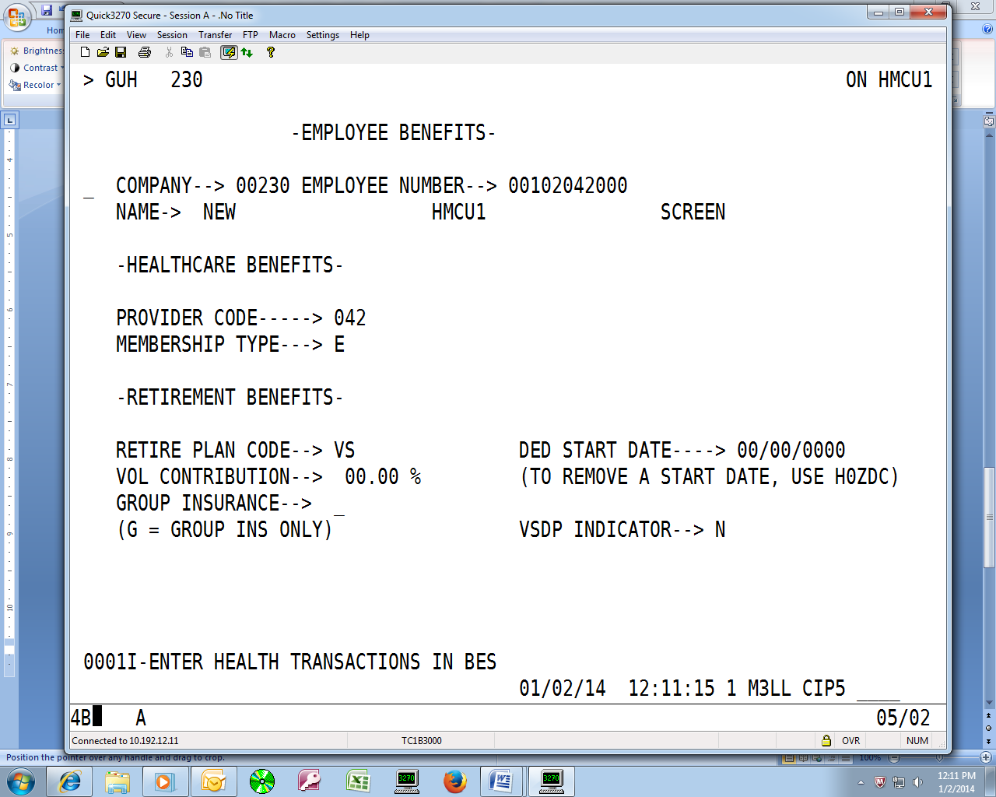

New VNAV to CIPPS Interface | A new monthly interface from VRS (VNAV) to CIPPS will begin on February 3rd. This interface will automatically update the VRS Retirement Plan Code on HMCU1 and subsequently establish the proper deductions on H0ZDC along with the SP 099, CONTBASE, on H10AS. The interface will help to ensure that the employee is placed in the proper retirement plan according to their eligibility as established by VRS.  In addition, PPS (Purchase Prior Service) Agreements (also known as Buyback Agreements) will be automatically established on H0ZDC using deductions #018 or #044 with a flat dollar amount. This amount will be automatically updated in the appropriate month via the interface when the employee receives a salary adjustment.  The interface will generally run on the 3rd of each month (or the next business day). Since the processes will run that night, agencies should look for the following reports on the next business day to review the activity that occurred during the interface:  - Report U184 – VNAV/CIPPS Transaction Error Listing – This report will show items that could not be processed during the interface. If an item appears on this report review it and manually enter the appropriate update in CIPPS as soon as possible.  - Report U185 – VNAV/CIPPS Update Listing – This report will show items that successfully updated CIPPS for the current month. Review for accuracy. Note – VRS is the source for plan code eligibility which is based on prior service (state and local governments included), prior withdrawals of service, and the employee’s current Role and SOC Codes in PMIS. Agencies should consult with VRS if they disagree on the plan code that the employee is placed in.  - Report U186 – VNAV/CIPPS Retro Transaction Listing – This report will show items that successfully updated CIPPS effective in a previous month. CIPPS was successfully updated; however, there may be some manual adjustments that are necessary to adjust retirement or Purchase of Prior Service adjustments for previous months.  Examples of these reports can be found at the end of this Bulletin.
Continued on next page

VRS Hybrid Retirement Plan, continued

Effect of Hybrid Plan Employees on Deferred Compensation | Employees in the VRS Hybrid Retirement Plan can voluntarily contribute up to 4% of their Special Pay #099, CONTBASE, to the Defined Contribution portion of the Hybrid Plan. As a 457 plan deduction, 016, EMPDC VC, will be counted as part of the annual 457 limit in addition to any contributions that Hybrid employees make to the supplemental 457 Deferred Compensation Plan using Deduction 038, DEF COMP.  Hybrid Plan employees will receive additional employer matches to the Defined Contribution portion of the Hybrid Plan depending on how much they contribute voluntarily. Because the employer match on the voluntary contribution is far more beneficial to the employee than the $20 maximum amount received on normal Deferred Compensation contributions, Hybrid Plan employees will not be eligible for the $20 Cash Match (Deduction #045) on contributions to the supplemental 457 Deferred Compensation Plan (Deduction #038) until the full 4% is contributed to the Defined Contribution portion (Deduction #016). In addition, Hybrid Plan employees will not be automatically enrolled in the supplemental Deferred Compensation Plan.  For these reasons, the Deferred Compensation interface and the new VNAV to CIPPS interface have been programmed to turn off Deduction 045, DC MATCH, if the employee has a Hybrid Retirement Plan Code on HMCU1 and they contribute less than 4% to Deduction 016, EMPDC VC.

Monitoring 457 Limits across Multiple Deductions | Deduction 016, EMPDC VC, and Deduction 038, DEF COMP, will be monitored together and will cease when the annual 457 limits are reached automatically.  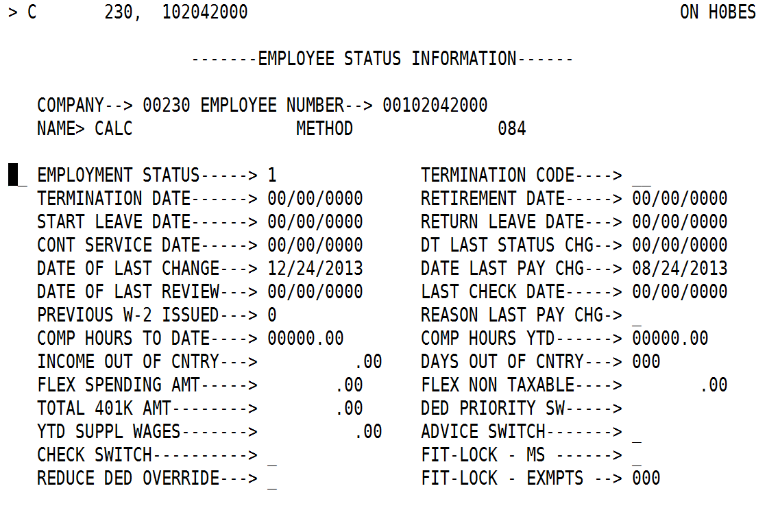  There is a field on H0BES called “Total 401K Amount”. Each time Deduction 016 and Deduction 038 are taken the amount of the deductions will post to this field to monitor the limits.
Continued on next page

VRS Hybrid Retirement Plan, continued

Monitoring 457 Limits across Multiple Deductions, continued | These deductions will cease for every employee when the combined YTD amounts for Deduction 016, EMPDC VC, and Deduction 038, DEF COMP, reach the normal annual limit (currently $17,500) UNLESS an additional goal amount is specified in the goal field for Deduction 038 on H0ZDC.  The Deferred Compensation interface has been programmed to insert a goal amount on H0ZDC representing the Age 50 Catch Up amount ($5,500 in 2014) for those employees who will be 50 years or over as of December 31, 2014. This goal amount will automatically add to the existing normal annual limit causing the total limit to be $23,000 for 2014.  ICMA-RC, the new third party administrator for the 457 Plans, will send the additional goal amounts for employees who are in the 457 Standard Catch Up via the interface. These amounts will be reflected in the goal on H0ZDC and will add to the normal annual limit to establish the total maximum that can be contributed between the two deductions.

Effect of Hybrid Plan on Garnishments | Deductions required by law are subtracted from Gross when calculating “Disposable Pay” for the purposes of garnishing wages. Deduction 015, EMPDC MD, and Deduction 012, EMP RET, are mandatory deductions required by law. Deductions 003 (GARNISH1), 004 (GARNISH2) and 005 (GARNISH3) will reduce “Disposable Pay” by the amounts taken using deduction 015, deduction 012 and taxes. If you follow the best practices as set forth in the CAPP Topic 50405 the system will withhold the proper amounts.

Effect of Hybrid Plan on One-Time Deferrals | Newly hired Hybrid Plan employees will NOT be automatically enrolled in the supplemental Deferred Compensation 457 Plan.  Leave payouts and bonuses cannot be deferred to Deduction 016, EMPDC VC.  If Hybrid Plan employees wish to defer leave payouts or bonuses to deferred compensation and they are not currently enrolled in the supplemental 457 Deferred Compensation Plan, they will need to enroll and complete the “One Time Deferral Form” in the month prior to receiving the payment they wish to defer.



