Department of Accounts
Payroll Bulletin

Calendar Year 2014 | April 28, 2014 | Volume 2014-06

In This Issue of the Payroll Bulletin….... | - Virginia State Employee Loan Program Changes | The Payroll Bulletin is published periodically to provide CIPPS agencies guidance regarding Commonwealth payroll operations. If you have any questions about the bulletin, please call Cathy McGill at (804) 371-7800 or Email at cathy.mcgill@doa.virginia.gov  State Payroll Operations  Director Lora L. George  Assistant Director Cathy C. McGill

Virginia State Employee Loan Program (VSELP) Changes

VSELP Deduction Change | Effective April 29, 2014, repayments sent to the Virginia State Employee Loan Program (VSELP) will be made via a new direct deposit deduction, DED NO 158. This change is only for new loans deductions made on or after April 29 reflected by a newly designed VSELP form. No changes should be made to any existing loans deductions.  - Establish the banking information using LINE 10 on H0BB1. Add the routing number, 251082615, as shown on the new VSELP form, under the ‘Bank’ field. In the ‘Account’ column, add the VSELP account (loan) number found on the form preceded by 5200. A change will be forthcoming from VACU to modify the form so that the ‘5200’ will be pre-printed at the beginning of the account number. Until that time, enter ‘5200’ as the first four digits of the account number.  - On H0ZDC insert deduction number 158 with data from the Loan Agreement as follows:  - Amt: enter VSELP payment per pay period amount  - Goal: enter total repayment amount from chart on the form that corresponds to the amount entered in (a) above  - Utility field:  - Positions 6-7, enter the number of payments to make (for semi-monthly employees enter 12, for monthly enter 06). Each time a loan payment is withheld this value is systematically reduced by one.  - Position 8, enter a 1 to decrement the goal.  - Positions 9-10, enter 10 to indicate that the banking information is located in line 10 on H0BB1.  By entering the number of payments and the goal, the deduction will automatically be deactivated once the number of payments reaches zero. The deduction will not start over when the YTD fields are cleared during year end processing.

Virginia State Employee Loan Program (VSELP) Changes, continued

VSELP Deduction Change, continued | For example, for an employee that is paid semi-monthly and gets a 500.00 loan, you would enter an amount of 46.00, goal of 552.00, and utility of 000001211000000000. If you enter a ‘Start Date’ of 06/10/2014 the deduction will not begin until the 6/10-24/2014 pay period (check date 7/1).  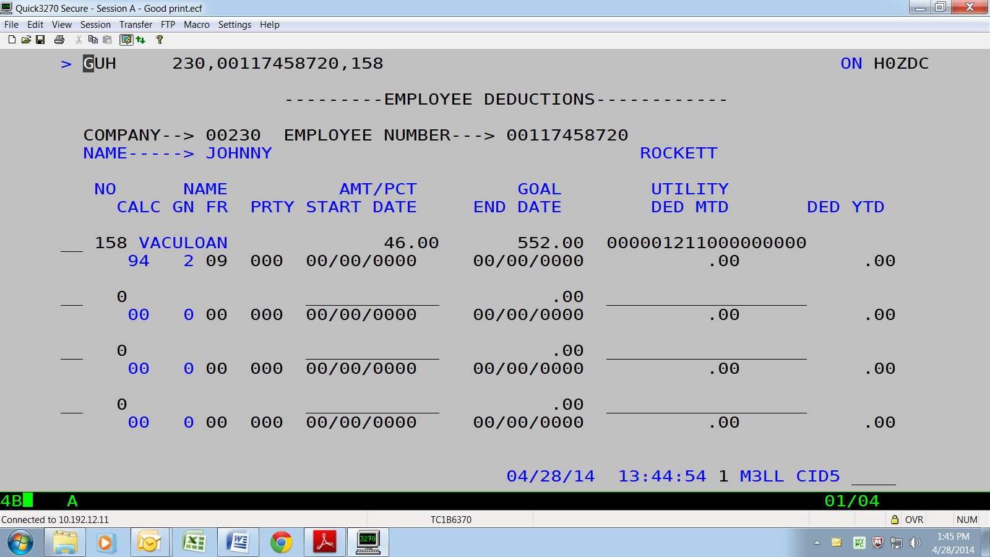  As noted on the new VSELP Employee Direct Deposit Authorization form, if payroll receives the VSELP form between the 1st -15th of the month, then the direct deposit should be set up to be withheld on both the 1st and 16th paychecks of the following month so that the payment is received by the VACU by the monthly loan payment due date of the 18th. Otherwise, it should be set up to begin on the 1st and 16th paychecks of the next month.  For example, if payroll receives a VSELP form between May 16 and June 15 the direct deposit repayment should begin with the 6/10-24 pay period. If payroll receives the VSELP form between June 16 and July 15 the repayment should begin 7/10-24. You can either hold the paperwork until processing those pay periods, or you can enter a Start Date of the 10th on H0ZDC to establish a future begin date. Example: Start Date of 07/10/2014 will begin with the 07/10-24/2014 pay period.  Note: If no action is taken to deactivate satisfied VSELP deductions established prior to 4/29/2014 the amount continuing to be withheld will be moved to the employee’s savings account by VACU. However, under the new process the deduction will be automatically deactivated once the loan is paid off (goal amount has been met).

