Department of Accounts
Payroll Bulletin

Calendar Year 2014 | December 4, 2014 | Volume 2014-16

In This Issue of the Payroll Bulletin….... | - PMIS to CIPPS New Hire Interface Update  - Employee Payline Accounts  - Virginia State Employee Loan Program  - Terminated Employees with Child Support  - Earnings Reclassification with Reciprocal State Taxation | The Payroll Bulletin is published periodically to provide CIPPS agencies guidance regarding Commonwealth payroll operations. If you have any questions about the bulletin, please call Cathy McGill at (804) 371-7800 or Email at cathy.mcgill@doa.virginia.gov  State Payroll Operations  Director Lora L. George  Assistant Director Cathy C. McGill

PMIS to CIPPS New Hire Interface Update

Additional PMIS Reason Codes | The PMIS New Hire Interface was updated on November 12 to allow CIPPS to create a new hire "shell" record for additional PMIS Reason Codes. A complete listing of PMIS Reason Codes that generate a new hire "shell" record in CIPPS is available below. New hires established through the interface can be reviewed on Report U179. Items that cannot be updated because of an error are listed on Report U178.  Initial PMIS Reason Codes:  Reason Code 301 - Original Appointment  Reason Code 302 - Rehire (Re-Establish)  Reason Code 304 - Reinstate  Additional PMIS Reason Codes added last night:  Reason Code 013 - Lateral/Competitive Voluntary Transfer  Reason Code 040 - Promotion  Reason Code 045 - Faculty Promotion  Reason Code 050 - Faculty Demotion  Reason Code 080 - Exceptional Promotion  Reason Code 081 - Exceptional Demotion  Reason Code 084 - Exceptional Transfer-In  As feedback is received from line agencies, other Reason Codes will be evaluated for inclusion in the future. If a new hire was added to PMIS with a Reason Code that is not shown above, the record will have to be manually added to CIPPS.

Employee Payline Accounts

New Employee Passwords | Payline establishes records for employees from the earnings data resulting from payroll certifications. New employees should be advised that they will not be able to establish an account in Payline until their first pay has been processed, normally three days prior to their first pay date.

Virginia State Employee Loan Program

Early Payoffs/New Loans | There has been an increase in the number of loan payments being returned to DOA by the VACU. In most cases, the funds are being returned because the accounts have been “closed” which means that the employee probably paid the loan off early and neglected to inform payroll that the deduction should be stopped. The agency receives no notification to stop the deduction unless the employee happens to mention it or subsequently requests a new loan and submits the direct deposit form for the new loan account.  If a direct deposit form for a VSE Loan is received, but the employee already has an active deduction 158, then it is likely that the employee paid the original loan off and has requested a new loan. If so, reestablish the deduction using the process for setting up a VSE Loan deduction:  - Ensure that the loan account number has been updated in line 10 on H0BB1.  - On H0ZDC, reset deduction number 158 for the new loan as follows:  - Amt: enter VSELP payment per pay period amount  - Goal: enter total repayment amount from chart on the form that corresponds to the amount entered in (a) above  - Utility field:  - Positions 6-7, enter the number of payments to make (for semi-monthly employees enter 12, for monthly enter 06). Each time a loan payment is withheld this value is systematically reduced by one.  - Position 8, enter a 1 to decrement the goal.  - Positions 9-10, enter 10 to indicate that the banking information is located in line 10 on H0BB1.  - If you are using the START DATE field, be sure to update with the top of a pay period based on the terms of the loan.  - Communicate to the VSELP unit at DHRM that the deduction has been established so the funds can be released. In this communication request confirmation that the prior loan amount has been paid off.  Note: Failure to reset the number of payments in positions 6-7 of the Utility field for the new loan will result in CIPPS taking a final deduction amount larger than the intended pay period amount.
Continued on the next page

Virginia State Employee Loan Program, continued

Lump-Sum Deduction upon Employee Termination | When a terminating employee has an active VSE Loan it is necessary to collect the entire remaining loan balance from the employee’s final regular pay and/or leave payment. A change to the UTILITY field for deduction 158, VACULOAN, is all that is necessary for a one-time lump sum deduction.  Change positions 6 and 7 of the UTILITY to a value of ‘01’. This tells CIPPS that there is one remaining payment for this loan. If the deduction GOAL is greater than the deduction AMT/PCT, CIPPS will deduct that GOAL as a balloon payment.  Note: The balloon payment still requires a sufficient net pay amount to be available.

Terminated Employees with Child Support

Report Terminations/Retirements to DSS | All employers are required to enforce child support orders; therefore, it is important that an employer, in order to relieve itself of this liability, notify the issuing agency if the employee retires or otherwise terminates their employment. The employer should send a copy of the order to the issuing agency and include the company name, employee's name and address, the date of separation from employment, and the new employer or pension administrator's name and address, if known.

Earnings Reclassification with Reciprocal State Taxation

Overview | Situations occur where it is necessary to reclassify regular earnings to another type of earnings or vice versa. In most circumstances, reclassification of earnings may be accomplished by keying an HTPSA in CIPPS. Even in certain situations like Workers’ Compensation, where the adjustment affects taxable wages for FIT, OASDI, HI, and SIT taxes, HTPSA may still be used for employees whose resident state and work state are both Virginia.  When state taxation is assigned to the employee’s resident state because of an existing reciprocal agreement between that state and Virginia, the existing process has been incomplete and required outside assistance. To date, this process has been to key the earnings reclassification for Virginia only. At the end of the quarter, agencies would submit to State Payroll Operations an Employee File Adjustment Form, with screen prints of the resident state tax Masterfile. State Payroll Operations personnel would manually update the resident state taxable earnings in CIPPS.  The Manual Pay Builder in CIPPS, screens HTM00 through HTMCK, provides the only method by which reciprocal state taxable earnings may be adjusted correctly through the system.
Continued on the next page

Earnings Reclassification with Reciprocal State Taxation, continued

Manual Pay Builder | Keying the Manual Pay Builder begins with the HTM00 screen. The information on HTM00 is the unique identifier for the manual pay.  - On HTM00, key these fields: Company, Employee No, Page Number, Check Number, Check Date, Beginning Date, and Ending Date. Put a ‘Y’ in the Y/Q Indicator field. CIPPS will move to the next screen when you press ENTER.  - On HTMPA, key the regular pay to be adjusted.  - On HTMSP, key the special pay to be adjusted.  - On HTMTD, replace the pre-loaded ST/LOC value (usually ‘470000’) on the first line with the ST/LOC value for the employee’s resident state & local.  - Review the Manual Pay Summary on HTMCK to ensure everything balanced.  - Press ENTER again to return to the HTM00 screen. Scroll through the Manual Pay Builder screens to review & verify everything shows as entered.  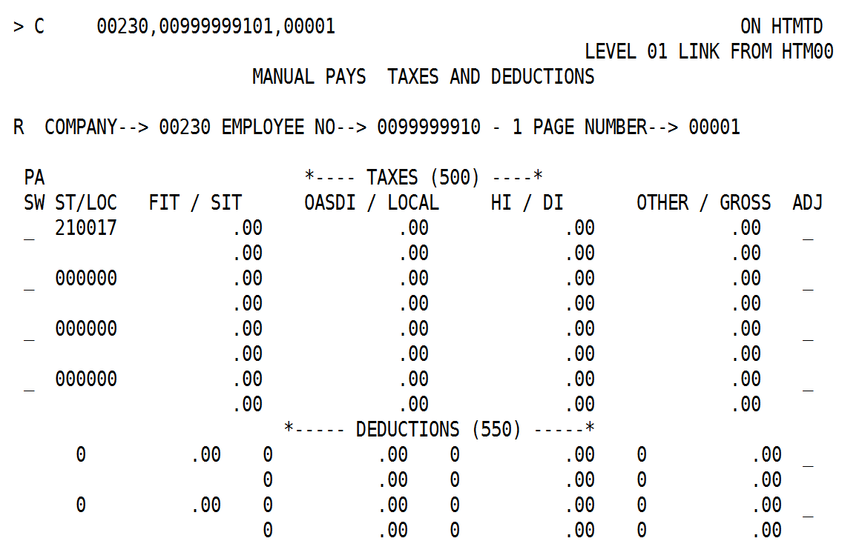
Continued on the next page

Earnings Reclassification with Reciprocal State Taxation, continued

Reviewing the Manual Pay | PA STATE/LOCAL: This field is optional. Employers with Pennsylvania residents may enter the employee’s resident state and local if the employee is subject to PA Act 32 local tax. If no value is entered, the resident state and resident local entered on the H0BAD screen are defaulted into this field when you press Enter.  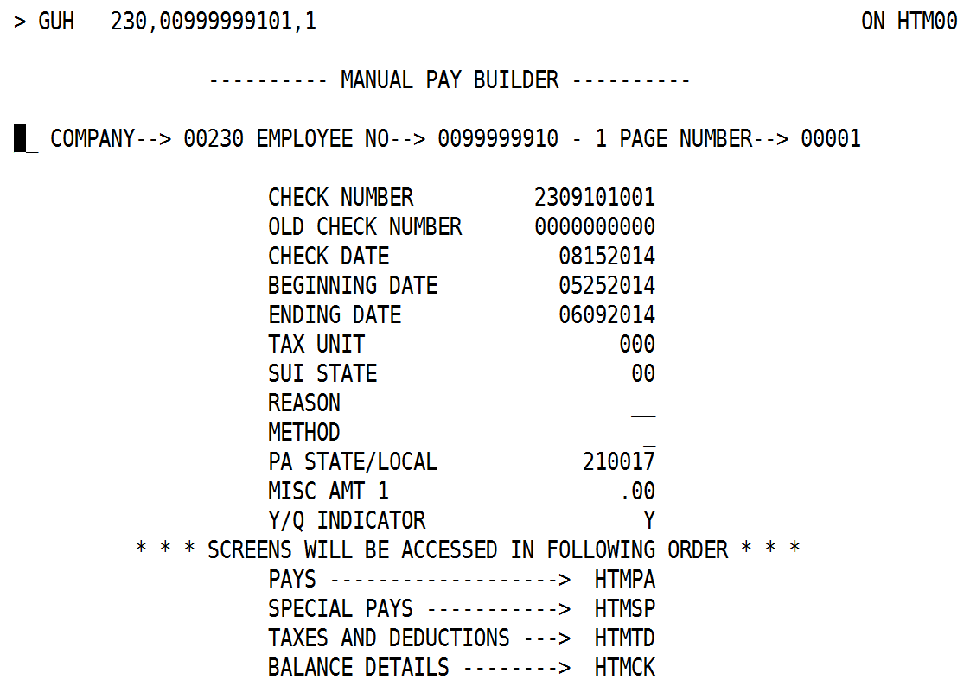  Figure 1: HTM00 after keying – MD resident state  The PA STATE/LOCAL value on HTM00 should be compared to the resident state and local codes entered on the HTMTD screen. If there is a discrepancy and the HTMTD is determined to be wrong, correct the HTMTD screen.  If the resident state and local code entered on HTMTD is correct:  - check that an H0ATX record for that state and local exists;  - verify that the state status on H0ATX is correct for both the work state and resident state records; and  - verify that the H0BAD is properly coded for work and resident states.  Work State on HTMTD: CIPPS will re-generate a line on HTMTD for the work state. This is correct. This transaction cannot be deleted.  Refer to CAPP Topic 50315, Employee Tax Maintenance, for additional assistance with configuring the employee tax Masterfile. Contact payroll@doa.virginia.gov if you have questions.

