Department of Accounts
Payroll Bulletin

Calendar Year 2015 | August 7, 2015 | Volume 2015-09

In This Issue of the Payroll Bulletin….... | - Cardinal Payroll Project Update  - Compensation Eligible for Deferral  - Modifications to Report 855 and 857  - CIPPS/FINDS Decommission  - Collection of Flexible Reimbursement Funds Outside of Payroll  - Return Policy for Closed VSLEP Accounts | The Payroll Bulletin is published periodically to provide CIPPS agencies guidance regarding Commonwealth payroll operations. If you have any questions about the bulletin, please call Cathy McGill at (804) 371-7800 or Email at cathy.mcgill@doa.virginia.gov  State Payroll Operations  Director Lora L. George  Assistant Director Cathy C. McGill

Cardinal Payroll Project Update

Completion of “As Is” Workshops | The Cardinal Payroll project team has just wrapped up the “As Is” workshops aimed to identify current practices and needs. Representatives included participants from higher education, legislative, judicial, independent, Payroll Service Bureau, DHRM, agencies with internal time and attendance systems, among others. These workshops were very informative and the participation of all is appreciated.  The next step will be for the Cardinal Payroll team to develop an agency survey that will be distributed to all CIPPS agencies. This should be distributed within the next several weeks. Agencies will have two weeks to complete the survey and return it to the project team. We will ask for representatives from payroll, fiscal, human resource, and benefit administration to come together to provide a consolidated and complete response.

Cleansing PMIS Data | For those agencies who utilize PMIS, the position data found in PMIS will be the basis for establishing the required information for Cardinal Payroll. Each agency should perform an audit of that information to ensure accuracy, particularly in regard to the overtime eligibility code. Many agencies have established the overtime eligibility code as “eligible” for ineligible positions simply to eliminate the step of modifying that value in PMIS when an employee becomes temporarily eligible for overtime due to special projects or assignments. Similarly, numerous records have been established as “eligible” due to such an assignment and never returned to “ineligible” upon completion of the assignment.  This is a key internal control to ensure improper payments for overtime cannot occur.
Continued on next page

Compensation Eligible for Deferral

Compensation Eligible for Deferral Under Section 457 | Not all compensation received is eligible for deferral under Section 457 of the Internal Revenue Code. Virginia Retirement System has provided the following definition related to compensation for the Deferred Compensation programs.  “Compensation”: A Participant’s wages, salary and other amounts received for personal services rendered to the Employer as an Eligible Employee during his current taxable year, including compensation payable as bonuses, as overtime or as taxable reimbursements for office expenses of members of the General Assembly, and excluding any compensation received in the form of non-taxable fringe benefits. Compensation shall include that portion of such amount deferred by the Participant as Deferred Compensation Contributions under this Plan. Compensation shall also include sick leave and family and personal leave payments, leave share payments and short term disability payments under the Virginia Sickness and Disability Program. Compensation shall also include compensatory time, accumulated sick pay (including the payout of disability credits under the Virginia Sickness and Disability Program), accumulated vacation pay and back pay (referred to as “post-employment compensation”) all payable with the Participant’s final paycheck or within the later of two and one-half (2-1/2) months following severance from employment or the end of the calendar year in which the severance from employment occurred. Compensation shall not include long term disability benefits paid under the Virginia Sickness and Disability Program or disability retirement payments under the Virginia Retirement System.

Modification to Reports 855 and 857

Addition of Roth Deductions | Reports 855 and 857 which monitor employees who will reach the annual maximum contributions for Section 457 and 403(b) retirement programs prior to year end has been enhanced to include the new Roth (post-tax) deductions. Agencies should periodically request these reports on HSRUT to advise employees of the loss of future cash match amounts when the maximum has been reached. Additionally, if an employee is contributing to both the pretax 403(b) and the post tax 403(b) manual intervention will be required when the combined YTD amounts reach the maximum. The entry of a START DATE of 01/01/20## (where ## reflects the next calendar year) should be entered for deduction 046, Annuity Cash Match, to halt the match until the next calendar year when the employee becomes eligible again.

CIPPS FINDS Decommissioned

Obtain Access to PAT | When CARS FINDS is decommissioned with the deactivation of CARS, CIPPS FINDS will also be decommissioned. If your agency is currently using downloads from CIPPS FINDS you will need to obtain access to PAT (Payroll Auditing Tool) to obtain the information desired. Modifications may be required to your systems/programs that utilize the downloaded information as there are some slight differences.  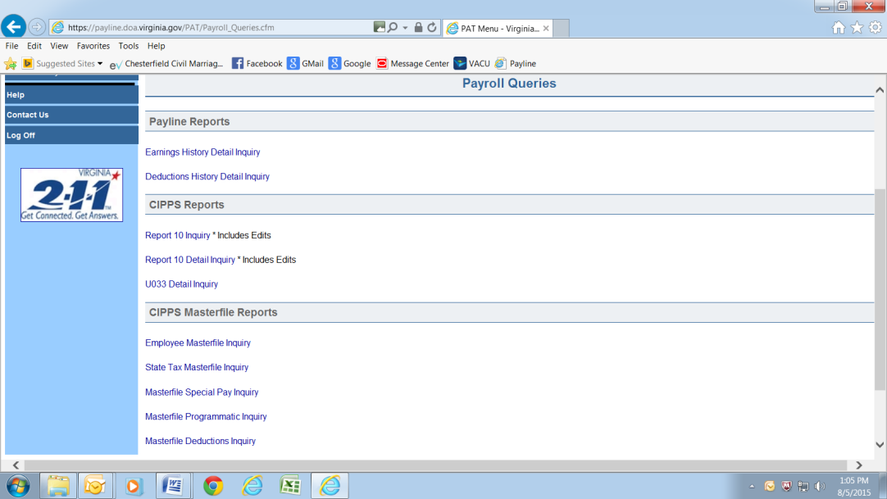  The authorization request form found at the link below should be completed with the PAT access level 5 circled. The Payroll Security Officer (PSO) identified on the Signatory card must authorize the request prior to it being sent to DOA.  http://www.doa.virginia.gov/Payroll/Forms/PaylinePATSecurityForm.pdf

Collection of Flexible Reimbursement Funds Outside of Payroll

Return to DOA | Flexible reimbursement elections are monthly amounts. If an employee is terminated mid-month or does not receive enough compensation to collect the full monthly amount through payroll the missing contribution must be obtained from the employee outside of payroll. Unlike health care or retirement, those funds collected outside of the system are not to be deposited to the agency, they are to be remitted to DOA. Please see page 14 of CAPP Topic 50435 for instructions.  http://www.doa.virginia.gov/Admin_Services/CAPP/CAPP_Topics/50435.pdf

Return Policy for Closed VSELP Accounts

Deposit to Employee Net DD Account | Effective immediately any funds returned from the Virginia Credit Union for closed Virginia State Employee Loan Program accounts will be deposited into the employee’s net direct deposit account. DOA will no longer reach out to the agency to inquire as to where the employee would like the funds deposited.  Please be aware that these returned funds may not show up in the employee’s account for up to 5 days after pay day.

