Department of Accounts
Payroll Bulletin

Calendar Year 2015 | November 2, 2015 | Volume 2015-12

In This Issue of the Payroll Bulletin….... | - Reclassification of Taxable Income for Flex Reimbursement Card Payments  - Name and Address Format Requirements | The Payroll Bulletin is published periodically to provide CIPPS agencies guidance regarding Commonwealth payroll operations. If you have any questions about the bulletin, please call Cathy McGill at (804) 371-7800 or Email at cathy.mcgill@doa.virginia.gov  State Payroll Operations  Director Lora L. George  Assistant Director Cathy C. McGill

Reclassification of Taxable Income for Flexible Reimbursement Card Payments

Reclassifica-tion | According to IRS guidelines (Revenue Ruling 2003-43, 2006-69), all Card transactions must be validated. The TPA is permitted, under the IRS guidelines, to automatically validate (auto-adjudicate) certain transactions. In the event that the TPA cannot auto-adjudicate card transactions, the TPA requests supporting documentation from the employee. If documentation is not received, then the outstanding transaction amounts must be reported to the Internal Revenue Service (IRS) as income on the employee’s W-2 form, and are subject to all applicable employment taxes (including federal and state income tax withholding and FICA).

Automated Reclassification | A file will be loaded on November 3 which will automatically update the taxable and non-taxable fields for those CIPPS employees who have been paid in 2015. This file will adjust the year-to-date accumulation fields and will not process through a payrun and will not reflect on a Report 10. Therefore, any agency maintaining control totals for the purpose of balancing quarterly or calendar year-end totals will need to make manual adjustments. The amounts can be obtained from the data available on the Report 1006.

2015  Terminations - Manual Payset Required | A manual payset will be required to invoke the collection of FICA taxes for those employees who have terminated in 2015. An example of the required transaction on HTQTA is provided on the next page.  The amount of OASDI (.062) and HI (.0145) tax related to the reclassified income must be calculated. The combined total should be entered in the NET field with an adjustment indicator of ‘-’and the individual amounts entered for OASDI and HI with an adjustment indicator of ‘+’. The employee must be reactivated in a non-auto time card status and a time and attendance transaction for $.01 must be entered to pull through the manual payset.  The Department of Accounts will create a journal entry to charge the line agency for the uncollected employee FICA amounts.
Continued on next page
Reclass. of Taxable Income for Flexible Reimbursement Card Payments, continued

2015  Terminations - Manual Payset Required | It is imperative that these transactions are processed in a timely manner in order for the taxes to be remitted to the IRS by the Department of Accounts. Failure to process these transactions will require payment of the taxes to the IRS via EFTPS. DOA will process the CARS transaction to create the payment and provide copies to the affected agency.  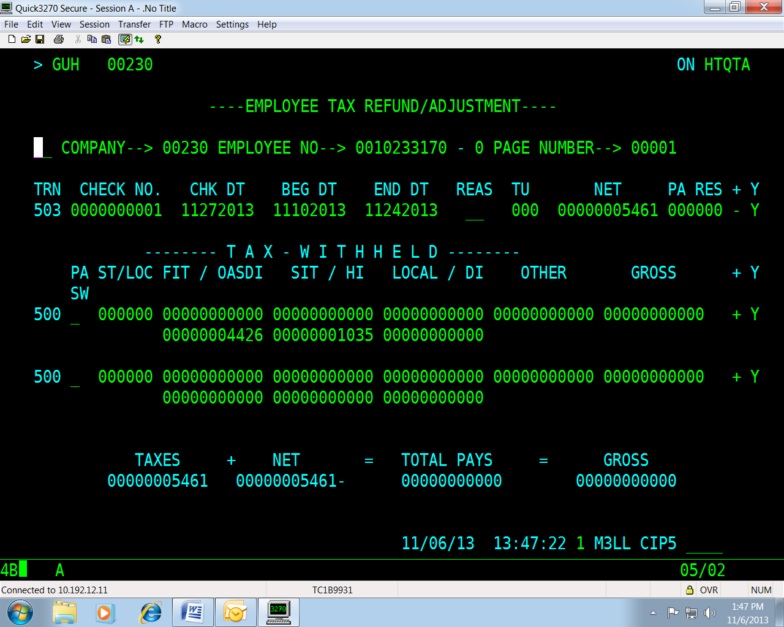

2014 Terminations | For those employees who terminated in 2014, the Department of Accounts will process W2Cs and 941Xs. DOA will process the CARS transaction to create the payment via EFTPS in conjunction with the filing of the 941X and provide copies to the affected agency.

Active Employees | No action is required for active employees as FICA will self-adjust when the employee is next paid in 2015. However, if you have an active employee who will not be receiving any payments in 2015, please follow the instructions provided for employees who have terminated during 2015.

Name and Address Format Requirements

Name (e.g. suffix) and Address Format Requirements | Keep the following requirements in mind when entering employee name and address information on the H0BID screen in CIPPS:  - Name must match exactly what is on social security card.  - Name fields can only contain letters, numbers (0-9), spaces, hyphens, periods, and/or apostrophes. Do not use accent marks.  - Suffixes must be in this format: last name,(space)suffix; for example, Smith, Jr  Do not use periods after the suffix or extra spaces between the last name and suffix.  - All names, addresses, city, state and zip code entries must begin in the first position of the field. Do not leave any blank spaces at the beginning.  - You must use a space or dash between the zip code and the extension; zip codes are five digits and extensions are four digits. For example, 22032-1712 or 22032 1712  - Do not use periods in state abbreviations; for example, NC not N.C.  - State abbreviations must be in the state field, not in the city field or zip code field. Do not use commas after the city name.  - You must use alpha characters (letters) in the state abbreviations on the address line; for example, OH not 0H (zero-H is not Ohio)  - You must use the official USPO two-position abbreviation for the state name; do not spell out the state name or try to extend it beyond two characters.

