Department of Accounts
Payroll Bulletin

Calendar Year 2016 | July 25, 2016 | Volume 2016-07

In This Issue of the Payroll Bulletin….... | - New NSSA Application  - PMIS to CIPPS New Hire Interface Update  - Request PIN from IRS  - Fiscal Officer Proxy for Payroll Certifications | The Payroll Bulletin is published periodically to provide CIPPS agencies guidance regarding Commonwealth payroll operations. If you have any questions about the bulletin, please call Cathy McGill at (804) 371-7800 or Email at cathy.mcgill@doa.virginia.gov  State Payroll Operations  Director Lora L. George  Assistant Director Cathy C. McGill

New NSSA Application

Moved to Payline | Although CARS will be decommissioned in the near future CIPPS has not been modified to reflect Cardinal’s Chart of Accounts. Each agency must continue to establish and maintain their NSSA programmatic data table. Effective July 28 the location of the NSSA application will be moved to within Payline. The CARS coding values will continue to be maintained in a set of descriptor tables stored within this new application. The descriptor tables for Project, Task, and Cost Code can be updated by authorized agency users to add desired values. All other values will be maintained by the General Accounting unit within the Department of Accounts.

Obtaining Access to NSSA | Users who should be authorized to use this feature need to submit a new “PAYLINE/PAT SECURITY AUTHORIZATION / DELETION REQUEST” form indicating “1. New” and either “1. View Only” or “2 – Update.” in the section designated for NSSA.  The form can be found at:  http://www.doa.virginia.gov/Payroll/Forms/PaylinePATSecurityForm.pdf

New NSSA Application, continued

Accessing NSSA | Once logged into Payline (or from the Main Menu page) a navigation button entitled “NSSA Table Maintenance” is displayed in the left hand side. Click the button to be taken to the CIPPS Table Maintenance page.
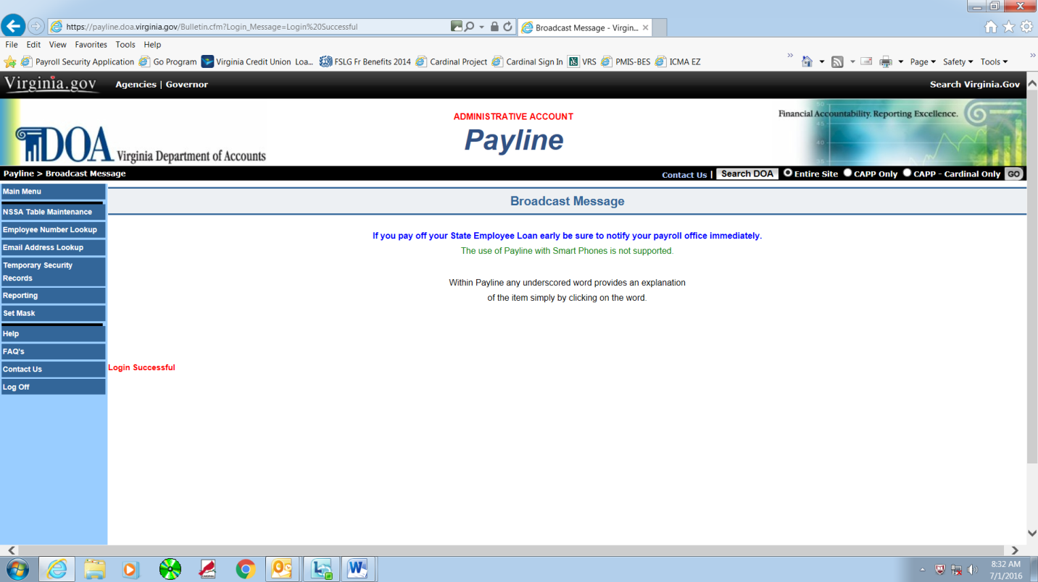

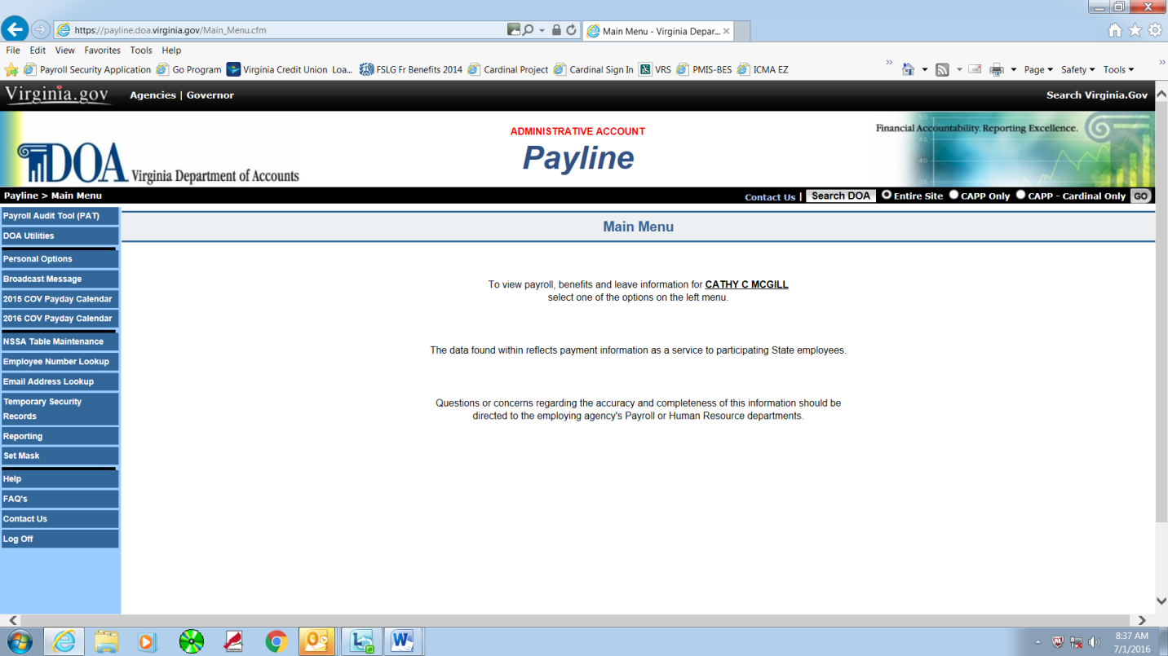

New NSSA Application, continued

Updating NSSA | From the CIPPS NSSA Table Maintenance page you may view existing records or “Add New Record.”  Limited editing, filtering, and search capabilities are provided. If agencies attempt to enter NSSA programmatic coding that has not yet been established in the Descriptor tables an error message appears on the screen during data entry or upon hitting “Accept.”
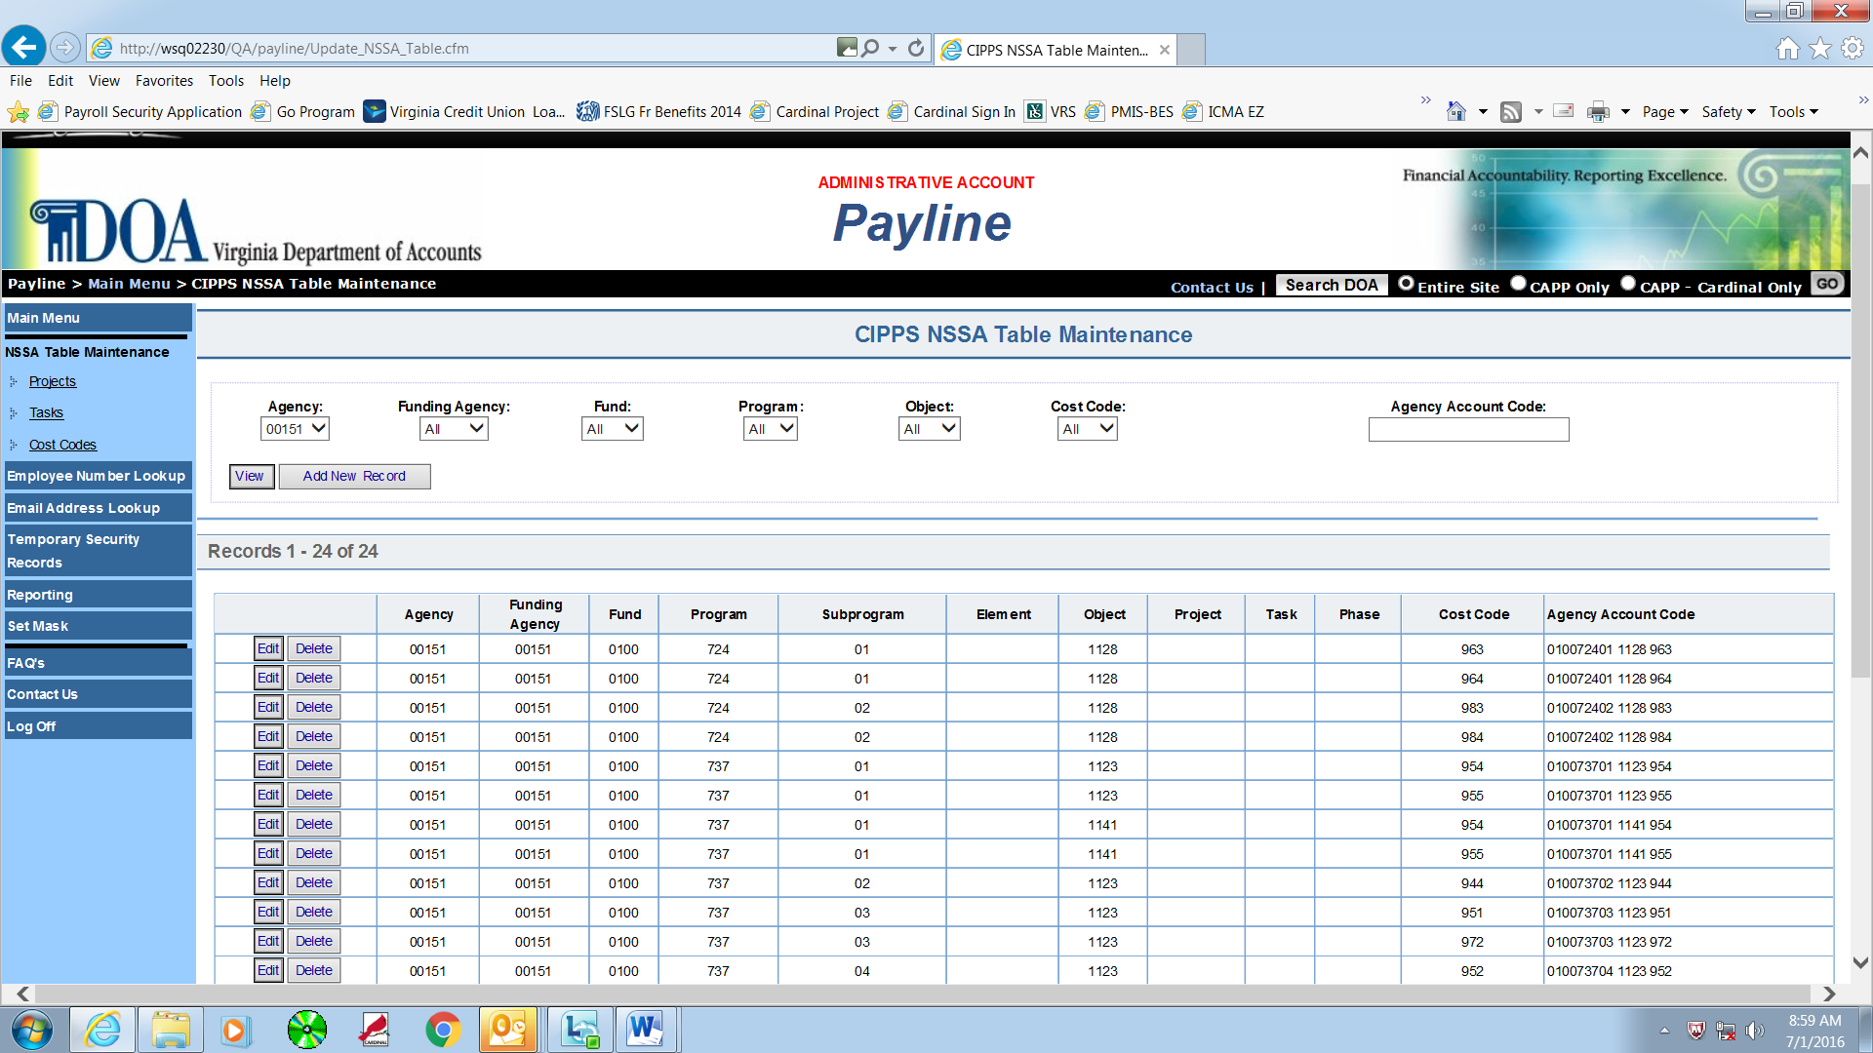

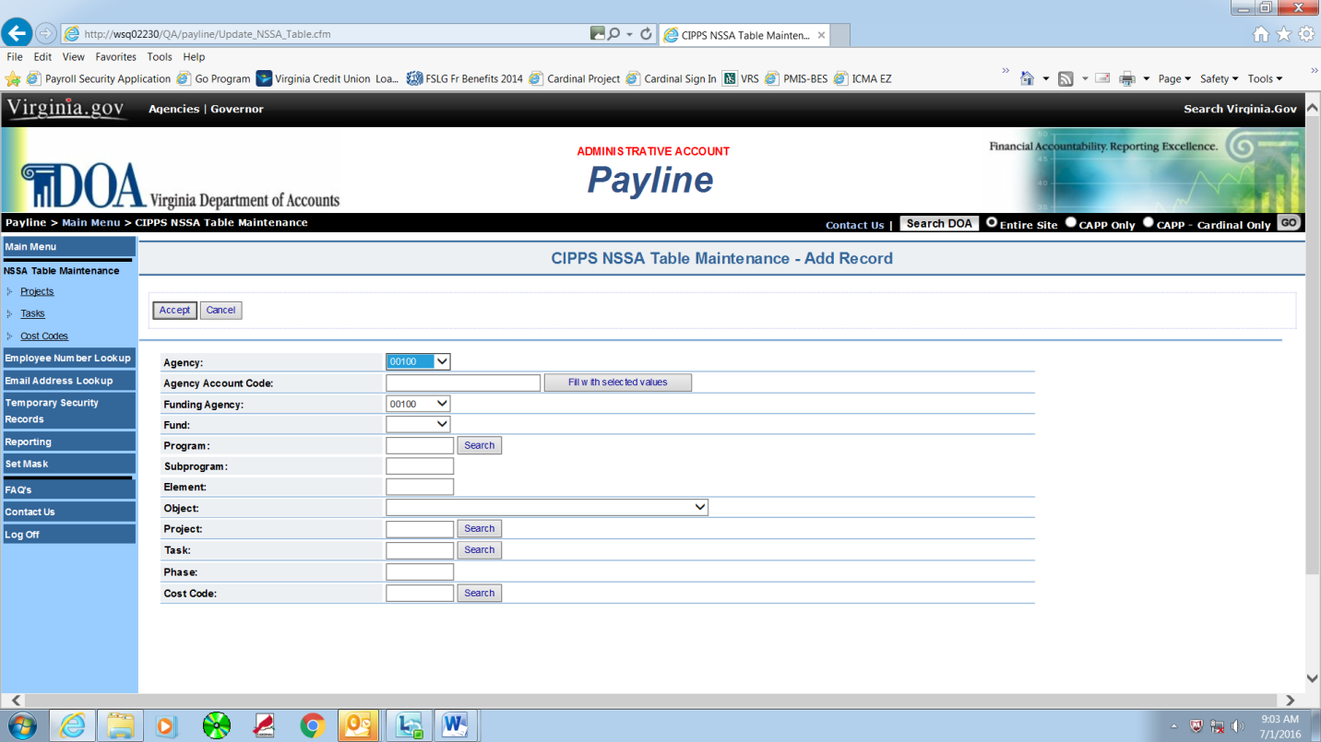

New NSSA Application, continued

Nightly Upload to CIPPS | New entries successfully added to NSSA will be loaded to CIPPS during nightly processing and be available for use in CIPPS the next business day.

PMIS to CIPPS New Hire Interface Update

Additional PMIS Reason Codes | The PMIS New Hire Interface was updated in May 2016 to allow CIPPS to create a new hire "shell" record for additional PMIS Reason Codes. A complete listing of PMIS Reason Codes that generate a new hire "shell" record in CIPPS is available below. New hires established through the interface can be reviewed on Report U179. Items that cannot be updated because of an error are listed on Report U178.  Initial PMIS Reason Codes:  Reason Code 301 - Original Appointment  Reason Code 302 - Rehire (Re-Establish)  Reason Code 304 - Reinstate  Reason Code 013 - Lateral/Competitive Voluntary Transfer  Reason Code 040 - Promotion  Reason Code 045 - Faculty Promotion  Reason Code 050 - Faculty Demotion  Reason Code 080 - Exceptional Promotion  Reason Code 081 - Exceptional Demotion  Reason Code 084 - Exceptional Transfer-In  Additional PMIS Reason Codes added:  Reason Code 015 – Non-Competitive Voluntary Transfer  Reason Code 021 – Rehire – Category I  Reason Code 022 – Rehire – Category II  Reason Code 023 – Rehire – Category III  Reason Code 024 – Return from Suspension  Reason Code 025 – Rehire – Category IV  Reason Code 026 – Rehire – Category V  Other Reason Codes will be evaluated for inclusion in the future as feedback is received from line agencies. If a new hire was added to PMIS with a Reason Code that is not shown above, the record will have to be manually added to CIPPS.

Request PIN from IRS

Contact the IRS | The Department of Accounts is often required to speak to the IRS on behalf of CIPPS agencies. The IRS is becoming stricter on their requirements to enable DOA to continue this practice, requiring us to provide a PIN associated with the agency. As the PIN numbers for many agencies were in existence prior to the time DOA began to centrally file the 941 reports, we do not have a list of all agency PIN numbers.  We are asking each agency to contact the IRS EFTPS division at 1-800-555-3453 and request that a PIN number be mailed to the agency. You will be asked to give your agency’s Full Name, FEIN and mailing address. Once you receive the IRS notice with your PIN number, please send a copy of the letter providing the PIN to Denise Halderman at denise.halderman@doa.virginia.gov.  To ensure the IRS does not receive multiple requests for this information it is suggested that the Fiscal Officer of each agency control this effort through either contacting the IRS personally or delegating the effort to one individual.

Fiscal Officer Proxy for Payroll Certifications

Fiscal Officer Proxy | When CIPPS certification access is requested for an employee and is signed by the Payroll Security Officer (PSO) as identified on the Authorized Signatory card it is presumed that agency management is authorizing that individual to approve payroll expenditures. However, there are other certifications related to payroll which are not controlled by systematic controls. Examples of these are the monthly Health Care Certification and the Quarterly Reconciliation and Certification. At times a Fiscal Officer may want or need to delegate authorization to another individual to perform such certifications. In order to validate authorizations by individuals other than the Agency Fiscal Officer, State Payroll Operations has created a Fiscal Officer Proxy form located http://www.doa.virginia.gov/Payroll/Forms/FiscalOfficerProxy.pdf .  Fiscal Officers who would like to have a proxy on file should complete the form and fax it to State Payroll Operations at (804) 225-3499 or email the completed form to payroll@doa.virginia.gov.

