Department of Accounts
Payroll Bulletin

Calendar Year 2016 | October 28, 2016 | Volume 2016-11

In This Issue of the Payroll Bulletin….... | - Reclassification of Taxable Income for Flex Reimbursement Card Payments  - 2016 Imputed Income for Terminated ORP Participants Eligible for Continued Group Life | The Payroll Bulletin is published periodically to provide CIPPS agencies guidance regarding Commonwealth payroll operations. If you have any questions about the bulletin, please call Cathy McGill at (804) 371-7800 or Email at cathy.mcgill@doa.virginia.gov  State Payroll Operations  Director Lora L. George  Assistant Director Cathy C. McGill

Reclassification of Taxable Income for Flexible Reimbursement Card Payments

Reclassifica-tion | According to IRS guidelines (Revenue Ruling 2003-43, 2006-69), all Card transactions must be validated. The TPA is permitted, under the IRS guidelines, to automatically validate (auto-adjudicate) certain transactions. In the event that the TPA cannot auto-adjudicate card transactions, the TPA requests supporting documentation from the employee. If documentation is not received, then the outstanding transaction amounts must be reported to the Internal Revenue Service (IRS) as income on the employee’s W-2 form, and are subject to all applicable employment taxes (including federal and state income tax withholding and FICA).

Automated Reclassification | A file will be loaded on November 3 which will automatically update the taxable and non-taxable fields for those CIPPS employees who have been paid in 2016. This file will adjust the year-to-date accumulation fields and will not process through a payrun and will not reflect on a Report 10. Therefore, any agency maintaining control totals for the purpose of balancing quarterly or calendar year-end totals will need to make manual adjustments. The amounts can be obtained from the data available on the Report 1006. In addition, Denise Halderman will email you a list of affected employees sometime next week.

2015  Terminations - Manual Payset Required | A manual payset will be required to invoke the collection of FICA taxes for those employees who have terminated in 2016. An example of the required transaction on HTQTA is provided on the next page.  The amount of OASDI (.062) and HI (.0145) tax related to the reclassified income must be calculated. The combined total should be entered in the NET field with an adjustment indicator of ‘-’and the individual amounts entered for OASDI and HI with an adjustment indicator of ‘+’. The employee must be reactivated in a non-auto time card status; however, you do NOT need to process a time and attendance transaction for $.01 to pull through the manual payset.  The Department of Accounts will create a journal entry to charge the line agency for the uncollected employee FICA amounts.
- Continued on next page
Reclass of Taxable Income for Flexible Reimbursement Card Payments, continued

2016  Terminations - Manual Payset Required | It is imperative that these transactions are processed in a timely manner in order for the taxes to be remitted to the IRS by the Department of Accounts. Failure to process these transactions will require payment of the taxes to the IRS via EFTPS. DOA will process the Cardinal transaction to create the payment and provide copies to the affected agency.  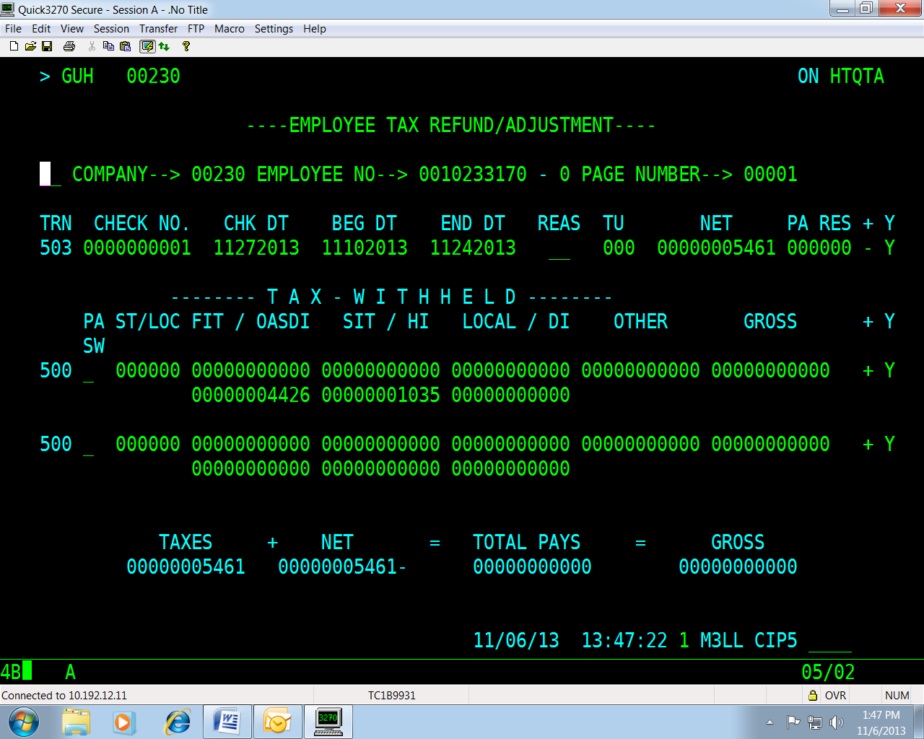

2015 Terminations | For those employees who terminated in 2015, the Department of Accounts will process W2Cs and 941Xs. DOA will process the Cardinal transaction to create the payment via EFTPS in conjunction with the filing of the 941X and provide copies to the affected agency.

Active Employees | No action is required for active employees as FICA will self-adjust when the employee is next paid in 2016. However, if you have an active employee who will not be receiving any payments in 2016, please follow the instructions provided for employees who have terminated during 2016.

2016 Imputed Income for Terminated ORP Participants Eligible for Continued Group Life

IRS Regulations | Many colleges, universities and agencies with political appointees have employees who choose to participate in one of the Optional Retirement Plans in lieu of VRS (deduction 109 – Fidelity, 111 – Political ORP, or 114 – TIAA-CREF). One of the benefits that these employees may continue to receive for a period of time once they have terminated from state service is coverage under the State’s Group Term Life (GTL) policy, provided they meet the age/service guidelines VRS requires for retirement. If the employee is eligible for continued group term life insurance coverage and the amount of the coverage exceeds $50,000, then imputed income must be calculated and reported on a W-2 for the former employee.  VRS provides W-2s to retirees under the Virginia Retirement System, but does not provide W-2s to employees who elected to participate in one of the Optional Retirement Plans (ORP); therefore, agencies with ORP participants who terminated in 2016 or before and meet the criteria outlined below, must report the amount of imputed income to DOA for inclusion on W-2s for 2016. For ORP participants who terminated in 2016, the amount of the imputed income for the months following date of termination must be included in taxable income. The uncollected social security and Medicare taxes on the imputed income will be reported separately in Box 12 on Form W-2 using codes M and N. The former employee must pay the employee’s uncollected share of Social Security and Medicare taxes with their income tax return.

Eligibility for Continued GTL Coverage | Employees in ORPs must meet the same eligibility requirements as VRS-covered employees to remain covered by the Commonwealth’s’ GTL policy at separation from service (VRS Employer Manual, Chapter 5, page 16). VRS service credits the employee may have in addition to the employee’s ORP service credits count towards meeting the age/service requirements. Each institution must verify whether their eligible terminated ORP participants have a plan account balance qualifying them for group life insurance benefits. Employers will receive an email from VRS outlining the procedures. If your agency did not receive a communication from VRS related to this subject, please contact ORPHE@varetire.org or call Steve Cerreto at 804-771-7731 for procedures on how to work with the providers for balance information using the forms found at the end of this bulletin.
- Continued on next page
2016 Imputed Income for ORP Participants Eligible for Continued Grp Life, continued

Reporting Criteria | The following criteria should be used to determine which employees are impacted:  - Employee elected to participate in one of the optional retirement plans instead of VRS, and  - Employee is eligible for continued coverage under Group Life Insurance (at least 50 with 10 years of service or 55 with 5 years of service), and  - Employee’s final annual salary is greater than $25,000, and  - Employee terminated or retired during 2016 or earlier.

Amount of Insurance Coverage | At the time the employee retires or terminates, the amount of life insurance coverage provided is twice the amount of the employee’s final salary. The following reductions take place as indicated:  25% reduction on January 1st after 12 months from separating service  25% reduction every January 1st thereafter  Final 25% reduction January 1st to fully reduced amount equal to 50% of final salary at time of retirement  Example: At the time Tom retired in May, 2016 his final annual salary was $75,000. He meets the criteria required for continued GTL insurance coverage and the coverage amount is $150,000 ($75,000 * 2). In January, 2018 the amount of his life insurance coverage will be reduced to $112,500 ($150,000 * .75). In January, 2019 the amount of coverage will be reduced to $75,000 ($150,000 *.5). In January, 2020 the amount of coverage will be reduced for the last time to $37,500 ($150,000 * .25) which is equal to 50% of his original final salary.

Calculate Amount of Imputed Life | Figure the monthly cost of the insurance to include in the retired employee's wages by multiplying the number of thousands of dollars of insurance coverage over $50,000 (figured to the nearest $1,000) by the cost shown in the table below. Use the employee's age on the last day of the tax year. Figure the total cost to include in the employee's wages by multiplying the monthly cost by the number of full months' coverage at that cost.  A spreadsheet to calculate the amount of imputed income and applicable OASDI and HI taxes is available on our website. Use the “Post Retirement Life Insurance Calculation Worksheet for ORP Retirees” to calculate imputed income for calendar year 2016.  http://www.doa.virginia.gov/Payroll/Payroll_Main.cfm
- Continued on next page

2016 Imputed Income for ORP Participants Eligible for Continued Grp Life, continued

Cost Per $1,000 of Protection For 1 Month | Age Cost  Under 25 $ .05  25 through 29 .06  30 through 34 .08  35 through 39 .09  40 through 44 .10  45 through 49 .15  50 through 54 .23  55 through 59 .43  60 through 64 .66  65 through 69 1.27  70 and older 2.06

ORP Participants no longer on CIPPS | If you have ORP participants who meet the reporting criteria, but have been purged from CIPPS, you will need to add them back to the system. Use the H0BNE screen to establish a record for each former employee who has imputed income to be reported. H0BNE must be completed to provide the data elements required to build an employee record in CIPPS. Certain data fields entered on H0BNE automatically generate H0BID, H0BAD, and H0ATX screens for the employee.

W-2 Reporting | Once you have completed the spreadsheet for the imputed income that needs to be added to the former employee’s CIPPS record for 2016, fax the “Post Retirement Life Insurance Calculation” page to Denise Halderman at DOA (804-225-3499). In order for DOA to enter the adjustment in CIPPS before certification for the final pay period in December and calculate the amount of employment taxes due to the IRS, all forms must be submitted no later than noon on Friday, December 18, 2016, and PRIOR to your final certification for this calendar year.

Example | Tom retired in May, 2016, after 23 years of service with one of Virginia’s community colleges. When Tom was hired, he chose to participate in one of the optional retirement plans offered to Higher Ed employees instead of the traditional retirement plan through VRS. At retirement, Tom’s annual salary was $75,000. Because Tom is 53 and has over 10 years of state service, he continues to be covered after his retirement by group-term life insurance at twice his annual salary ($150,000). Tom’s W-2 must include a total of $276.00 in his wages as imputed life for the calendar year of 2016. The community college prepares the “Post Retirement Life Insurance Calculation” and prints a copy to fax to DOA. DOA compares the YTD amount in CIPPS to the amount reported on the spreadsheet and makes the necessary adjustments. Tom’s W-2 will include uncollected FICA amounts in boxes M and N; however, the community college portion of FICA will be paid to the IRS.
- Continued on next page
2016 Imputed Income for ORP Participants Eligible for Continued Grp Life, continued

Payment to IRS | DOA will make the federal tax deposit for the employer portion of the OASDI and HI taxes prior to the end of the calendar year. Former employees will be responsible for the employee portion when they file their income tax returns.

DOA Contacts | Please contact Denise Halderman at 804-371-8912 or Cathy McGill at 804-371-7800 if you have any questions.

FIDELITY INVESTMENTS
Fax to Fidelity Investment: 877-800-5712, Attn. Tom O’Rourke
State Employers: Terminated ORP Participants with Imputed Income
Contact Email
Contact Phone
Contact Fax
Optional Retirement Plan Account Balance Verification
Employer #
Employer Name
Contact Name

Fax this template to Fidelity Investments for participants that used Fidelity Investments as their provider, Fax: 877-800-5712, Attn. Tom O’Rourke
DO NOT EMAIL THIS TEMPLATE. EMAIL IS NOT SECURE
Employer Completes |  |  | Fidelity Completes |  | Employer Completes
SSN | Last Name | First Name | Balance  (Yes or No) | Date of Zero Balance* | GLI Eligible, Grandfathered* or Not GLI Eligible

* Participants with a zero balance on or before 6/15/2010 are grandfathered and will qualify for retiree group life insurance.
Revised: 11/14/14
TIAA-CREF
Fax to TIAA-CREF: (704) 988-1470, Attn. Yolanda Langford, Account Balance Project
State Employers: Terminated ORP Participants with Imputed Income
Contact Email
Contact Phone
Contact Fax
Optional Retirement Plan Account Balance Verification
Employer #
Employer Name
Contact Name

Fax this template to TIAA-CREF for participants that used TIAA-CREF as their provider
Fax: (704) 988-1470, Attn. Yolanda Langford, Account Balance Project
DO NOT EMAIL THIS TEMPLATE. EMAIL IS NOT SECURE
Employer Completes |  |  | TIAA-CREF Completes |  | Employer Completes
SSN | Last Name | First Name | Current Balance or Annuity  (Yes or No) | Date of Zero Balance or Annuity Expiration* | GLI Eligible, Grandfathered* or Not GLI Eligible
* Participants with a zero balance or an expired annuity on or before 6/15/2010 are grandfathered and will qualify for retiree group life insurance.
Revised: 11/14/14

