Department of Accounts
Payroll Bulletin

Calendar Year 2018 | August 15, 2018 | Volume #2018-09

In This Issue of the Payroll Bulletin….... | - New Parental Leave Codes (CIPPS Leave Agencies)  - Payroll Expenditure Update  - Report 10 and Report 21 Update | The Payroll Bulletin is published periodically to provide CIPPS agencies guidance regarding Commonwealth payroll operations. If you have any questions about the bulletin, please call Cathy McGill at (804) 371-7800 or Email at cathy.mcgill@doa.virginia.gov  State Payroll Operations  Director  Acting Director Cathy C. McGill

New Parental Leave Codes (CIPPS Leave Agencies)

Parental Leave Codes (CIPPS Leave) | As mentioned in Payroll Bulletin #2018-08, CIPPS Leave was modified to re-purpose the existing “Bonus Leave” for tracking “Parental Leave”.  The new leave codes for Parental Leave are:  - BE – Parental Leave Earned  - BT – Parental Leave Taken  - BL – Parental Leave Lost (system generated)

Adjusted Eligibility Date | Line agencies should review DHRM Policy 4.21 “Parental Leave” to determine employee eligibility. Once Parental Leave has been authorized for an employee, determine the “Adjusted Eligibility Date” which will be used further in the instructions to load the Parental Leave.  - Obtain the eligibility date of the award (the first day that the leave is available for use).  - Subtract 6 months from the eligibility date.  - Subtract one day from the result in Step 2.  - The result will be known as the “Adjusted Eligibility Date”  Example A  - Agency authorizes 320 hours of Parental Leave effective 6/25/2018  - Subtract 6 months from the eligibility date (12/25/2017)  - Subtract one day from the result in Step 2 (12/24/2017)  - The “Adjusted Eligibility Date” is 12/24/2017  Example B  - Agency authorizes 320 hours of Parental Leave effective 8/7/2018  - Subtract 6 months from the eligibility date (2/7/2018)  - Subtract one day from the result in Step 2 (2/6/2018)  - The “Adjusted Eligibility Date” is 2/6/2018
Continued on the next page

New Parental Leave Codes (CIPPS Leave Agencies), continued

How to Load Parental Leave in CIPPS Leave | Agencies can only load Parental Leave on screen HMSUA. Using HMSUA, load the Parental Leave using the leave code “BE” as shown in the examples below.  Reminder: If you key BE, CE or RE on screen HMSUM the system will accept the batch. However, on the next business day Report U011 will show the error “Breakdown Hrs Exceeded” and the hours will not be added to the employee record.  The “Adjusted Eligibility Date” described in the previous section should be used on each BE transaction. Initially, agencies will have to key 4 separate transactions to load the leave as shown in Example A. Eventually, agencies will be able to load the entire 320 hours in one transaction as shown in Example B. State Payroll Operations will send a message to CIPPS Leave agencies when that functionality becomes available.  Example A:  Agency authorizes 320 hours of Parental Leave effective 6/25/2018. Parental Leave is loaded to the employee record as shown below on screen HMSUA:  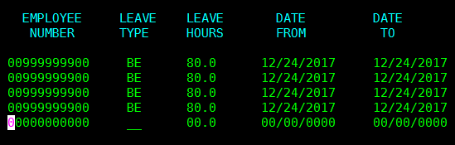  Example B:  Agency authorizes 320 hours of Parental Leave effective 8/7/2018. Parental Leave is loaded to the employee record as shown below on screen HMSUA (Note: After the online edit is removed agencies will be able to load the Parental Leave in one transaction as shown.)  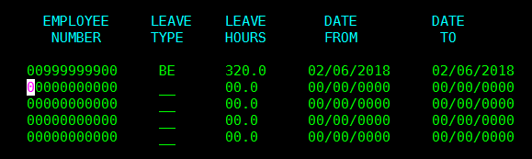
Continued on the next page

New Parental Leave Codes (CIPPS Leave Agencies), continued

Parental Leave Expiration After 6 Months | If the batch processes successfully, the amount of the award will be visible on HPHUN and HPDUN the next business day.  Example A: The agency awarded the Parental Leave effective 6/25/2018 and loaded the leave using the “Adjusted Eligibility Date” of 12/24/2017. The “Adjusted Eligibility Date” will cause the Parental Leave to expire at the close of the 12/10-24/2018 leave period. By policy, the award expires 6 months after the date it was earned. In this example, the employee has between 6/25/2018 and 12/24/2018 to use the awarded leave.  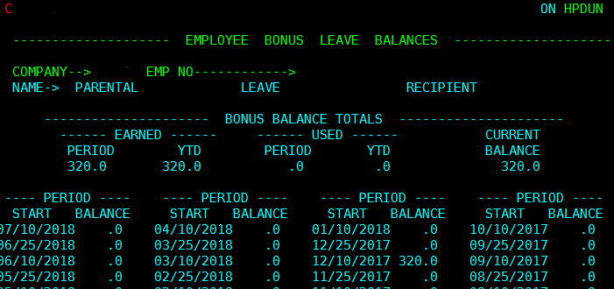  Example B: The agency awarded the Parental Leave effective 8/7/2018 and loaded the leave using the “Adjusted Eligibility Date” of 2/6/2018. The “Adjusted Eligibility Date” will cause the Parental Leave to expire at the close of the 1/25-2/9/2019 leave period. By policy, the award expires 6 months after the date it was earned. In this example, the employee has between 8/7/2018 and 2/6/2019 to use the awarded leave.  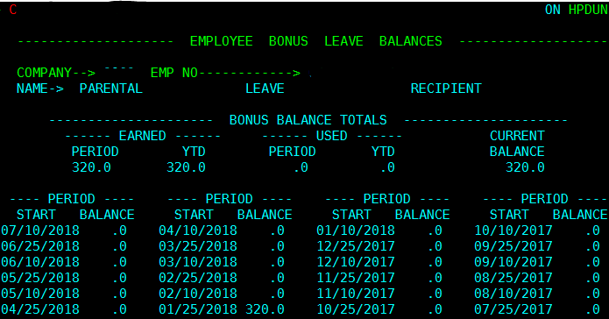
Continued on the next page

New Parental Leave Codes (CIPPS Leave Agencies), continued

Using Parental Leave | 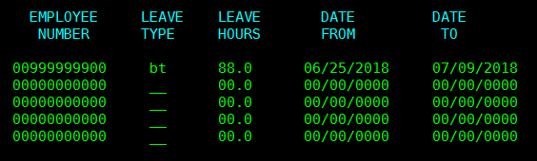  Leave used by the employee should be recorded as “BT” (Parental Leave Taken) using from and to dates that reflect the actual date(s) of the absence. Use screen HMSUA to enter the activity as shown below:

Other Considerations | Some screens and reports will read “BONUS LEAVE” instead of “PARENTAL LEAVE” until all programming changes are complete. The labels in Payline correctly reflect “PARENTAL LEAVE” for the benefit of the employee. The incorrect labels will not affect processing.  Parental Leave is not eligible for payout and therefore will not be included in leave liability reporting.

Payroll Expenditure Update

Eliminated Payroll Account Codes | During the Cardinal payroll project it was identified that certain deduction mappings used by CIPPS to charge payroll expenditures will not work after conversion to Cardinal HCM.  To better prepare for future conversion, it has been decided to move forward with the elimination of the following Account (object) codes effective 08/13/2018:  - Account 5011130 (object 1113) will no longer be used to identify payroll FICA expenditures related to wage employees. Instead, all payroll related FICA expenditures will be charged to account 5011120 (object 1112).  - Account 5011650 (object 1165) which is currently used to capture employee contributions to retirement made by the employer on behalf of the employee for certain eligible positions (Deduction 127) will be eliminated. Instead, Deduction 127 will be charged to account 5011110 (object 1111).
Continued on the next page

Payroll Expenditure Update, continued

Reminder: Agency Account Code | The convention used for the Agency Account Code on the NSSA Table is unique to each agency. Therefore, agencies can create a “key” or a shortcut code that is a better representation of the expenditure coding or Cardinal “Speedtype” associated with the payroll expenditure.  Many agencies continue to use an old convention which required the complete string of old CARS codes and included spaces making it hard to type on screen HMBU1 in CIPPS. This convention is not a State Payroll Operations requirement.  As long as the individual codes (Fund, Program, Service Area, etc.) are mapped to the Agency Account Code field in NSSA and reflect the old CARS values, agencies can use any shortcut in the “Agency Account Code” field that better conforms to their own purposes.

Report 10 and Report 21 Update

SSNs Removed | The Social Security Number (SSN) has been removed from Report 10 and Report 21.  The SSN is still visible on historical reports printed before the update. With that in mind, be especially careful to redact sensitive information from historical reports even when emailing State Payroll Operations.

