Department of Accounts
Payroll Bulletin

Calendar Year 2018 | October 10, 2018 | Volume 2018-13

In This Issue of the Payroll Bulletin….... | - SmartShopper Shared Savings Program  - New Direct Deposit Stop Payment Form | The Payroll Bulletin is published periodically to provide CIPPS agencies guidance regarding Commonwealth payroll operations. If you have any questions about the bulletin, please call Cathy McGill at (804) 371-7800 or Email at cathy.mcgill@doa.virginia.gov  State Payroll Operations  Director Cathy C. McGill

SmartShopper Shared Savings Program

New Healthcare Incentive Opportunity | The Governor recently announced a new opportunity for employees enrolled in COVA Care and COVA HDHP to save money and earn rewards. SmartShopper is an incentive and engagement program designed to encourage members to shop for better-value/lower-cost medical services, such as certain procedures or tests. Members register for the program, shop and receive a cash reward which varies depending on the covered service and selected provider. The incentive will be added to paychecks for active employees about 60 days after the claim is paid. Be advised that when a covered family member earns a cash reward, it will be paid to the enrolled participant, not the family member.

General Incentive Info | To aid in processing the incentives through payroll each month a file will be placed in each agency’s repository containing names, employee numbers, addresses and amounts for employees entitled to the incentive. A few things to remember:  - DHRM will reimburse each agency for the total of the incentive and OASDI/HI taxes.  - Payments to employees will be made in the first pay period of each month  - Incentives are taxable income  - The first file is expected at the beginning of December

CIPPS Processing | DOA will create the transactions needed to pay the incentives for CIPPS agencies:  Active employees currently in CIPPS:  - Transactions will process for special pay 033, HLTINCTV  - Tax/Check/Deduction indicators will be 5 0 0

Questions | Please contact Office of Health Benefits at 888-642-4414 with all questions related to Medical Loss Ratios and the Kaiser rebate.

New Direct Deposit Stop Payment Form

Stop Payments | State Payroll Operations (SPO) has revised the Direct Deposit Stop Payment Form now available on our website. Please begin using it immediately. The agency fiscal officer or other individual authorized to certify payroll must sign the stop payment request. To ensure proper handling, send completed forms in encrypted emails to all three of the following: cathy.gravatt@doa.virginia.gov, kevin.mcelroy@doa.virginia.gov and cathy.mcgill@doa.virginia.gov. DO NOT submit forms by fax or send to payroll@doa.virginia.gov.

Begin Using New Version Immediately | The new form includes a “Decision” section. Depending on the nature of the stop payment, the agency will need to communicate certain decisions regarding each deposit to SPO.  Void Pay: To void the entire payment (i.e., error in payment – it should not have been made or needs to be recalculated), check the box under “Void Pay” on the right hand side of the form. Payroll expenditures charged to the agency will be reduced for the pay run in which the void is processed. Employees must be in an active status for voids to process. Third party checks resulting from the original payment should be deposited to the Treasurer to offset charges that will be initiated when payment is voided.  Rewire*/Suspense: Choose “Rewire” or “Suspense” to re-route the direct deposit funds to another location (employee bank account closed). This option is only available if you are not voiding the entire payment. ONLY INCLUDE THE DOLLAR AMOUNTS OF THE DEPOSITS YOU WISH TO STOP. If you select “Rewire” provide the Account Name, ABA and Acct Number that you wish to rewire the funds to on the form. If you select “Suspense” SPO will send the money to the suspense account at your agency. If you wish to send the funds to an agency Petty Cash Fund (PCF), select “Rewire” and provide the petty cash account information on the form.  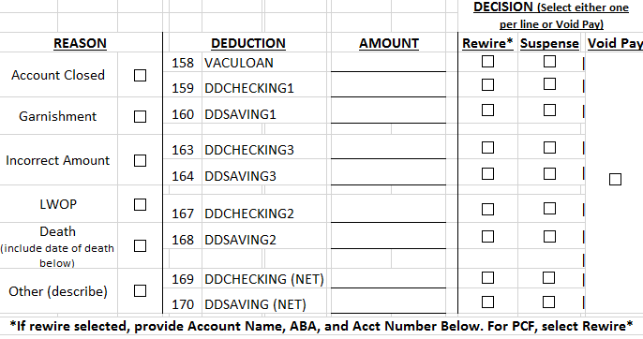

New Direct Deposit Stop Payment Form, continued

Direct Deposit Reminders | If the stop payment is requested by the agency at least three business days prior to the check date, a “delete” is possible. This means that SPO will ask the bank to remove the transaction from the file before submitting it to the Federal Reserve system. This stops the deposit to the employee’s account and the funds are returned by the check date.  If the agency DOES NOT request the stop payment at least three business days prior to the check date, SPO can only request a “reversal”. The bank will attempt to reverse the deposit already posted to the employee’s account. In some cases, the bank will not be able to return the funds (i.e., the account balance is below the amount of the stop payment or there is a hold on the employee’s account). If this happens, the agency will have to collect the overpayment directly from the employee and adjust the payroll records through a manual payset.  To minimize the risk of further overpaying the employee, DO NOT issue more payments to the employee until notified by SPO that the bank has returned the requested amount. Please keep in mind that it may take up to a week before the bank notifies SPO of the status of the request. You will be contacted as soon as funds are returned.  As stated in CAPP Topic 50530, the number of off-cycle payments and voids/stop payments should be kept to a minimum. If the overpayment is 10% or less of the net pay received AND the employee is actively receiving pay, do not request a stop payment. Instead, use Deduction #10, DUE AGENCY, on the employee’s next paycheck to collect the net overpayment (requires manual payset to adjust payroll records). Please email payroll@doa.virginia.gov if you have any questions about how to retrieve an overpayment from the employee’s next paycheck.  To increase the viability of recovering employee overpayments through the stop payment process:  - Review your edit to prevent processing errors that cause overpayments.  - Minimize the number of voids/stop payments. If the employee’s leave balance is greater than the amount due, consider collecting the overpayment from a future paycheck. Waiting for the results of the “reversal” will delay when the employee receives corrected compensation and may cause the employee a hardship.  - Send the Stop Payment Form to SPO as soon as you are aware of an overpayment.  - Certify large payrolls at least four business days prior to the check date whenever possible. For example, if the check date is Friday, certify the payroll on Monday. As stated before, stop payment requests must be submitted at least three business days prior to the check date in order to request a “delete” from the bank. If payroll is certified on Tuesday for a Friday check date, and an overpayment is discovered on Wednesday, the stop payment will be treated as a “reversal”. If the bank is unable to return the funds, the line agency will have to contact the employee directly to recover the overpayment.

