Department of Accounts
Payroll Bulletin

Calendar Year 2019 | November 22, 2019 | Volume 2019-08

In This Issue of the Payroll Bulletin….... | - Change in Process for Handling Unadjudicated Flex Account Claims  - 2019 Imputed Income for Terminated ORP Participants Eligible for Continued Group Life | The Payroll Bulletin is published periodically to provide CIPPS agencies guidance regarding Commonwealth payroll operations. If you have any questions about the bulletin, please call Cathy McGill at (804) 225-2245 or Email at cathy.mcgill@doa.virginia.gov  State Payroll Operations  Director Cathy C. McGill  Assistant Director Carmelita Holmes

Change in Process for Handling Unadjudicated Flex Account Claims

Documentation | According to IRS guidelines (Revenue Ruling 2003-43, 2006-69), all Card transactions must be validated. The TPA is permitted, under the IRS guidelines, to automatically validate (auto-adjudicate) certain transactions. In the event that the TPA cannot auto-adjudicate card transactions, the TPA requests supporting documentation from the employee. If documentation is not received, then the outstanding transaction amounts must be reported to the Internal Revenue Service (IRS) as income on the employee’s W-2 form, and are subject to all applicable employment taxes (including federal and state income tax withholding and FICA).

Change in Process – New Special Pay Code | In the past State Payroll Ops processed separate transactions to update each taxable field as appropriate. Because these adjustments were not processed through a payrun, the amounts had to be added manually to quarterly recons, W2Cs had to be requested for terminated employees, etc. In an effort to simplify this process, a new special pay code has been added for each agency in CIPPS. Non-Paid Special Pay 051 (UNDOCFLX) will be utilized to update the amount the TPA has identified as un-adjudicated. This special pay code will update gross pay and the appropriate taxable fields. Active employees receiving pay will see an increase in the taxes withheld from their checks.

Timing | A file containing special pay 051 transactions for all employees identified as having unadjudicated claims for plan year 2019 will be loaded into CIPPS the week ending December 6. These transactions will be reflected on your 1001 and 1004 reports. In addition, State Payroll Ops will send each agency a list of affected employees and amounts no later than Friday, December 6. Active employees receiving pay will see an increase in the taxes withheld from their 12/16 checks.

Corrections | Employees who dispute the adjustments should be directed to the DHRM Office of Health Benefits (OHB@dhrm.Virginia.gov). Changes to the amounts reported in Special Pay 051 must first be approved by Office of Health Benefits before the HTQTA to reduce the taxable pay is entered. Changes not approved prior to certification of the last payroll for 2019 should be requested during the CYE reconciliation process.

Change in Process for Handling Unadjudicated Flex Account Claims, continued

Terminated Employees | Terminated employees will be returned to an active, non-auto status so the special pay transactions will process. This will result in uncollected FICA (see instructions in next section for clearing uncollected FICA) which MUST be cleared before final cert deadline for 2019. Agencies must wait until the special pay transactions and adjustments to clear the uncollected FICA have gone through a payrun before terming the records again.  Terminated employees with no other pay in CIPPS during 2019 will receive a W2 for 2019. In the past W2Cs were necessary for employees with no other pay in the current calendar year. However, IRS guidance in the General Instructions for Forms W-2 and W-3 (2019) allows employers to report “as wages for income tax withholding and employment tax purposes on the employee’s Form W-2 (or W-2C) for the employee’s taxable year in which, or with which, ends the cafeteria plan year in which the correction is made.” These adjustments are for the Commonwealth’s cafeteria plan year that ended June 30, 2019; therefore, taxable wages for 2019 will be increased and W-2Cs should be unnecessary.

Terminations - Manual Payset Required to Adjust Uncollected FICA | A manual payset will be required to invoke the collection of FICA taxes for those terminated employees. An example of the required transaction on HTQTA is provided on the next page.  Calculate the amount of OASDI (.062) and HI (.0145) tax related to the undocumented claim amount (should equal the uncollected FICA on H0BTT). The combined total should be entered in the NET field with an adjustment indicator of ‘-’and the individual amounts entered for OASDI and HI with an adjustment indicator of ‘+’. The employee must be reactivated in a non-auto time card status; however, you do NOT need to process a time and attendance transaction for $.01 to trigger the manual payset.  The Department of Accounts will create a journal entry to charge the line agency for the uncollected employee FICA amounts.
- Continued on next page

Change in Process for Handling Unadjudicated Flex Account Claims, continued

Terminations - Manual Payset Required to Adjust Uncollected FICA, cont. | It is imperative that these transactions are processed in a timely manner in order for the taxes to be remitted to the IRS by the Department of Accounts. Failure to process these transactions will require payment of the taxes to the IRS via EFTPS at CYE. DOA will process the Cardinal transaction to create the payment and provide copies to the affected agency.  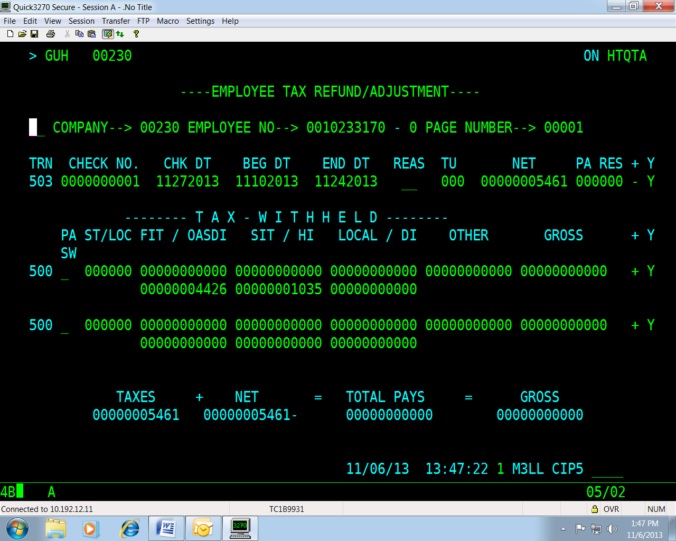

Active Employees | No action is required for active employees as FICA will self-adjust when the employee is paid in 2019. However, if you have an active employee who will not be receiving any further payments in 2019, please follow the instructions provided for terminated employees.

2019 Imputed Income for Terminated ORP Participants Eligible for Continued Group Life

IRS Regulations | Many colleges, universities and agencies with political appointees have employees who choose to participate in one of the Optional Retirement Plans in lieu of VRS (deduction 107 – ORPHE DC, 109 – Fidelity, 111 – Political ORP, or 114 – TIAA). One of the benefits that these employees may continue to receive for a period of time once they have terminated from state service is coverage under the State’s Group Term Life (GTL) policy, provided they meet the age/service guidelines VRS requires for retirement. If the employee is eligible for continued group term life insurance coverage and the amount of the coverage exceeds $50,000, then imputed income must be calculated and reported on a W-2 for the former employee.  VRS provides W-2s to retirees under the Virginia Retirement System, but does not provide W-2s to employees who elected to participate in one of the Optional Retirement Plans (ORP). Therefore, agencies with ORP participants who terminated in 2019 or before and meet the criteria outlined below, must report the amount of imputed income to DOA for inclusion on W-2s for 2019. For ORP participants who terminated in 2019, the amount of the imputed income for the months following date of termination must be included in taxable income. The uncollected social security and Medicare taxes on the imputed income will be reported separately in Box 12 on Form W-2 using codes M and N. The former employee must pay the employee’s uncollected share of Social Security and Medicare taxes with their income tax return.

Eligibility for Continued GTL Coverage | Employees in ORPs must meet the same eligibility requirements as VRS-covered employees to remain covered by the Commonwealth’s’ GTL policy at separation from service (VRS Employer Manual, Chapter 5, page 16). VRS service credits the employee may have in addition to the employee’s ORP service credits count towards meeting the age/service requirements. In accordance with the VRS policy changes effective January 1, 2017, terminated ORP participants are no longer required to maintain a plan account balance to qualify for group life insurance benefits. ORP participants must meet the age and service requirements for reduced or unreduced retirement under the VRS plan for which the employee would have been eligible, based on hire date, had the employee not elected ORP. Employers should review their list of group life insurance imputed income tax eligible retirees in the VRS Navigator to determine if any of their participants are deceased. Employers will receive an email from VRS outlining the procedures. If your agency did not receive a communication from VRS related to this subject, please contact ORPHE@varetire.org.

Reporting Criteria | The following criteria should be used to determine which employees are impacted:  - Employee elected to participate in one of the optional retirement plans instead of VRS, and  - Employee is eligible for continued coverage under Group Life Insurance (at least 50 with 10 years of service or 55 with 5 years of service under Plan 1 and at least 60 with 5 years of service under Plan 2), and  - Employee’s final annual salary is greater than $25,000, and  - Employee terminated or retired during 2019 or earlier.
- Continued on next page

2019 Imputed Income for ORP Participants Eligible for Continued Grp Life, continued

Amount of Insurance Coverage | At the time the employee retires or terminates, the amount of life insurance coverage provided is twice the amount of the employee’s final salary. The following reductions take place as indicated:  25% reduction on January 1st after 12 months from separating service  25% reduction every January 1st thereafter  Final 25% reduction January 1st to fully reduced amount equal to 50% of final salary at time of retirement  Example: At the time Tom retired in May 2019 his final annual salary was $75,000. He meets the criteria required for continued GTL insurance coverage and the coverage amount is $150,000 ($75,000 * 2). In January 2020 the amount of his life insurance coverage will be reduced to $112,500 ($150,000 * .75). In January 2021 the amount of coverage will be reduced to $75,000 ($150,000 *.5). In January 2022 the amount of coverage will be reduced for the last time to $37,500 ($150,000 * .25) which is equal to 50% of his original final salary.

Calculate Amount of Imputed Life | Figure the monthly cost of the insurance to include in the retired employee's wages by multiplying the number of thousands of dollars of insurance coverage over $50,000 (figured to the nearest $1,000) by the cost shown in the table below. Use the employee's age on the last day of the tax year. Figure the total cost to include in the employee's wages by multiplying the monthly cost by the number of full months' coverage at that cost.  A spreadsheet to calculate the amount of imputed income and applicable OASDI and HI taxes is available on our website under Payroll – Important Documents. Use the “Post Retirement Life Insurance Calculation Worksheet for ORP Retirees” to calculate imputed income for calendar year 2019.  https://www.doa.virginia.gov/reference/payroll

Cost Per $1,000 of Protection For 1 Month | Age Cost  Under 25 $ .05  25 through 29 .06  30 through 34 .08  35 through 39 .09  40 through 44 .10  45 through 49 .15  50 through 54 .23  55 through 59 .43  60 through 64 .66  65 through 69 1.27  70 and older 2.06
- Continued on next page
2019 Imputed Income for ORP Participants Eligible for Continued Grp Life, continued

ORP Participants no longer on CIPPS | If you have ORP participants who meet the reporting criteria, but have been purged from CIPPS, you will need to add them back to the system. Use the H0BNE screen to establish a record for each former employee who has imputed income to be reported. H0BNE must be completed to provide the data elements required to build an employee record in CIPPS. Certain data fields entered on H0BNE automatically generate H0BID, H0BAD, and H0ATX screens for the employee.

W-2 Reporting | Once you have completed the spreadsheet for the imputed income that needs to be added to the former employee’s CIPPS record for 2019, email the “Post Retirement Life Insurance Calculation” page to State Payroll Operations at payroll@doa.virginia.gov. In order for DOA to enter the adjustment in CIPPS before certification for the final pay period in December and calculate the amount of employment taxes due to the IRS, all forms must be submitted no later than noon on Friday, December 13, 2019, and PRIOR to your final certification for this calendar year.

Example | Tom retired in May 2019, after 23 years of service with one of Virginia’s community colleges. When Tom was hired, he chose to participate in one of the optional retirement plans offered to Higher Ed employees instead of the traditional retirement plan through VRS. At retirement, Tom’s annual salary was $75,000. Because Tom is 53 and has over 10 years of state service, he continues to be covered after his retirement by group-term life insurance at twice his annual salary ($150,000). Tom’s W-2 must include a total of $276.00 in his wages as imputed life for the calendar year of 2019. The community college prepares the “Post Retirement Life Insurance Calculation” and prints a copy to fax to DOA. DOA compares the YTD amount in CIPPS to the amount reported on the spreadsheet and makes the necessary adjustments. Tom’s W-2 will include uncollected FICA amounts in boxes M and N; however, the community college portion of FICA will be paid to the IRS.

Payment to IRS | DOA will make the federal tax deposit for the employer portion of the OASDI and HI taxes prior to the end of the calendar year. Former employees will be responsible for the employee portion when they file their income tax returns.

DOA Contacts | Please contact Payroll@doa.virginia.gov if you have any questions.

