Department of Accounts
Payroll Bulletin

Calendar Year 2020 | June 3, 2020 | Volume 2020-11

In This Issue of the Payroll Bulletin….... | - Virginia State Employee Loan Program Reminders | The Payroll Bulletin is published periodically to provide CIPPS agencies guidance regarding Commonwealth payroll operations. If you have any questions about the bulletin, please email payroll@doa.virgina.gov  State Payroll Operations  Director Cathy McGill  Assistant Director Carmelita Holmes

Virginia State Employee Loan Program

Virginia State Employee Loan Program | The Virginia State Employee Assistance Fund (VSEAF) was created in 2007. The original purpose of this 501(c)3 charity was to make grants available to employees who were facing a financial crisis due to an emergency (home repairs due to storm damage, funeral expenses, and other unplanned events). Since then it was determined that some employees may have an equally urgent need for financial help that was not related to an emergency or unplanned event. As a result, the Virginia State Employee Loan Program (VSELP) was created. The program provides small, short-term loans through the Virginia Credit Union (VACU) in partnership with the Virginia State Employee Assistance Fund. Please direct all questions to Jonathan Singleton at jonathan.singelton@dhrm.gov or Vilma Alejandro at vilma.alejandro.@dhrm.virginia.gov or call 804-225-2159 or 804 -225-2212.
Eligible Employees | Currently only full-time, classified employees in a non-probationary status, who have been with the Commonwealth at least twelve (12) months and are paid semi-monthly or monthly, are eligible to participate. Membership in the VACU is required and employees must complete and pass an on-line training course and agree to repay the loan through direct deposit payroll deduction not to exceed six months. Of note, individuals employed by independent agencies (VRS, SSC, etc.), most decentralized higher education agencies (VCU, VT, etc.) and wage employees are not eligible for the program at this time.
Payroll Responsibilities | Before loan proceeds are disbursed to the employee, the employee is required to complete and submit to Payroll a direct deposit authorization form created especially for the program. Once the employee’s payroll office has received the form and updated CIPPS to reflect any changes indicated on the form, the payroll office must send a confirmation email to the Program email address: FSPRMB@dhrm.virginia.gov. This email address is to be used exclusively for correspondence between the Benefits Administrator/Payroll Office and the Program. Loan payoff amounts for terminating employees should be requested prior to final payout of wages and/or leave balances. Changes in the employee’s employment status affecting the employee’s ability to repay the loan should be communicated promptly to the Program by email or phone.

Continued on next page
Virginia State Employee Loan Program, continued

Summary of Payroll Responsibilities | Coordination between the VSELP and payroll offices is essential to ensure success of the loan program:  - Payroll confirmation of direct deposit form processing  Send email to FSPRMB@dhrm.virginia.gov after processing the employee direct deposit form. In the email, include “The payroll direct deposit form has been completed for “John Q. Public, Employee ID 1234567 for his new loan.”  If payroll has questions about the form or the direct deposit process, they should email the loan administrators at the same email address.  - Payroll notification of change in employee status  Notify VSELP promptly of terminations, transfers or other issues with employees with Program loans FSPRMB@dhrm.virginia.gov or call 804-225-2212 (Jonathan Singleton). Balance of loan to be collected from final paycheck.  - Payroll confirmation that employee is separating from the agency or the state  Send an email to FSPRMB@dhrm.virginia.gov stating “Jane Doe will be separating from our agency on dd/mm/yyyy. Please advise amount of loan balance to be deducted from her last paycheck.

Deduction  NO 158 | Repayments sent to the Virginia State Employee Loan Program (VSELP) are made via a direct deposit deduction, DED NO 158.  - Establish the banking information using LINE 10 on H0BB1. Add the routing number, 251082615, as shown on the new VSELP form, under the ‘Bank’ field. In the ‘Account’ column, add the VSELP account (loan) number found on the form (starts with 5200).  - On H0ZDC insert deduction number 158 with data from the Loan Agreement as follows:  - Amt: enter VSELP payment per pay period amount  - Goal: enter total repayment amount from chart on the form that corresponds to the amount entered in (a) above  - Utility field:  - Positions 6-7, enter the number of payments to make (for semi-monthly employees enter 12, for monthly enter 06). Each time a loan payment is withheld this value is systematically reduced by one.  - Position 8, enter a 1 to decrement the goal.  - Positions 9-10, enter 10 to indicate that the banking information is located in line 10 on H0BB1.  By entering the number of payments and the goal, the deduction will automatically be deactivated once the number of payments reaches zero. The deduction will not start over when the YTD fields are cleared during year end processing.
Continued on next page

Virginia State Employee Loan Program, continued

Deduction  NO 158, continued | For example, for an employee that is paid semi-monthly and gets a 500.00 loan: enter an amount of 46.00, goal of 552.00, and utility of 000001211000000000. If you enter a ‘Start Date’ of 06/10/2020 the deduction will not begin until the 6/10-6/24/2020 pay period (check date 7/1).  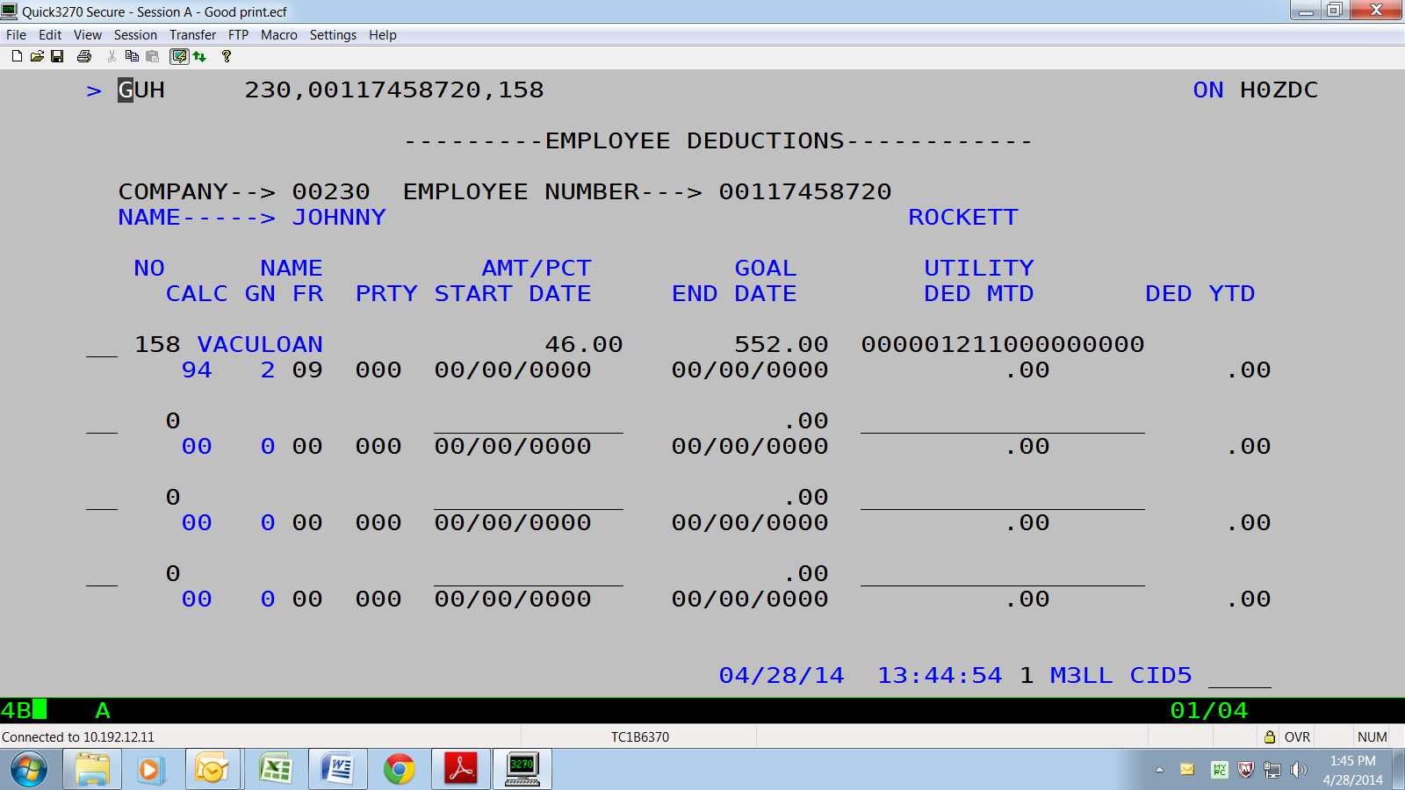  As noted on the VSELP Employee Direct Deposit Authorization form, if payroll receives the VSELP form between the 1st -15th of the month, then the direct deposit should be set up to be withheld on both the 1st and 16th paychecks of the following month so that the full monthly payment is received by the VACU by the monthly loan payment due date of the 18th. Otherwise, it should be set up to begin on the 1st and 16th paychecks of the next month.  For example, if payroll receives a VSELP form between May 16 and June 15 the direct deposit repayment should begin with the 6/10-24 pay period (07/01 check date). If payroll receives the VSELP form between June 16 and July 15 the repayment should begin 7/10-24 (08/01 check date). You can either hold the paperwork until processing those pay periods, or you can enter a Start Date of the 10th on H0ZDC to establish a future begin date. Example: Start Date of 07/10/2020 will begin with the 07/10-24/2020 pay period (08/01 check date).

