Department of Accounts
Payroll Bulletin

Calendar Year 2021 | September 23, 2021 | Volume 2021-08

In This Issue of the Payroll Bulletin….... | - SPO SharePoint  - DocuSign – CIPPS/Payline/ PAT Security and FO Proxy Requests | The Payroll Bulletin is published periodically to provide CIPPS agencies guidance regarding Commonwealth payroll operations. If you have any questions about the bulletin, please email SPO at payroll@doa.virginia.gov  State Payroll Operations  Director Cathy C. McGill  Assistant Director Carmelita Holmes

SPO SharePoint

Introduction | This Payroll Bulletin addresses the launch of the DOA State Payroll Operations SharePoint site which will be used to send and receive all sensitive documents between SPO and the agencies.  Emails have been distributed to notify users that access has been provided. Based on information from your agency, you should be able to add, modify, or edit documents within the designated folders for sensitive documents. In addition, you will receive an email alert when a document has been added to one of the folders SPO uses to provide information to the agencies  This is a link to the SPO SharePoint site:  https://covgov.sharepoint.com/sites/doa/SPO/  If you have trouble accessing the site, first check with your agency Fiscal Officer to be sure that you have been given access. If so, then please send an email to the payroll@doa.virginia.gov email box and describe the problem you are having. Please be sure to include any error messages you may receive.

Using SPO SharePoint | SPO SharePoint must be used to transfer all documents that flow between the agencies and State Payroll Operations. It is mandatory if the document contains sensitive data.  In order to add a document, simply drag and drop from your origination location (Folder or desktop) to the appropriate folder in SPO SharePoint. A list of the folders and their purpose is included on the next page.  Word or Excel documents can be opened and completed as necessary. SharePoint will save changes automatically, but you can also download a copy of the document, make your changes and submit it to SharePoint again.

SPO SharePoint, continued

Folders | Each agency has the following set of folders:  ACH Returns – SPO will notify you when you have funds that have been rejected or returned by the bank using this folder. Please complete and return ACH Return form to the folder as soon as possible.  Confirmation – this will be used by agency Fiscal Officers or designated proxies to transfer the completed Agency HCM Payroll Certification form required prior to each HCM payroll confirmation.  Garnishments – Release 1 agencies will need to submit copies of all garnishments along with the Garnishment Request form as soon as they are received so that SPO can set up the garnishment screens in HCM. Release 2 agencies should continue to use Payline and submit the Request To Add Garnishment/Vendor form to payroll@doa.virginia.gov and should not post copies of garnishments to SPO SharePoint until notified to do so.)  General Deduction Mass Upload Requests – agencies will submit spreadsheets that will be used for mass uploads to general deductions when required. Agencies will also submit requests for off-cycle paysheets and balance adjustments to this folder (forms will be available by 10/1).  Gross Pay Differences – the requirement to explain any differences between the certified amount and the actual amount of gross pay processed will continue to be enforced. Gross Pay Difference reports will be submitted to this folder.  Health Care Reconciliations – all documentation and ATA’s currently sent to the healthrecons@doa.virginia.gov mailbox will be submitted here instead  HR Payroll Exception Reports – also known as the PMIS/CIPPS Audit, this report will continue in HCM. All agencies will be required to submit responses to discrepancies to this folder.  Quarterly Reporting – all employee adjustment forms, quarterly and calendar year-end certifications will be submitted to this folder  SPO to Agency – SPO will use this folder to transfer any other documents containing sensitive data to the agencies  Stop Payment – agencies will submit all requests for stop payments to this folder  W2C Requests – agencies will submit all requests and documentation for changes to W2s to this folder

SPO SharePoint Access Forms | A new form will be added to the Payroll Forms section of the website that agencies will use to add, change or delete access to the various folders for users, as appropriate.

Questions | Please send all questions related to SPO SharePoint access and use to payroll@doa.virginia.gov

DocuSign - CIPPS/Payline/PAT Security and FO Proxy Requests

Payroll Security User Requests | SPO has implemented the use of DocuSign, an electronic signature and digital transaction management tool that is used to replace manual, paper-based transactions and processes. The DocuSign forms for CIPPS access and the Fiscal Officer Proxy for Payroll Certifications are located on DOA’s website under Payroll Forms-CIPPS Security Forms. The DocuSign form for Payline/PAT Security is located under Forms-Payline/PAT.  Only requests submitted via DocuSign will be accepted.

Document Workflow | When a new “envelope” is created, the first step that is required is to identify the recipients. Each individual identified will receive a copy of the final signed document once it has been approved by DOA. The first name that is required is the name of the individual initiating the form (“Requestor”). The second name and email address that must be entered is for the Agency Payroll Security Officer (“PSO”). PSOs are identified on the DA-04-121-Cardinal Authorized Signatories form and are the only ones authorized to approve the request. The third name and email address required is for the employee/user (“User”). Once the required information has been completed, click “Begin Signing”.  PAYLINE/PAT AND CIPPS:  New/Change  Requestor > Payroll Security Officer > Employee > SPO  Delete  Requestor > Payroll Security Officer > SPO  AGENCY FISCAL OFFICER PROXY:  New/Change  Requestor > Agency Fiscal Officer > Proxy(s) > SPO  Delete  Requestor > Agency Fiscal Officer > SPO

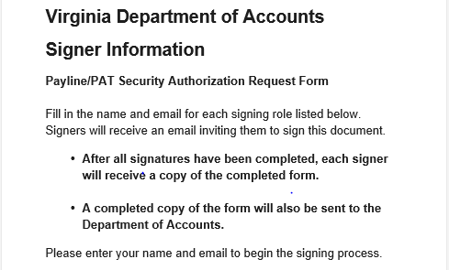

Continued on the next page

DocuSign - CIPPS/Payline/PAT Security and FO Proxy Requests, continued

Document Workflow, cont. | The Requestor will receive a notice from DocuSign and an email notification providing an Access Code for use on the notice.  Copy and paste the Access Code into the notice and click “Validate” (yellow box beside the code). The document will be displayed and the Requestor will be asked to click the “Electronic Signature and Disclosure Agreement” and then “Continue” on the right side of the screen. The next message that displays indicates that all of the recipients have been identified and the form is ready for signing. Once the Requestor clicks “Done”, the document is sent to the PSO.

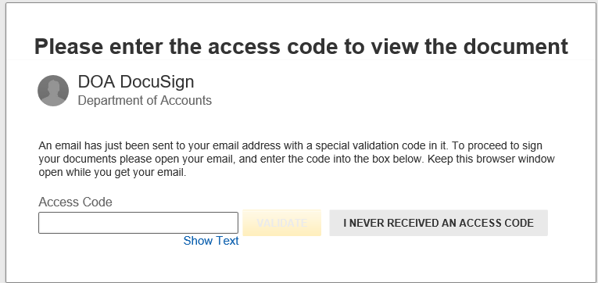

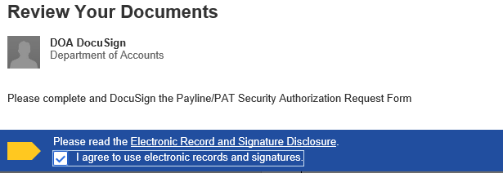

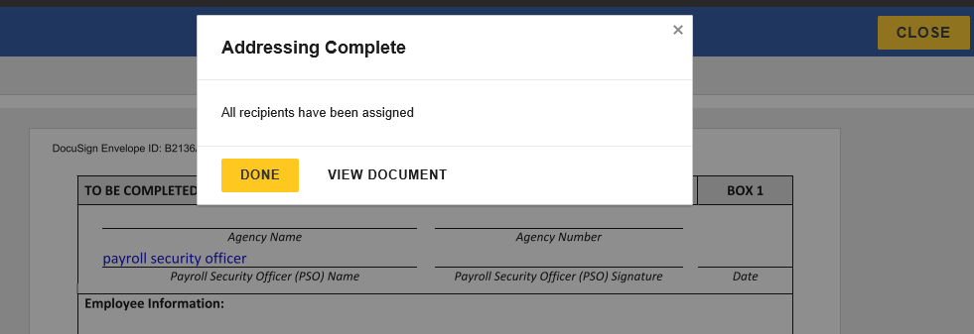
Continued on the next page
DocuSign - CIPPS/Payline/PAT Security and FO Proxy Requests, continued

Document Workflow, cont. | The PSO receives an email containing a link to the document and is asked to also agree to the Electronic Record and Disclosure Agreement. Once the box has been checked the “Continue” button on the right appears (screen shots on the following page). The PSO clicks “Continue” and is asked to then complete the following information as applicable to the form.  CIPPS Security Authorization /Deletion Requests  The following information is required:  • Name and signature of agency’s Payroll Security Office (the date will auto fill).  • Request Type (new, change, delete).  • Security Access (multiple access allowed).  • Agency (s) the request is for.  • CIPPS User information (CIPPS user name, CIPPS user title, employee #, phone number, email address, CIPPS User ACF2 logon ID)  • CIPPS user signature (the date will auto fill).  Payline/PAT Authorization Requests  The following information is required:  • Name and signature of agency’s Payroll Security Office (the date will auto fill).  • Employee information (Name, employee 3, email address)..  • Security Level  • Agency (s) the request is for.  • Employee signature (the date will auto fill).  Agency Fiscal Officer Proxy for Payroll Certifications  The following information is required:  • Name, signature, and email address of agency’s Fiscal Officer (the date will auto fill).  • Name, signature, and email address of Proxy 1 (the date will auto fill.  • Name, signature, and email address of Proxy 2 if applicable (the date will auto fill).  If, for some reason, the PSO declines to complete and approve the form, there are options available by clicking the “Other Actions” box. Otherwise, once the required information has been completed, the PSO clicks “Finish” and the form then goes to the User for completion, following the same steps to agree to the Electronic Record and Signature Agreement and sign the form.  Each signer is given the opportunity to download or print the form after they have signed; however, each recipient is also provided with a copy of the completed form by DocuSign once it has been approved by DOA. Be sure to “Close” the document or click “Finish” so that it will be forwarded to the next recipient.
Continued on the next page

DocuSign - CIPPS/Payline/PAT Security and FO Proxy Requests, continued

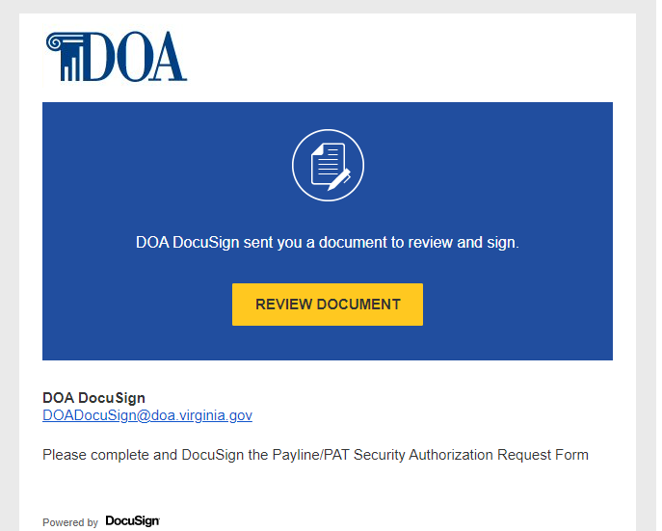

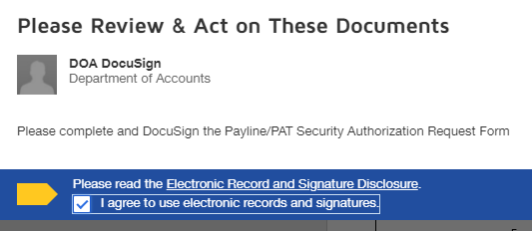
Continued on the next page

DocuSign - CIPPS/Payline/PAT Security and FO Proxy Requests, continued

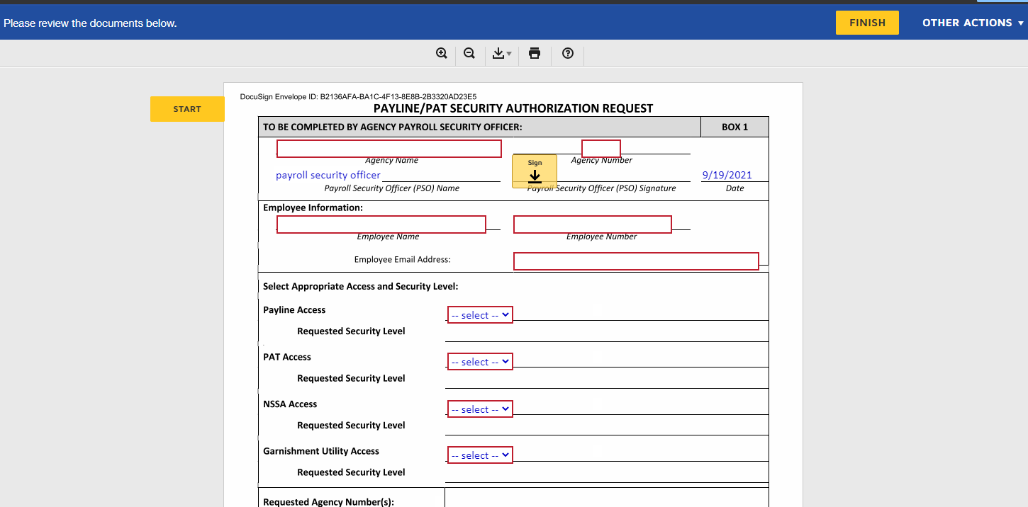

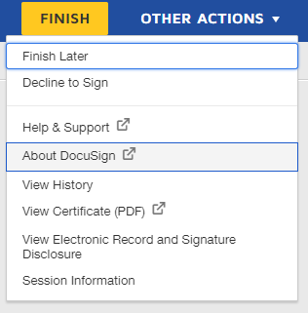

Continued on the next page

DocuSign - CIPPS/Payline/PAT Security and FO Proxy Requests, continued

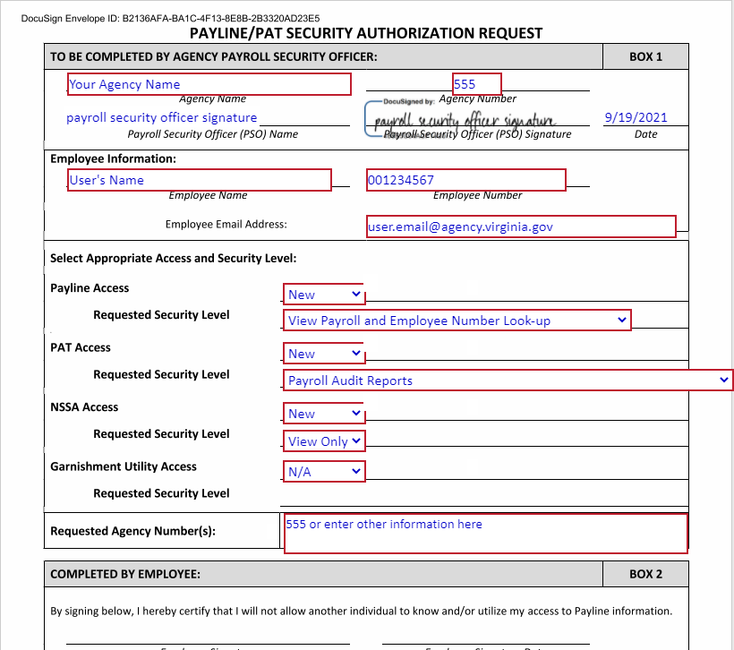

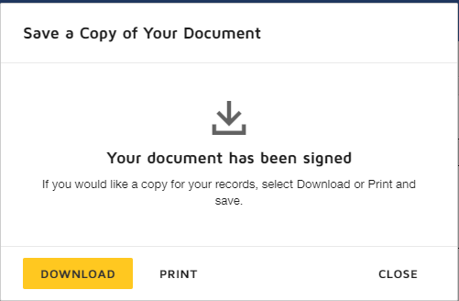

Continued on the next page

DocuSign - CIPPS/Payline/PAT Security and FO Proxy Requests, continued

Declined Documents | Documents that do not contain the required information will be declined.  The Requestor will receive an email notification form DocuSign that the request has been declined. To see the reason it was declined, click on the Other Actions option, then View Certificate (see below).  Declined documents are voided.  A new request with the correct information is required.  