Department of Accounts
Payroll Bulletin

Calendar Year 2021 | December 8, 2021 | Volume 2021-11

In This Issue of the Payroll Bulletin….... | - Unadjudicated Flex Account Claims  - Dependent Care Deductions in Excess of IRS Max  - Uncollected FICA  - Employer-Paid FICA | The Payroll Bulletin is published periodically to provide CIPPS agencies guidance regarding Commonwealth payroll operations. If you have any questions about the bulletin, please call Cathy McGill at (804) 225-2245 or Email at cathy.mcgill@doa.virginia.gov  State Payroll Operations  Director Cathy C. McGill  Assistant Director Carmelita Holmes

Unadjudicated Flex Account Claims

Documentation | According to IRS guidelines (Revenue Ruling 2003-43, 2006-69), all debit card transactions for medical reimbursement claims must be validated. The TPA is permitted, under the IRS guidelines, to automatically validate (auto-adjudicate) certain transactions. In the event that the TPA cannot auto-adjudicate card transactions, the TPA requests supporting documentation from the employee. If documentation is not received, then the outstanding transaction amounts must be reported to the Internal Revenue Service (IRS) as income on the employee’s W-2 form, and are subject to all applicable employment taxes (including federal and state income tax withholding and FICA).

Timing | DHRM extended the grace period for submission of required documentation for Plan Year 2020-2021 to November 30 due to the pandemic. As a result, the information needed was not available until today. SPO will provide the necessary information to agencies as quickly as possible. Agencies must enter the transactions for processing the unadjudicated amounts, along with any transactions needed to account for uncollected FICA (see Terminated Employees below), with the 12/16 pay date.

Special Pay Code 051 | In 2019 a new special pay code was added for each agency in CIPPS. Use Non-Paid Special Pay 051, UNDOCFLX, to update the taxable wages for the amount reported by the Flex Program TPA as un-adjudicated. Transactions should be entered with 5-0-0 as the tax, check and deduction indicators. This tax indicator will update gross pay and the appropriate taxable fields and withhold the appropriate taxes. Deduction overrides may be entered if FIT and/or SIT taxes result in no net pay to the employee. FICA taxes must be withheld.

HCM Earnings Code UNA | Release 1 agencies should use earnings code, UNA – Un-Adjudicated Flex, to update the taxable wages for the amount reported by the Flex Program TPA as un-adjudicated. SPOT Earnings batches should be entered with benefit and general deductions taken. Make sure you do NOT treat this as a separate check. Please submit an Update to Paysheet form to override the FIT/SIT taxes in the event the taxes due result in no net pay to the employee. FICA taxes must be withheld.

Unadjudicated Flex Account Claims, continued

CIPPS Active and Terminated Employees | No action is required for active employees as FICA will self-adjust when the employee is paid in 2021. However, if you have an active employee who will not be receiving any further payments in 2021, please follow the instructions provided for terminated employees in the last section of this bulletin.  Terminated employees must be returned to an active, non-auto status in a paid frequency (i.e., 70) so the special pay transactions will process. See the section on Uncollected FICA at the end of this bulletin.

2021 Dependent Care Deductions

IRS Maximum | One of the changes enacted as part of the American Rescue Plan was a change to the maximum amount of tax-free employer-provided dependent care benefits. For 2021 only, the amount increased to $10,500. As a result, there is no need to adjust taxable wages for 2021 for those employees who exceeded the $5000 limit because they enrolled in both the 2020-2021 and 2021-2022 flex plans for the full amount allowed per plan year after the beginning of the calendar year (2021).

Corrections

Corrections | Employees who dispute the adjustments should be directed to the DHRM Office of Health Benefits (OHB@dhrm.Virginia.gov). Changes to the amounts reported must first be approved by Office of Health Benefits before adjustments to reduce the taxable pay are entered. If entered prior to the final pay cert for the calendar year, the FICA taxes will be refunded to the employee. Changes not approved prior to certification of the last payroll for 2021 should be requested during the CYE reconciliation process.

Uncollected FICA

Terminated Employees | Further instructions will be provided to HCM R1 agencies regarding adjustments for terminated employees.  CIPPS Terminated employees must be returned to an active, non-auto status in a paid frequency (i.e., 70) so the special pay transactions will process. This will result in uncollected FICA which MUST be cleared before final cert deadline for 2021. Agencies must wait until the special pay transactions and adjustments to clear the uncollected FICA have gone through a payrun before terming the records again.  Terminated employees with no other pay in CIPPS during 2021 will receive a W-2 for 2021. In the past W-2Cs were necessary for employees with cafeteria plan adjustments and no other pay in the current calendar year. However, IRS guidance in the General Instructions for Forms W-2 and W-3 (2021) allows employers to report “as wages for income tax withholding and employment tax purposes on the employee’s Form W-2 (or W-2C) for the employee’s taxable year in which, or with which, ends the cafeteria plan year in which the correction is made.” These adjustments are for the Commonwealth’s cafeteria plan year that ended June 30, 2021; therefore, taxable wages for 2021 will be increased and W-2Cs should be unnecessary.
Continued on the next page

Uncollected FICA, continued

Terminations - Manual Payset Required to Adjust Uncollected FICA | A manual payset is required to invoke the collection of FICA taxes for terminated employees. An example of the required transaction on HTQTA is provided below.  Check the employee’s H0BPA screen to make sure the needed amount is in the YTD bucket for Net Pay. If not, contact DOA before you process the HTQTA. Calculate the amount of OASDI (.062) and HI (.0145) tax related to the undocumented claim or excess deduction amount (should equal the uncollected FICA on H0BTT). The combined total should be entered in the NET field with an adjustment indicator of ‘-’and the individual amounts entered for OASDI and HI with an adjustment indicator of ‘+’. The employee must be reactivated in a non-auto time card status; however, you do NOT need to process a time and attendance transaction for $.01 to trigger the manual payset if this adjustment is entered in the same pay period as the transaction for the special pays..

In this example, the unadjudicated amount added through special pay 051 is 713.86. Uncollected FICA taxes are 54.61 (44.26 for OASDI and 10.35 for HI, verified on H0BTT).

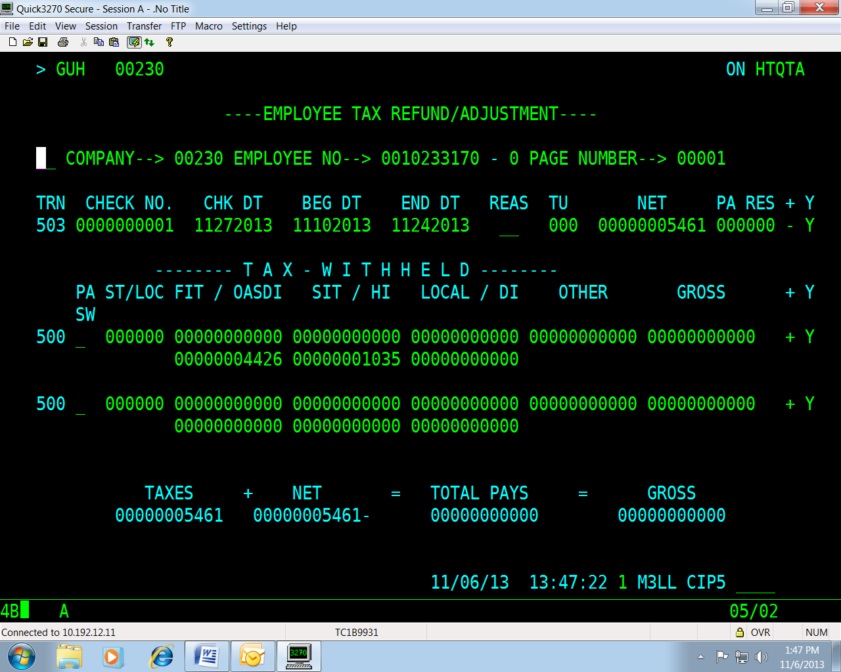
Continued on the next page

Employer-Paid FICA

Employer-Paid FICA | While the employee share of the tax is included in the payment made to the IRS, it is the agency’s responsibility to contact the employee in an attempt to receive reimbursement for the employee portion of FICA paid by the employer. If reimbursement is not received, the amount of taxes paid for on behalf of the employee then becomes additional taxable income to the employee for that calendar year. This again leads to additional income causing a “pyramiding” effect on tax liability. In other words, adding the tax paid to the employee’s taxable income generates additional taxes that the employer has to pay on the employee’s behalf, thus creating additional taxable income and on and on. (See IRS Publication 15-A, Section 7.)  In the event that collection is not possible or is deemed administratively burdensome, the agency must include the amount of the employee-tax paid by the agency in the employee’s taxable wages using the method explained on the following pages.  All of the necessary adjustments must be processed in a timely manner in order for the taxes to be remitted to the IRS by the Department of Accounts. Failure to process these transactions will require payment of the taxes to the IRS via EFTPS at CYE. If payment is made through EFTPS, DOA will process the Cardinal transactions to create the payments and charge the agency. Copies of the transactions will be provided to the affected agency.

Calculations for Special Pay 071,  Employer-Paid Tax | General guidelines to increase 2021 Taxable Wages for non-cash taxable fringe benefit adjustments when there will be no further pay in 2021 or uncollected FICA remains uncollected:  - Calculate the “Grossed Up” non-cash award amount by dividing the amount of the non-cash award by .9235  - The amount of the non-cash taxable fringe benefit has already been entered using the non-cash special pay code (049, 051, 056, 057 or 059)  - Enter the difference between the grossed up amount and the actual amount of the non-cash award in special pay code 071  - The amount of OASDI (6.2%) and HI (1.45%) tax related to the grossed up value must be calculated and entered through manual payset on HTQTA to force tax payment.  If the employee repays the agency for the taxes paid on their behalf by the agency, the amount of the repayment is based only on the original uncollected FICA amount. If the repayment is received prior to the end of regular processing for 2021, an adjustment to back-out Special Pay 071 is performed. If the repayment is received after final regular processing for 2021 but before W-2s have been distributed, a year-end adjustment should be submitted. If the repayment is received after W-2s have been distributed, then a W-2C must be prepared for 2021.
Continued on the next page

Employer-Paid FICA, continued

Employer-paid Tax Examples | Example 1: An unadjudicated flex adjustment (SP 051) has been processed in CIPPS to increase employee’s 2020 taxable wages by $713.86. Additionally the HTQTA to force a payment of the uncollected (not the amount based on the “grossed up” amount) FICA taxes paid on behalf of the employee was performed (see page 3; $54.61). However, nothing has been entered to record the taxable income generated by taxes paid for the employee by the employer. Therefore, the amount of Special Pay 071 must be determined and an additional HTQTA entry for the grossed up taxes not previously processed must be entered.  - Employee is re-activated to non-auto status, frequency 70 in CIPPS and 713.86 is entered on HUE01 as special pay 051 with 5-0-0  - 713.86 * .0765 = 54.61; 54.61 entered on HTQTA with 44.26 in OASDI and 10.35 in HI. Make sure amount of Net Pay is available in YTD bucket of H0BPA  - 713.86 (SP 051) divided by .9235 = 772.99 (grossed up amount)  - 772.99 minus 713.86 (SP 051) = 59.13 (total of employee tax paid by employer)  - 59.13 is entered on HUE01 using Special Pay code 071 and tax/check/deduction indicators of 5-0-0  - 59.13 – 54.61 (44.26 and 10.35 already entered on HTQTA) = 4.52  - OASDI tax: 59.13 multiplied by .062 = 3.67  HI tax: 59.13 multiplied by .0145 = .86  Combined total of OASDI/HI: 3.67 + .85 = 4.52  - The combined total of 4.52 should be entered in the NET field on HTQTA with an adjustment indicator of ‘- Y’ and the individual amounts for OASDI of 3.67 and HI of .86 should be entered in the proper fields of the 500 transaction line with an adjustment indicator of ‘+ Y’.  - Please note that you do not need to process a penny of regular pay to activate the manual payset if processed during the same pay period as the special pay for 071.  Note: Remember that the amount of FICA repayment from the employee would be determined using the original tax rates (713.86 multiplied by .0765 = 54.61).

Example 2: No entries have yet been entered to record the taxable value of the unadjudicated flex adjustment which is $713.86:

- Employee is re-activated to non-auto status, frequency 70 in CIPPS and 713.86 is entered using Special Pay 051 for the unadjudicated adjustment amount on HUE01 and tax/check deduction indicators of 5-0-0
- 713.86 (SP 051) divided by .9235 = 772.99
- 772.99 minus 713.86 (SP 051) = 59.13 (SP 071)
- 59.13 is entered on HUE01 using Special Pay Code 071 and tax/check deduction indicators of 5-0-0
- OASDI tax on 772.99 = 47.92
HI tax on 772.99 = 11.21
Combined total of OASDI/HI = 47.92 + 11.21 = 59.13
- The combined total of 59.13 should be entered in the NET field on HTQTA with an adjustment indicator of ‘- Y’ and the individual amounts for OASDI of 47.92 and HI of 11.21 should be entered in the proper fields of the 500 transaction line with an adjustment indicator of ‘+ Y’. Make sure amount of Net Pay is available in YTD bucket on H0BPA
- Please note that you do not need to process a penny of regular pay to activate the manual payset if processed during the same pay period as the special pays for 051 and 071.

Note: Remember that the amount of FICA repayment from the employee would be determined using the original tax rates (713.86 multiplied by .0765 = 54.61).

