Department of Accounts
Payroll Bulletin

Calendar Year 2022 | August 10, 2022 | Volume 2022-09

In This Issue of the Payroll Bulletin….... | - HCM Paycheck History Report  - HCM New Hire Reporting  - SPO SharePoint Update | The Payroll Bulletin is published periodically to provide CIPPS agencies guidance regarding Commonwealth payroll operations. If you have any questions about the bulletin, please call Cathy McGill at (804) 371-7800 or Email at cathy.mcgill@doa.virginia.gov  State Payroll Operations  Director Cathy C. McGill  Assistant Director Carmelita Holmes

Paycheck History Report

Paycheck History Report | This report will list the confirmed paycheck history for a specific employee for the payrolls included in the identified check date range, including earnings/taxes/deductions, which can be specified if only a particular code(s) is needed. Employee Number and Check date range are the only required fields on the run control page. The remaining fields are optional.  Navigator > Payroll for North America > Payroll Processing USA > Pay Period Reports > Paycheck History Report  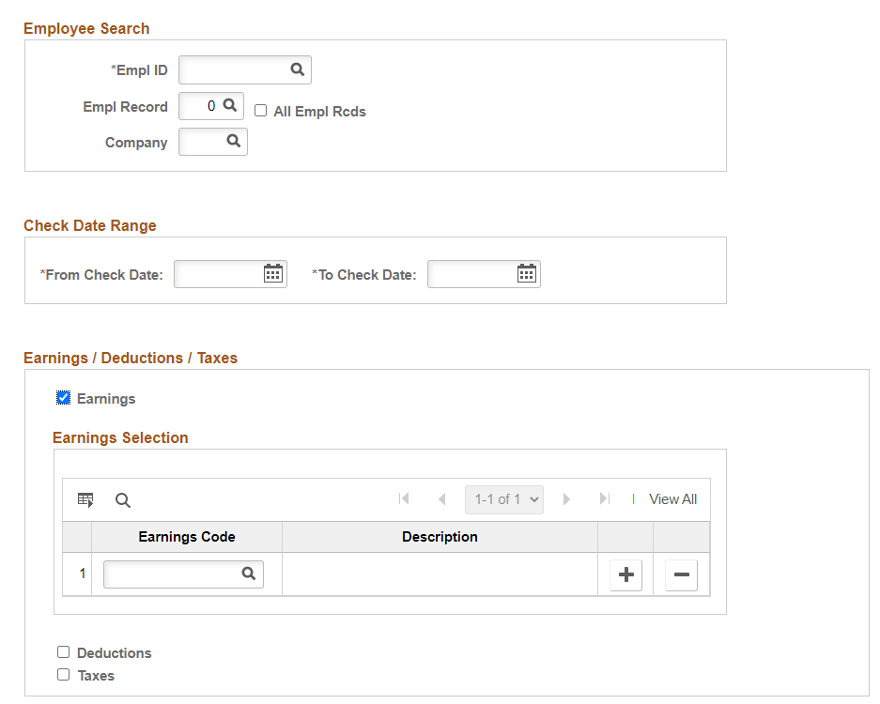

New Hire Reporting

New Hire Reporting | State Payroll Operations uploads the New Hire Report to the New Hire Reporting Center every other Wednesday. This report looks for new hire records added to the system with effective dates that fall within the last 21 days of the date the report is run. It is possible that employees added retroactively will not be included in the report. In those cases, the agency must report them directly to the New Hire Reporting Center (https://va-newhire.com)

Data Query | HCM payroll agencies should use the following tools to determine whether or not there are employees that missed the New Hire Report.  Run the V_HR_JOB_QUERY and use “HIR” (Hire) in the Action field and “New” in the Reason field. Run a second time with “REH” (rehire) in the Action field and “REH” in the Reason field. Enter the end date from the new hire report date range (you can see the date ranges in the monthly detailed operations schedule) in the As of Date field. You may leave the Business Unit field blank to see results for all agencies you have access to or you can run for a specific agency.  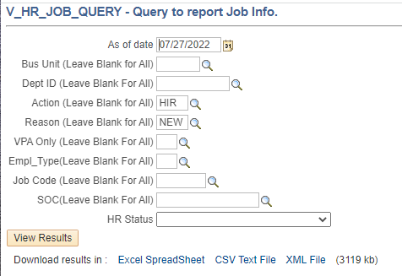  Pay particular attention to the Effective Date and the Action Date. The effective date provides the actual hire date and the Action Date indicates when the record was added to the system. If the Effective Date is prior to the beginning date of the date range of the New Hire Report and the Action Date is within the date range of the New Hire Report, then the employee was not included on the file that went to the New Hire Reporting Center and must be reported by the agency.
Continued on the next page

New Hire Reporting, cont.

New Hire Report | The New Hire Report can be run to confirm whether or not an employee was included.  Navigator>Workforce Monitoring>Meet Regulatory Requirements>Regulatory Reports>PRWORA Newhire  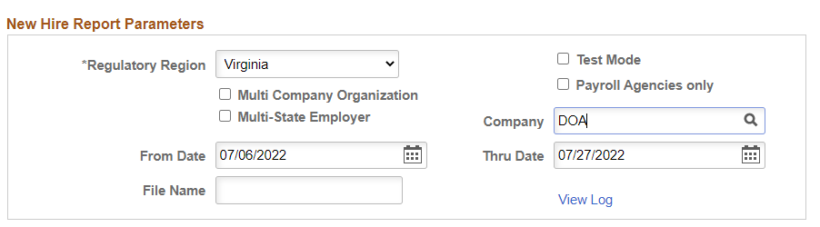  The Process Scheduler Request box will open when you click Run. Make sure the format is set to PDF and click Ok.  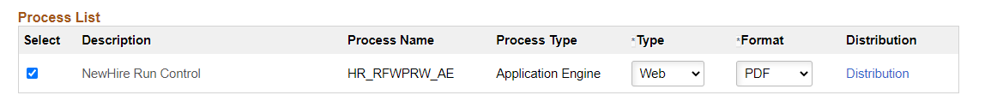

SPO SharePoint Update

SPO Sharepoint | SPO’s SharePoint has been revised and is now available for use. Security for access requests previously submitted has been established and the old site will be disabled as of 8/12. Please submit all documentation shared with SPO in the appropriate folder located within your agency’s library to ensure that the appropriate SPO staff is alerted. All changes to access should be requested using the SharePoint Security Authorization available in Miscellaneous Forms on the SPO website: www.doa.virginia.gov/forms/Payroll/SPO-SharePoint-Security-Authorization-Request.pdf  This is the link to the new version:  https://covgov.sharepoint.com/sites/DOA_SPO  A reminder for “external” agencies – you must have a .virginia.gov email address before you can access. Please send an email to payroll@doa.virginia.gov if you do not already have an email address ending in Virginia.gov and need access to SPO SharePoint. Include both your actual and your alias email addresses on the security form.
Continued on the next page

